How do I exchange necessary information not foreseen in case-specific SEDs?
H_BUC_01_Subprocess: Ad hoc exchange of information
Description:
The Horizontal sub-process ‘Ad hoc exchange of information’ is used in a situation where you want to request, or communicate information, with another institution within an existing sectorial case.
Legal base:
 | Basic Regulation (883/04)
SED | Article 76
H001 Notification/Request for information
H002 Reply to request for information

Glossary of relevant terms used in H_BUC_01_Subprocess:
Actor name | Description
Triggering Participant | The Triggering Participant (you) is an active participant in the main process who triggers this BUC. This will be an Institution where the main process permits their role to do so
Other Participant(s) | Other Participant(s) represents all other active participants in the main process. This will be one or more Institutions as determined by the main process.

Steps:
You have to fill out a 'Notification/Request for Information' SED H001 and send it, including any attachments, to all the Other Participant(s). The Other Participant(s) review the H001 and may optionally choose to fill in and send a 'Reply to Request for Information' SED H002 together with any attachments to you or optionally more active participants.
Special Requirements:
- SED H002 can only be sent as a reply after receiving an SED H001
- The SEDs H001 and SED H002 might be sent more than once if necessary
- Administrative sub-processes ‘Invalidate’ and ‘Update’ might be used more than once if necessary

Business process:
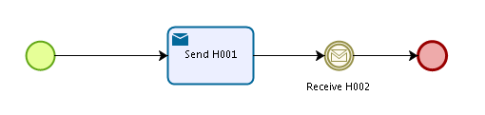
Administrative sub-processes available to the Triggering Participant and Other Participant(s):
I want to Invalidate a sent SED (AD_BUC_06)
I want to Update information contained in a sent SED (AD_BUC_10)

