How do I exchange information necessary to determine residence?
H_BUC_02_Subprocess: Determine Residence
Description:
The Horizontal sub-process ‘Determine Residence, Request for Information, Disagreement Procedure and Notification of Residence,’ is used to find out the person's residence, request for information, launch a disagreement procedure or notify about the residence in accordance with EU law within an existing sectorial case. This sub-process consists of three options that can be used separately or one after the other based on the action you need to do take.
Legal base:
SED | Implementing Regulation 987/2009 | Basic Regulation 883/2004
 | 11 | 76
H003 Proposal/Notification on State of Residence
H004 Reply to proposal on State of Residence/Disagreement with decision on State of Residence
H005 Request for information on Residence
H006 Reply to request for information on Residence

Glossary of relevant terms used in H_BUC_02_Subprocess:
Actor name | Description
Triggering Participant | The Triggering Participant (you) is an active participant in the main process who triggers this BUC. This will be an Institution where the main process permits their role to do so.
Other Participant(s) | Other Participant(s) represents all other active participants in the main process. This will be one or more Institutions as determined by the main process.

Steps:
You can choose one of the three options below depending on the information that you need or the action you have to take. You can also do them one after the other if necessary.

1. If you need to request information on residence, you have to fill in a ‘Request for Information on Residence’ SED H005 by entering all the required information and send it, including any attachments, to Other Participant(s). Each Other Participant reviews the H005 and attachments and sends a ‘Reply to Request for Information on Residence’ SED H006, including any attachments to all Participants. Once you have received all H006 replies, you can determine the person's residence using this additional information.
2. If you need to notify the state of residence, you have to fill in a ‘Proposal/Notification on State of Residence’ SED H003 by entering all the required information and send it to Other Participant(s). Each Other Participant reviews the H003 and sends a ‘Reply to Proposal on Residence’ SED H004.
3. If you need to send a Reply to Proposal on State of Residence/Disagreement with decision on State of Residence, you have to fill in ‘Reply to Proposal on Residence’ SED H004 by entering all the required information and send it to Other Participant(s). Each Other Participant receives and views the H004.
Special Requirements:
- H003 and H004 can be sent more than once
- H003, H004, H005 must be sent to all Other Participants; H006 must be sent to the Requester

Business process:
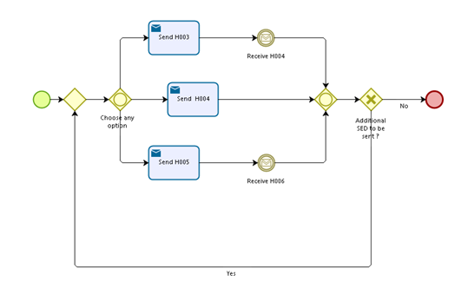

Administrative sub-processes available to the Triggering Participant and Other Participant(s):
I want to Invalidate my sent SED H003, H005 or H006 (AD_BUC_06). Note that you can choose to send a new H003 SED after invalidating the initial H003.
I want to Update information contained in a sent SED (AD_BUC_10).
Sub-processes 'Invalidate' and 'Update' can be used more than once both by the Triggering Participant and Other Participant(s).

