How do I exchange Personal Identification Numbers?
H_BUC_05_Subprocess: Exchange of PINs
The Horizontal sub-process 'Exchange of PINs' is used to exchange Personal Identification Numbers (PIN) described in Article 2(2) and Article 52(1)(a) of Regulation (EC) No 987/2009, within an existing sectorial case. It allows an exchange of Personal Identification Numbers under Article 52 when migrant workers move to another Member State and register to work.

Legal base:
SED | Implementing Regulation 987/2009
 | 2 (2) | 52(1)(a)
H061 Notification/Request of Personal Identification Number
H062 Confirmation/Reply to Request of Personal Identification Number

Glossary of relevant terms used in H_BUC_05_Subprocess:
Actor name | Description
Triggering Participant | The Triggering Participant is an active participant in the main process who triggers this BUC. This will be an Institution where the main process permits their role to do so
Other Participant(s) | Other Participant(s) represents all other active participants in the main process. This will be one or more Institutions as determined by the main process.

Steps:
To exchange this information, you have to send a ‘Notification/Request of Personal Identification Number’ SED H061 to Other Participant(s). Each Other Participant answers with a ‘Confirmation/Reply to Request of Personal Identification Number’ SED H062 by sending it to you and the Other Participant(s). You receive H062 and the case ends here.

Special Requirements:
- H061 can be sent only once. If you need to change or add to the information that you provided, you can use the possibility to update the information provided in your initial H061.
- The other Participants can send H062 only as a reply to your H061.

Business process:
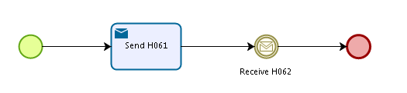
Administrative sub-processes available to the Triggering Participant and the Other Participant(s):
I want to invalidate a sent SED (AD_BUC_06_Subprocess).
I want to update the information contained in a sent SED (AD_BUC_10).

Sub-processes 'Invalidate' and 'Update' can be used more than once by the Triggering Participant and Other Participant(s).

