How do I Request for Administrative Check?
H_BUC_10_Subprocess: Administrative Check
The Horizontal sub-process 'Administrative Check' is used to request the institution of the place of residence or stay to carry out an administrative check of the person concerned in accordance with the procedures laid down by the legislation of the Member State of Stay or Residence. It can also be used to ask the institution of the Member State of Stay or Residence for information about estimated costs or the required administrative check.

Legal base:
SED | Basic Regulation (883/04) |  |  | Implementing Regulation (987/09)
 | 36 (3) | 21 | 82 | 33(1) | 27(5)(10) | 87(1)(3)
H130 Request for Estimation on costs /Request for Administrative Check
H131 Information on Estimated Costs / Reply to Request for Administrative Check

Glossary of relevant terms used in H_BUC_10_Subprocess:
Actor name | Description
Triggering Participant | The Triggering Participant (you) is an active participant in the main process who triggers this BUC. This will be an Institution where the main process permits their role to do so
Other Participant(s) | Other Participant(s) represents all other active participants in the main process. This will be one or more Institutions as determined by the main process.

Steps:
You have to send a ‘Request for Estimation on Costs / Request for Administrative Check’ SED H130 by entering all the required information to Other Participant(s). The Other Participant(s) receive the H130 and fill in and send a 'Reply to Request for Administrative check' SED H131. You receive H131 and the use case ends here.

Business process:
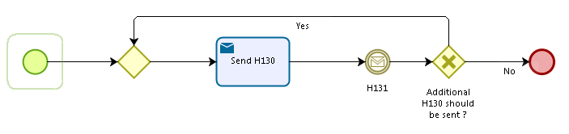
Administrative sub-processes available to the Triggering Participant and the Other Participant(s):
I want to invalidate a sent SED (AD_BUC_06).

Sub-process 'Invalidate SED' can be used more than once by the Triggering Participant and Other Participant(s).

