

APPROVED

EESSI Business Use Case

*UB_BUC_01*

*Exchange of Information to determine a claim for UB*





# Table of Contents

Table of Contents 2

1. Introduction 7

1.1. Purpose 7

1.2. Scope 7

1.3. Definitions, Acronyms and Abbreviations 7

1.4. References 8

1.5. Overview 8

2. Description 9

2.1. Business Scenario 9

2.2. Legal Base 9

3. Actors & Roles 10

4. Use Case 11

4.1. RUP Table Representation 11

4.2. Request – Reply SEDs 20

4.3. Attachments Allowed 20

4.4. Artefacts used 20

5. Business Processes 22

5.1. Case Owner 23

5.2. Counterparty 24

5.3. Sub Processes 25

5.3.1. Case Owner's Sub Process "Request for Insurance Records" 25

5.3.2. Case Owner's Sub Process "Request for Salary Info" 25

5.3.3. Case Owner's Sub Processes "Request for Family Info" 26

5.3.4. Counterparty's Sub Process "Receive Request for Insurance Records" 26

5.3.5. Counterparty's Sub Process "Receive Request for Salary Info" 27

5.3.6. Counterparty's Sub Processes "Receive Request for Family Info" 27

6. Appendices 28

6.1. Issues 28

**Document Control Information**

|  |  |
| --- | --- |
| **Settings** | **Value** |
| **Document Title:** | **Business Use Case**  **UB_BUC_01 - Exchange of Information to determine a claim for UB** |
| **Project Title:** | **EESSI (Electronic Exchange of Social Security Information) Project** |
| **Document Author:** | **European Commission, DG EMPL F5** |
| **System Owner:** | **European Commission, DG EMPL D2** |
| **Doc. Version:** | **v4.1.0** |
| **Sensitivity:** | **Public** |
| **Date:** | **03/08/2018** |

**Document history:**

The Document Author is authorized to make the following types of changes to the document without requiring that the document be re-approved:

* Editorial, formatting, and spelling
* Clarification

To request a change to this document, contact the Document Author or Owner.

| **Revision** | **Date** | **Created by** | **Short Description of Changes** |
| --- | --- | --- | --- |
| v0.07 | 28/08/2014 | Mihai Dinca | Draft |
| v0.08 | 15/10/2014 | Eric Briffoz | Updated draft following AHG Unemployment Benefits comment – please see collated comments chart. |
| v0.09 | 01/12/2014 | Eric Briffoz | Adaptations after AHG Kick-off meeting: BPMN Model updated. + SR2 (Special Requirements) |
| v0.10 | 29/01/2015 | Eric Briffoz | - Removed links to the Reject SED for this BUC.  (Reject will be used in upcoming BUC's).  - Adaptation Use case diagram |
| v0.11 | 18/02/2015 | Eric Briffoz | - Adaptations following comments from Testing Team on 16/02/2015  - Adaptations concerning Horizontal integration BUC's: removal of all H_BUC's except H_BUC_01 Adhoc exchange of information.  - Admin tasks can be used throughout the case life-cycle for more flexibility.  - Close SED can be possibly used, only by the Process Owner.  - Re-Open SED can be possibly used, either by the Process Owner or by the Counterparty |
| v0.12 | 23/03/2015 | Eric Briffoz | Adaptations following comments from testing team. |
| v0.13 | 22/04/2015 | Eric Briffoz | Adaptations following comments from testing team. |
| v0.14 | 11/11/2015 | Eric Briffoz | Correction in Use Case Diagram (Section 4.2):  - Added missing AD_BUC_08 Clarify Content. |
| v0.99.0 | 20/11/2015 | Phil Cummings | **Candidate for AHG Approval**  Inclusion of Request-Reply Table  Inclusion of Attachment Allowed Table  Inclusion of SED & Sub-process Versioning Information |
| v1.0.0 | 05/01/2016 | Eric Briffoz | **AC APPROVED VERSION** |
| v1.0.1 | 24/11/2016 | Heidi Warson | Alignment to the standard description and layout of the BUC:  - Throughout the document updated with grammatical changes and formatting.  - Aligned the BUC title throughout the applicable sections and header.  - Renamed section 2.2 from 'Legal Regulations / Policy Issues / Other' to 'Legal Base' & aligned the text and table to the standard BUC.  - Section 3 Actors & Roles: deleted actor 'Petitioner (An unemployed person applying for unemployment benefits.)', as this is not an active actor in the BUC. The information should be included in the guideline, when required.  - Section 4.1 RUP Table Representation:  Removed 'Petitioner' form Actors section;  Added 2 additional steps for the invalidate branches, to allow a new creation of the SED after an invalidate has been executed;  Split the invalidate and update branches which were applicable to 2 SEDs (U001 and U001CB, U002 and U0017, U004 and U004_IT) into 2 branches, 1 per branch.  - Section 4.5 SED and Sub-process Versioning: added subprocess AD_BUC_12_Subprocess – Change of Participant in the table 'SUB PROCESS'  - Section 5 Business Processes: rephrased first paragraph.  - Renamed section 5.3 – 'Called sub Processes' to 'Sub Processes'. Deleted section 5.3.1 – 'Identify Participants' and section 5.3.2 – 'Fill and Send'. Both sections will be regarded as only 1 activity and not as a sub process. |
| v1.1.0 | 27/06/2017 | Heidi Warson | Approval of change request for "UB_BUC_01 – Remove U004_IT from the process", see JIRA EESSI-1755.  Approval of change request for "UB_BUC_01 – Include Admin Subprocess Reject SED", see JIRA EESSI-1754.  Updated the document accordingly:  - added branch 57 and added the BUC in section 4.4 and 4.5);  - removed the alternative branches related to U004_IT. All countries including Italy will use SED U004 (rephrased branch 2, removed branches 2.1, 4.1, 24, 29, 43, and 48, deleted the SED from sections 2.2, 4.2, 4.3, and 4.5, and updated the business processes accordingly).  Updated section 5.3 to include the applicable subprocesses  Updated Branch 8 to "…or [branches 1 to 7 as from step 3] and [branches 1 to 7 to step 7]…", this to be more precise as it was assumed that only a reference was needed to the basic scenario. |
| v1.1.1 | 15/12/2017 | Heidi Warson | Updated section 4.1 to improve the readability of the document:  - Removed steps related to PD U1 from main scenario and included them as Preconditions.  - Updated step 8 and branch 1 step 4: changed 'periods of insurance' to 'insurance record information', because U002 contains various details, not just periods of insurance;  - Removed branch 2 on Salary info and combined this in branch 4;  - Removed branch 3, 5, and 6 on Family info and included this in branch 7;  - Updated branch reference steps accordingly for branches 8 to 57 and the Exception branch and removed branches 22 to 26, 30 to 33, 41,42,44,45, and 49 to 52;  - Rephrased SR1 accordingly.  Added the BPMN version of the diagram  Correction in the sub-process table from section 4.5.  Removed Use Case diagram (section 4.4). |
| v1.1.2 | 15/03/2018 | Heidi Warson | Corrected branch 17 wording from " in case a branch is invoked as soon as an SED has been send …" to " in case a branch is invoked as soon as an SED has been received by the Counterparty " following EESSI-2636 |
| v4.1.0 | 03/08/2018 | Heidi Warson | - Section 4.4: merged 2 tables (for SED & for Subprocesses) into 1 Artefact table.  - Version adaptations to release 4.1.0. |

# Introduction

## Purpose

The purpose of this document is to construct an external view of, part of, the 'EESSI business system' as described in EC Regulations 883/2004 and 987/2009. The ‘EESSI Business System’ describes the business and expected business processes without consideration as to which part(s) may be realised by an IT System (i.e. the proposed EESSI IT System).

The external view comprises of models and descriptions of business use cases, the services of a business system offered to business actors: customers, business partners, or other business systems.

A business use case is described from an actor's perspective; it describes the interaction between an actor and the business system, meaning it describes the behaviours of the business system that the actor utilises. The Business Use Case includes Use Case Diagrams and Business Process Models.

Use case diagrams show actors, business use cases, and their relationships. Use case diagrams do not describe procedures. Alternative scenarios also remain hidden. These diagrams give a good overview of the behaviours of the EESSI business system which will direct and govern part of the expected behaviours and functionality delivered by the EESSI IT System.

## Scope

This document is limited to the external view on the Unemployment sector process of Exchange of Information to determine a claim for UB. The different elements like use case description, business actors, and business process as well as supporting UML diagrams and BPMN models pertaining to the Exchange of Information to determine a claim for UB.

## Definitions, Acronyms and Abbreviations

Please see the EESSI Project Glossary [here](https://webgate.ec.europa.eu/CITnet/confluence/display/EESSI/Project+Information+for+Stakeholders).

## References

|  |  |  |
| --- | --- | --- |
| **#** | **Description** |  |
| 1 | EC Regulation 883/2004 | Regulation EC No 883- 2004.pdf |
| 2 | EC Regulation 987/2009 | Regulation EC No 987-2009.pdf |
| 3 | UML 2.x | <http://www.omg.org/spec/UML/> |
| 4 | BPMN 2.0 | <http://www.omg.org/spec/BPMN/index.htm> |
| 5 | UML 2.0 In Action | Henriette Baumann, Patrick Grassle & Philippe Baumann, 2005, ISBN 1904811558 |
| 6 | RUP@EC standard 5.0 | <http://www.cc.cec/RUPatEC_Standard/> |
| 7 | RUP op maat | <http://www.rupopmaat.nl/> |

## Overview

Chapter1 introduces the external view on the business system under review and lists the elements of this specification.

Chapter 2 introduces the Exchange of Information to determine a claim for UB business processes. The chapter gives a short and detailed description as well as a reference to business process legal base.

Chapter 3 lists the actors involved in the Exchange of Information to determine a claim for UB business process.

Chapter 4 describes in detail the Exchange of Information to determine a claim for UB business process based on the RUP use case template, as well as the relationship to other use cases.

Chapter 5 describes the Exchange of Information to determine a claim for UB business process using business process modelling notation (BPMN).

# Description

## Business Scenario

The "Exchange of Information" business process in the Unemployment sector describes how situations regarding the exchange of information needed in order to determine the benefits to which an unemployed person is entitled are handled according to article 54 of Regulation (EC) No 987/2009.

Normally, the person concerned is someone who has completed in the past periods of insurance or periods of employment in Member State(s) different from the one that grants unemployment benefit. However, it could also be just someone whose relative(s) resides in another Member State(s) and they are taken into account by the competent state for granting unemployment benefit. If he applies for unemployment benefits in the Member State of residence and there is a need to get information concerning his insurance record/salary details/family composition from another Member State then the Competent Institution in that state will initiate an “Exchange of Information” business process (thus becoming the Case Owner) with the Competent Institution from the state of former insurance or a State where his relatives reside (Counterparty).

## Legal Base

This Business Use Case document's legal base is described in the following Regulations

* basic Regulation (EC) No 883/2004
* implementing Regulation (EC) No 987/2009

The following matrix specifies the SEDs that are used in this Business Use Case and documents the articles that provide the legal basis for each SED.

|  |  |  |  |  |  |  |  |
| --- | --- | --- | --- | --- | --- | --- | --- |
|  | **Basic Reg (883/04)** | | | | **Implementing Reg (987/09)** | | |
| **SED** | **5** | **61** | **62** | **65** | **54 (1)** | **54(2)** | **54(3)** |
| U001 |  | **✓** |  |  | **✓** |  |  |
| U002 |  | **✓** |  |  | **✓** |  |  |
| U003 |  |  | **✓** |  |  | **✓** |  |
| U004 |  |  | **✓** |  |  | **✓** |  |
| U005 | **✓** |  |  |  |  |  | **✓** |
| U006 | **✓** |  |  |  |  |  | **✓** |
| U001CB |  | **✓** |  | **✓** | **✓** |  |  |
| U017 |  |  |  | **✓** | **✓** |  |  |

Table 1: SED – Legal base relationship matrix

# Actors & Roles

This chapter captures details of the actors which are important to understand the different types of system users. An actor is anyone or anything that exchanges data with the business system. An actor can be a user, external hardware, or another system.

The overarching description of each actor described in this Business Use Case can be found in the Glossary. Below you will find a short description which provides further clarity of this actor within the context of this Business Use Case.

|  |  |
| --- | --- |
| **Actor name** | **Description** |
| ***Case Owner*** | Institution of a Member State that is being petitioned by an unemployed person in order to determine the proper Unemployment Benefits. |
| ***Counterparty*** | Institution of a Member State of former insurance that holds information about the petitioner's work and contribution records and salary details. (If within the reference period the Petitioner worked in more Member States, the insurance record might be requested from all of them.  In case information on family members is needed, the Counterparty is the institution(s) of Member State(s) where family member(s) reside(s).)  In case info is needed from multiple counterparties, then there will be one case for each Counterparty. |

Table 2: Actors & Roles

# Use Case

## RUP Table Representation

|  |  |  |  |  |
| --- | --- | --- | --- | --- |
| **Use Case ID:** | **UB _BUC_01** | | | |
| **Use Case Name:** | Exchange of Information to determine a claim for UB | | | |
| **Created By:** | Mihai Dinca | | **Last Updated By:** | Heidi Warson |
| **Date Created:** | 20/02/2014 | | **Last Revision Date:** | 13/10/2017 |
| **Actors:** | | Case Owner  Counterparty (one case for each Counterparty) | | |
| **Description:** | | A competent institution from a Member State asks for information about an unemployed person to a Counterparty institution in a different Member State. The information may be related to:  - that person's insurance record,  - that person's salary,  - that person's family. | | |
| **Trigger:** | | The unemployed person (Petitioner) applies for unemployment benefits and some of the elements necessary for granting unemployment benefits is placed in another Member State (insurance record, salary details, family members). | | |
| **Preconditions:** | | The person is unemployed.  **And**  the person has previously worked in a state other than the state which grants unemployment benefits and/or his/her family members reside in another Member State.  **And**  no Portable Document (PD) U1 form has been supplied by the petitioner or an incomplete PD U1 has been supplied or a complete PD U1 has been supplied but there is still a need for further information from another MS (on insurance record, salary details, or family members). | | |
| **Post conditions:** | | The Competent Institution in the state of residence (which grants benefits) now has enough information to calculate the requested unemployment benefits. | | |
| **Main Scenario:** | | **Identify Participants**   1. The Case Owner identifies the EU Member State of former insurance or the Member State of residence of family member; 2. The Case Owner then identifies the correct institution (the Counterparty) in the respective Member State which holds the data required for granting the unemployment benefits. There will be only one Counterparty. The Case Owner and the Counterparty are herein collectively referred to as the Participants;   **Send the request for information**   1. The Case Owner needs to request insurance record information from another MS; 2. The Case Owner checks if the petitioner is a crossborder worker and determines he/she is not; 3. The Case Owner fills out a request for an insurance record (U001) SED by entering the required information; 4. The Case Owner sends the U001 SED to the Counterparty; 5. The Counterparty receives the U001 SED; 6. The Counterparty replies to the U001 by filling out a Insurance Record (U002) SED by providing the relevant insurance record information in their Member State; 7. The Counterparty sends the U002 to the Case Owner; 8. The Case Owner receives the U002; 9. The BUC Ends. | | |
| **Alternative Scenarios:** | | 1. ***the petitioner is a crossborder worker; in this case the steps 5 to 10 will be replaced by*** 2. The Case Owner fills out a specialised type of request for an insurance record (U001CB) SED by entering the required information; 3. The Case Owner sends the U001CB SED to the counterparty; 4. The Counterparty receives the U001CB SED; 5. The Counterparty replies to the U001CB by filling out an Insurance Record (U017) SED by providing the relevant insurance record information in their Member State; 6. The Counterparty sends the U017 to the Case Owner; 7. The case owner receives the U017; 8. [This branch] Ends. | | |
| 1. ***Removed*** | | |
| 1. ***Removed*** | | |
| 1. ***at [step 3] or at any moment between [step 7] and [step 11] or between [branch 1 step 3] and [step 11] or between [branch 7 step 3] and [step 11], the Case Owner requires additional information on the petitioner's salary*** 2. The Case Owner fills out a request for more information related to the salary of the petitioner (U003) SED; 3. The Case Owner sends the U003 SED to the Counterparty; 4. The Counterparty receives the U003; 5. The Counterparty fills out an Salary Information (U004) SED providing the information about the petitioners Salary; 6. The Counterparty sends the U004 SED; 7. The Case Owner receives the U004 SED; 8. [This branch] Ends. | | |
| 1. ***Removed*** | | |
| 1. ***Removed*** | | |
| 1. ***at [step 3] or at any moment between [step 7] and [step 11] or between [branch 1 step 3] and [step 11] or between [branch 4 step 3] and [step 11] in case calculation of benefit vary with number of family members, therefore additional information on the petitioner's family is required*** 2. The Case Owner fills out a request for information related to the family of the petitioner (U005) SED; 3. The Case Owner sends the U005 SED to the Counterparty; 4. The Counterparty receives the U005 SED; 5. The Counterparty fills out a Family Information (U006) SED by providing information about the petitioners Family; 6. The Counterparty sends the U006 SED to the Case Owner; 7. The Case Owner receives the U006 SED; 8. [This branch] Ends. | | |
| ***The Following Branches Determine the use of Horizontally Defined Sub Processes within this Business Process*** | | |
| 1. ***at any step between [step 7] and [step 11] or between [branches 1 to 7 from step 3] and [branches 1 to 7 to step 7] any Participant may optionally choose to request AdHoc Information from another participant.*** 2. The participant executes business use case ***H_BUC_01_SubProcess – Adhoc Exchange of Info***; 3. [This Branch] Ends. | | |
| 1. ***Removed*** | | |
| 1. ***Removed*** | | |
| 1. ***Removed*** | | |
| 1. ***Removed*** | | |
| 1. ***Removed*** | | |
| 1. ***Removed*** | | |
| 1. ***Removed*** | | |
| ***The Following Branches Determine the use of Administrative SubProcesses within this Business Process*** | | |
| 1. ***at any step between [step 7] and [step 11], or in case a branch is invoked as soon as an SED has been sent by the Case Owner, the Case Owner may choose to Forward this Business Process to another Competent Institution within their MS who assumes responsibility for handling it*** 2. The Case Owner executes business use case ***AD_BUC_05_SubProcess – Forward Case;*** 3. [This Branch] Ends. | | |
| 1. ***at any step between [step 7] and [step 11], or in case a branch is invoked as soon as an SED has been received by the Counterparty, the Counterparty may choose to Forward this Business Process to another Competent Institution within their MS who assumes responsibility for handling it*** 2. The Counterparty executes business use case ***AD_BUC_05_SubProcess – Forward Case;*** 3. [This Branch] Ends. | | |
| 1. ***at any step between [step 7] and [step 11] the Case Owner may choose to advise all recipients of their U001 that it is Invalid under Art 5 of 987/09*** 2. The Case owner executes business use case ***AD_BUC_06_SubProcess - Invalidate_SED;*** 3. Optionally, the Case Owner fills in a new U001 SED; 4. Optionally, the Case Owner sends the U001 SED to the Counterparty; 5. [This Branch] Ends. | | |
| 1. ***at any step between [Branch 1 step 2] and [step 11] the Case Owner may choose to advise all recipients of their U001CB that it is Invalid under Art 5 of 987/09*** 2. The Case owner executes business use case ***AD_BUC_06_SubProcess - Invalidate_SED;*** 3. Optionally, the Case Owner fills in a new U001CB SED; 4. Optionally, the Case Owner sends the U001CB SED to the Counterparty; 5. [This Branch] Ends. | | |
| 1. ***at any step between [step 9] and [step 11] a Counterparty may choose to advise all recipients of their U002 that it is Invalid under Art 5 of 987/09*** 2. The Counterparty executes business use case ***AD_BUC_06_SubProcess - Invalidate_SED;*** 3. Optionally, the Counterparty fills in a new U002 SED; 4. Optionally, the Counterparty sends the U002 SED to the Case Owner; 5. [This Branch] Ends. | | |
| 1. ***at any step between [Branch 1 step 5] and [step 11] a Counterparty may choose to advise all recipients of their U017 that it is Invalid under Art 5 of 987/09*** 2. The Counterparty executes business use case ***AD_BUC_06_SubProcess - Invalidate_SED;*** 3. Optionally, the Counterparty fills in a new U017 SED; 4. Optionally, the Counterparty sends the U017 SED to the Case Owner; 5. [This Branch] Ends. | | |
| 1. ***Removed*** | | |
| 1. ***Removed*** | | |
| 1. ***Removed*** | | |
| 1. ***Removed*** | | |
| 1. ***Removed*** | | |
| 1. ***where [branch 4 step 2] has been executed then at any step between [branch 4 step 2] and [step 11] the Case Owner may choose to advise all recipients of their U003 that it is Invalid under Art 5 of 987/09*** 2. The Case Owner executes business use case ***AD_BUC_06_SubProcess - Invalidate_SED;*** 3. Optionally, the Case Owner fills in a new U003 SED; 4. Optionally, the Case Owner sends the U003 SED to the Counterparty; 5. [This Branch] Ends. | | |
| 1. ***where [branch 4 step 5] has been executed then at any step between [branch 4 step 5] and [step 11] the Counterparty may choose to advise all recipients of their U004 that it is Invalid under Art 5 of 987/09*** 2. The Counterparty executes business use case ***AD_BUC_06_SubProcess - Invalidate_SED;*** 3. Optionally, the Counterparty fills in a new U004 SED; 4. Optionally, the Counterparty sends the U004 SED to the Case Owner; 5. [This Branch] Ends. | | |
| 1. ***Removed*** | | |
| 1. ***Removed*** | | |
| 1. ***Removed*** | | |
| 1. ***Removed*** | | |
| 1. ***Removed*** | | |
| 1. ***where [branch 7 step 2] has been executed then at any step between [branch 7 step 2] and [step 11] the Case Owner may choose to advise all recipients of their U005 that it is Invalid under Art 5 of 987/09*** 2. The Case Owner executes business use case ***AD_BUC_06_SubProcess - Invalidate_SED;*** 3. Optionally, the Case Owner fills in a new U005 SED; 4. Optionally, the Case Owner sends the U005 SED to the Counterparty; 5. [This Branch] Ends. | | |
| 1. ***where [branch 7 step 5] has been executed then at any step between [branch 7 step 5] and [step 11] the Counterparty may choose to advise all recipients of their U006 that it is Invalid under Art 5 of 987/09*** 2. The Counterparty executes business use case ***AD_BUC_06_SubProcess - Invalidate_SED;*** 3. Optionally, the Counterparty fills in a new U006 SED; 4. Optionally, the Counterparty sends the U006 SED to the Case Owner; 5. [This Branch] Ends. | | |
| 1. ***where [step 11] or [exception 1] has been executed, the Case Owner or the Counterparty may choose to exchange Information despite the formal finishing of the Process*** 2. The Case Owner or the Counterparty executes business use case ***AD_BUC_02_SubProcess - ReOpen_Process;*** 3. [This Branch] Ends. | | |
| 1. ***at any step between [step 7] and [step 11] the Case Owner may choose to send an updated version of U001*** 2. The Case Owner executes business use case ***AD_BUC_10_SubProcess - Update_SED;*** 3. [This Branch] Ends. | | |
| 1. ***at any step between [branch 1 step 3] and [step 11] the Case Owner may choose to send an updated version of U001CB*** 2. The Case Owner executes business use case **AD_BUC_10_SubProcess - Update_SED;** 3. [This Branch] Ends. | | |
| 1. ***at any step between [step 9] and [step 11] the Counterparty may choose to send an updated version of U002*** 2. The Counterparty executes business use case ***AD_BUC_10 _SubProcess - Update_SED;*** 3. [This Branch] Ends. | | |
| 1. ***at any step between [branch 1 step 6] and [step 11] the Counterparty may choose to send an updated version of U017*** 2. The Counterparty executes business use case ***AD_BUC_10 _SubProcess - Update_SED;*** 3. [This Branch] Ends. | | |
| 1. ***Removed*** | | |
| 1. ***Removed*** | | |
| 1. ***Removed*** | | |
| 1. ***Removed*** | | |
| 1. ***Removed*** | | |
| 1. ***where [branch 4 step 2] has been executed then at any step between [branch 4 step 3] and [step 11] the Case Owner may choose to send an updated version of U003*** 2. The Case Owner executes business use case ***AD_BUC_10_SubProcess - Update_SED;*** 3. [This Branch] Ends. | | |
| 1. ***where [branch 4 step 5] has been executed then at any step between [branch 4 step 5] and [step 11] the Counterparty may choose to send an updated version of U004*** 2. The Counterparty executes business use case ***AD_BUC_10_SubProcess - Update_SED;*** 3. [This Branch] Ends. | | |
| 1. ***Removed*** | | |
| 1. ***Removed*** | | |
| 1. ***Removed*** | | |
| 1. ***Removed*** | | |
| 1. ***Removed*** | | |
| 1. ***where [branch 7 step 2] has been executed then at any step between [branch 7 step 2] and [step 11] the Counterparty may choose to send an updated version of U005*** 2. The Counterparty executes business use case ***AD_BUC_10_SubProcess - Update_SED;*** 3. [This Branch] Ends. | | |
| 1. ***where [branch 7 step 5] has been executed then at any step between [branch 7 step 5] and [step 11] the Counterparty may choose to send an updated version of U006*** 2. The Counterparty executes business use case ***AD_BUC_10_SubProcess - Update_SED;*** 3. [This Branch] Ends. | | |
| 1. ***as soon as at least one SED has been sent within the Case, any Participant may optionally choose to send a Reminder to another Participant for the return of information they were expecting from that participant but did not receive*** 2. The participant who invokes this branch executes business use case ***AD_BUC_07_SubProcess - Reminder;*** 3. [This Branch] Ends. | | |
| 1. ***as soon as any participant has received at least one SED within the Case, that Participant may optionally choose to Request another participant who previously sent them Information provides clarification of the data that they have sent*** 2. The participant executes business use case ***AD_BUC_08_SubProcess - Clarify Content****;* 3. [This Branch] Ends. | | |
|  | | 1. ***After [step 7], or [branch 1 step 3] or [branch 4 step 3] the Counterparty may optionally choose to notify the Case Owner that they Reject a SED (U001, U001CB, or U003) they have received from them (provided that they did not act on the SED they are trying to reject via invoking U002, U017, or U004 respectively)*** 2. The Counterparty executes business use case ***AD_BUC_09_SubProcess – Reject SED****;* 3. [This Branch] Ends. | | |
| **Exceptions:** | | ***Exception 1: at any step between [step 6] and [step 11] or between [branch 1 step 2] and [step 11] or between [branch 4 step 2] and [step 11] or between [branch 7 step 2] and [step 11] the Case Owner may optionally choose to end the process due to unexpected information becoming known to them during the course of their investigations***   1. The Case Owner executes the business use case***AD_BUC_01_SubProcess – Close Case;*** 2. This BUC Ends. | | |
| **Includes:** | | See section 4.4. | | |
| **Special Requirements:** | | **SR1:** The BUC can be started with any of the following SEDs U001, U001CB, U003 or U005. The SED U003 (Branch 4) or SED U005 (Branch 7) requests may be invoked in any given order, in parallel and independent of any other SED U001/U001CB, U005 (for branch 4) or U003 (for branch 5).  **SR2:** Only one instance of the U001 / U001CB / U003 / U005 can be created (updates are possible anyway for each of them). No SED's are mandatory in this BUC.  **SR3**: After a U001 has been initiated, a U001CB cannot be initiated anymore. (And vice-versa). | | |
| **Assumptions:** | |  | | |
| **Notes and Issues:** | |  | | |

## Request – Reply SEDs

The following table specifies the SED that have a logical pairing to one another, usually this is known as a request-reply pair.

| REQUEST SED | REPLY SED(s) |
| --- | --- |
| U001 | U002 |
| U001CB | U017 |
| U003 | U004 |
| U005 | U006 |

## Attachments Allowed

The following table specifies whether attachments are permitted to be included when sending a SED type.

| SED | Attachments |
| --- | --- |
| U001 | Allowed |
| U002 | Allowed |
| U003 | Allowed |
| U004 | Allowed |
| U005 | Allowed |
| U006 | Allowed |
| U001CB | Allowed |
| U017 | Allowed |

## Artefacts used

The following table specifies the artefacts that are used in this Business Use Case.

| Artefact name | Artefact type |
| --- | --- |
| U001 | SED |
| U002 | SED |
| U003 | SED |
| U004 | SED |
| U005 | SED |
| U006 | SED |
| U001CB | SED |
| U017 | SED |
| H_BUC_01_Subprocess | BUC |
| AD_BUC_01_Subprocess – Close Case | BUC |
| AD_BUC_02_Subprocess – Reopen Case | BUC |
| AD_BUC_05_Subprocess – Forward Case | BUC |
| AD_BUC_06_Subprocess – Invalidate SED | BUC |
| AD_BUC_07_Subprocess – Reminder | BUC |
| AD_BUC_08_Subprocess – Clarify Content | BUC |
| AD_BUC_09_Subprocess – Reject SED | BUC |
| AD_BUC_10_Subprocess – Update SED | BUC |
| AD_BUC_11_Subprocess – Business Exception | BUC |
| AD_BUC_12_Subprocess – Change of Participant | BUC |

# Business Processes

This chapter describes the Business Use Case Exchange of Information to determine a claim for UB using BPMN 2.0.

## Case Owner

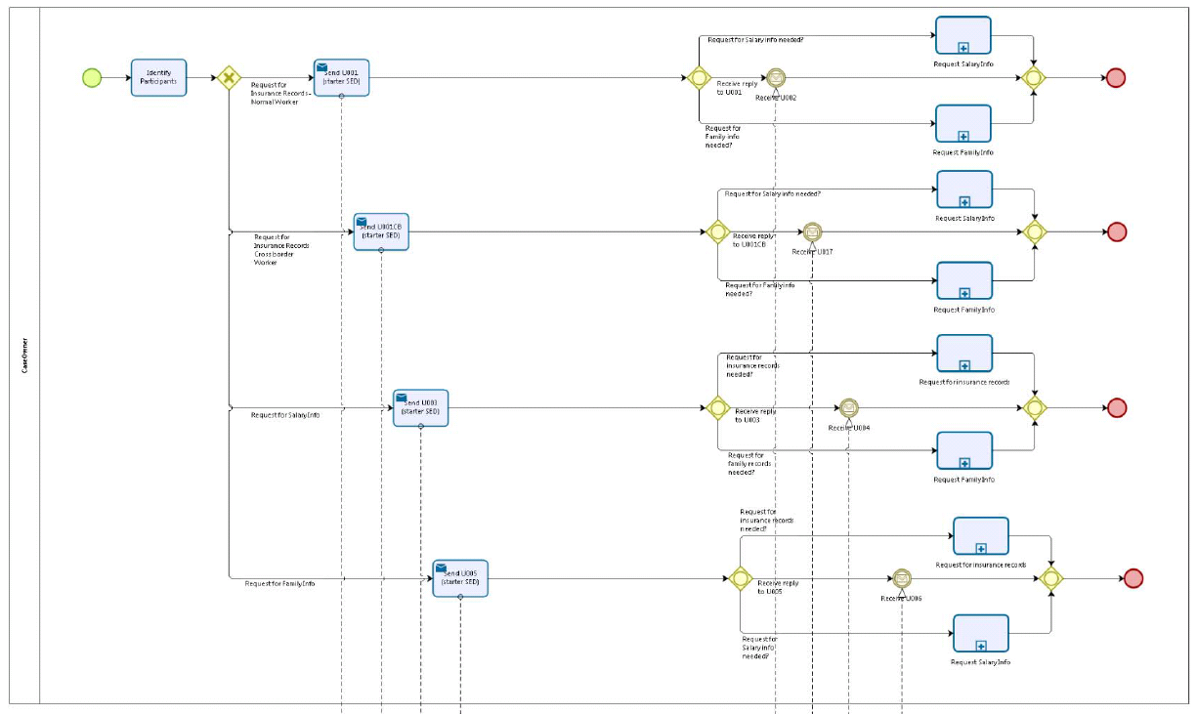

Figure 1: depicts the use case end-to-end of the Case Owner, from a high level, using the BPMN 2.0 collaboration diagram

## Counterparty

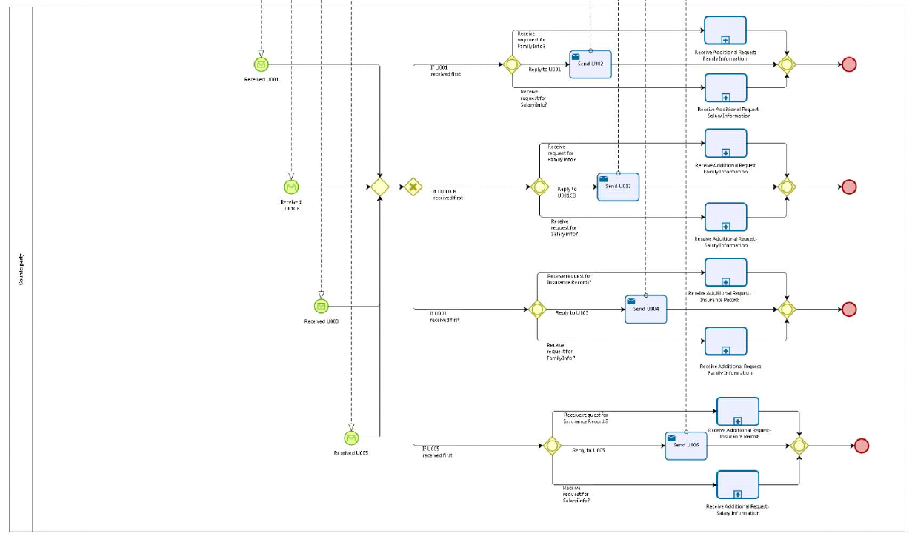

Figure 2: depicts the use case end-to-end of the Counterparty, from a high level, using the BPMN 2.0 collaboration diagram

## Sub Processes

## Case Owner's Sub Process "Request for Insurance Records"

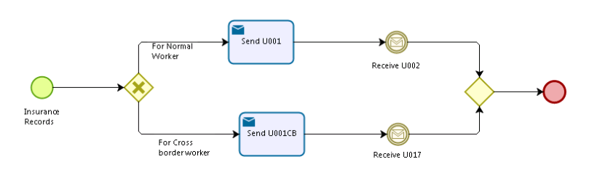

Figure 3: depicts the subprocess 'Request for Insurance Records" of the Case Owner

## Case Owner's Sub Process "Request for Salary Info"

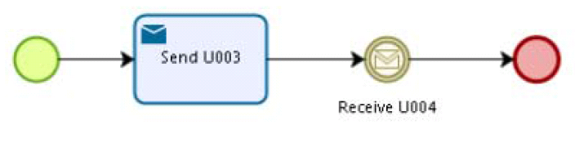

Figure 4: depicts the subprocess 'Request for Salary Information" of the Case Owner

## Case Owner's Sub Processes "Request for Family Info"

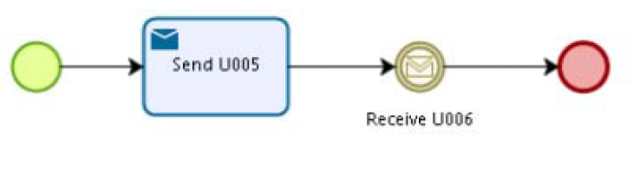

Figure 5: depicts the subprocess 'Request for Family Information" of the Case Owner

## Counterparty's Sub Process "Receive Request for Insurance Records"

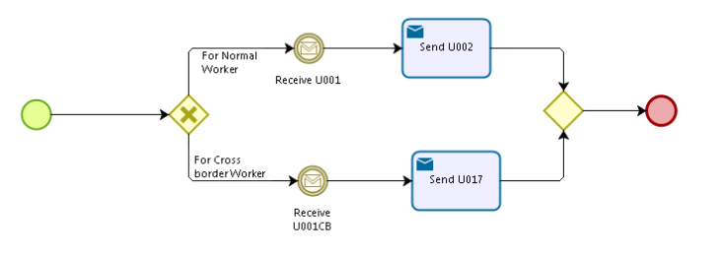

Figure 6: depicts the subprocess 'Request for Insurance Records" of the Counterparty

## Counterparty's Sub Process "Receive Request for Salary Info"

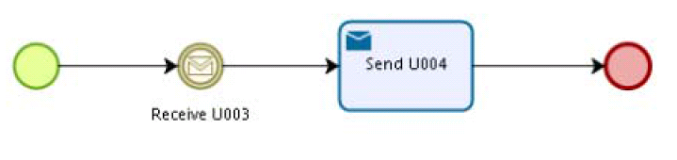

Figure 7: depicts the subprocess 'Request for Salary Information" of the Counterparty

## Counterparty's Sub Processes "Receive Request for Family Info"

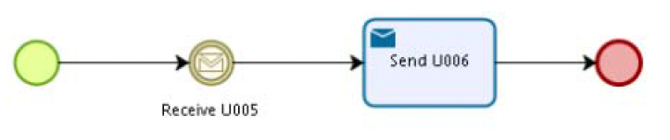

Figure 8: depicts the subprocess 'Request for Family Information" of the Counterparty

# Appendices

## Issues

|  |  |  |  |  |  |
| --- | --- | --- | --- | --- | --- |
| **#** | **Issue date** | **Description** | **Replies** | **Action/Resolution** | **Close date** |
| 1 |  |  |  |  |  |
| 2 |  |  |  |  |  |
| 3 |  |  |  |  |  |
| 4 |  |  |  |  |  |