International Process Guidelines

Introduction

Date: November 2018

TABLE OF CONTENTS

Welcome to the EESSI guidelines 3
How to navigate the EESSI guidelines 3
Technical Requirements and Troubleshooting 4
Global Glossary 4
Optional/Mandatory fields in SEDs 5

Welcome to the EESSI guidelines
The EESSI guidelines are created in order to assist clerks in understanding the international part of the processes of EESSI Business Use Cases.
- The guidelines do NOT cover any national processes – member states can prepare more detailed instructions specifying the more complex aspects of the exchange of information for their staff.
- Please note that these guidelines are NOT exhaustive and are not an official interpretation of the provisions of the social security regulations (Regulations (EC) No 883/2004 and Regulation (EC) No 987/2009).
- The guidelines are also NOT providing guidance on the use or functionalities of an electronic exchange system, for this please see either the RINA guidelines or the respective national electronic system guidelines for your Member State and social security coordination sector.
These guidelines form the basis of the instructions for the clerks. They include the description of the respective sector, the relevant Business Use Case (BUC) with steps to take for each role including the relevant Horizontal and Administrative sub-processes which can be used for obtaining or providing certain types of information.
The guidelines also contain:
- Descriptions and the actual forms of the Structured Electronic Documents (SEDs) corresponding to the data model version 4.1.0 that are used for the exchange of information in each BUC;
- Descriptions and forms of the Portable Documents (PDs) linked to the relevant BUC if appropriate;
- Descriptions of the BUC processes as Business Process Model and Notation (BPMN) diagrams (i.e. BUCs presented in process diagrams using the BPMN notation). For details of using the BPMN standard click here.

How to navigate the EESSI guidelines
The EESSI Guidelines consist of a package of documents that allow you to either navigate through the guidance of the business process from beginning to end by using the hyperlinks connecting the respective sections and documents or to go directly to a certain folder and find the relevant information when you know what you are looking for and don't want to click through the whole process description.
The first step for you is to select the relevant social security sector from the list below:
Accidents at Work and Occupational Diseases
Family Benefits
Legislation Applicable
Pensions
Recovery
Sickness
Unemployment Benefits
Additional categories:
Miscellaneous
Horizontal
Administrative sub-processes
Horizontal sub-processes
After clicking ‘CTRL + click on the hyperlink’ on the sector another file will open and you will see an overarching sector description with a list of BUCs available for this sector. Clicking on the relevant BUC title will allow you to navigate to the desired BUC guideline.
Each BUC guideline starts with a short description of the Business Use Case. Subsequently, you find a set of questions to determine your role in the process. There are different options available to your role at each step, which are described and indicated by hyperlinks that will guide you through the BUC guideline. At each step you will see sub-processes allowing certain functions available to your role at this stage of the process. After following a hyperlink to a different step or section within the document, you can return to the previous text passage by pressing ‘ALT + left arrow key’. Clicking on a sub-process will open separate file explaining how to execute it. Similarly, the guidelines also include hyperlinks to SEDs, PDs and BPMN-models relevant for this particular BUC. These links will guide you to a separate file containing information about these items. After reading and closing this file, you can continue reading the BUC guideline.
All files can also be manually browsed to and opened by using the file browser of your operating system.

Technical Requirements and Troubleshooting
The BUC guidelines consist of OOXML (.docx) files, PDF files and HTML (.htm) files. It is recommended to always use an up-to-date PDF-Reader and Office Suite that is able to handle OOXML (.docx) files for viewing the BUC guidelines. When using older versions the hyperlinks may not work as expected. In this case, you need to manually browse to the respective sections or files. For reading the HTML files you should use Internet Explorer, otherwise the forms might appear distorted.

Global Glossary
Term used | Description
Business Use Case (BUC) | A collection of steps that are required to complete a case related to a certain social security sector.
Structured Electronic Document (SED) | Structured Electronic Documents are any structured documents in a format designed for the electronic exchange of information between member states.
Portable Document (PD) | Portable Documents are forms created by the Member States for the citizens. Former paper ‘E-forms’ disappear under modernised coordination, but in some cases the information required by a citizen will be issued in the form of a portable document.
Administrative sub-processes | In addition to the BUCs specific to each sector there is also series of Administrative sub-processes which have a generic functionality. These sub-processes can be used in any sector of social security coordination, whenever there is a business need to do so and where they are allowed. Administrative sub-processes should be invoked only if no sectorial SEDs can be used for the task at hand.
Horizontal sub-processes | In addition to the Business Use Cases in each sector a clerk can use also Horizontal sub-processes which have a generic functionality. These sub-processes can be used in any sector of social security coordination, whenever there is a business need to do so and where they are allowed. Horizontal sub-processes should be invoked only when no sectorial SEDs can be used for the task at hand.
Common Data Model | The Common Data Model is an organized collection of artefacts that represents in a standardized and structured fashion the data elements that are to be exchanged using EESSI and the relationships between them. The version on the Guideline title page is relevant to check which version of the SED html forms are used in the respective version of Guideline package of folders and files.

Optional/Mandatory fields in SEDs
Sections and Fields are the two key elements that are used to construct a SED. Understanding these concepts is vital to the understanding of how mandatory/optional fields work in the SED in EESSI.
- A field is a data element that a clerk will complete. A Field will always have a specific data type which specifies what kind of data should be filled in.
- A section is a group of fields and/or sections. When a section is used inside a section is it often referred to a ‘child’ of the ‘parent’ section.
Mandatory or Optional is an attribute that applies to both Fields and Section. This means that a field can either be Mandatory or Optional and a section can also be Mandatory or Optional. In EESSI mandatory fields and sections are marked with an asterisk (*) symbol.
Some fields are always mandatory meaning that they always MUST be filled in. This applies to any field that is marked as mandatory AND its section is also mandatory.
In certain cases, a field that will be marked with the "*" sign will in fact not always be mandatory and can be in fact optional, depending on the specific circumstances of the case in question. We call this ‘conditionally mandatory’, since the field becomes mandatory under certain conditions.
For example the P2000 SEDs is about an insured person. In this SED, we also need to know about the person’s children. However it is clear that not all persons have children, so the section about children can only be optional. But IF a person has children THEN we would need to know some information about them and fields such as Forename, Last Name and Date of Birth become mandatory!
But pay attention, once a field which is conditional mandatory is filled in, ALL the other fields which are conditional mandatory become mandatory (in other words all the fields which are marked with the "*" sign under an optional section are mandatory once one of the fields is filled in).
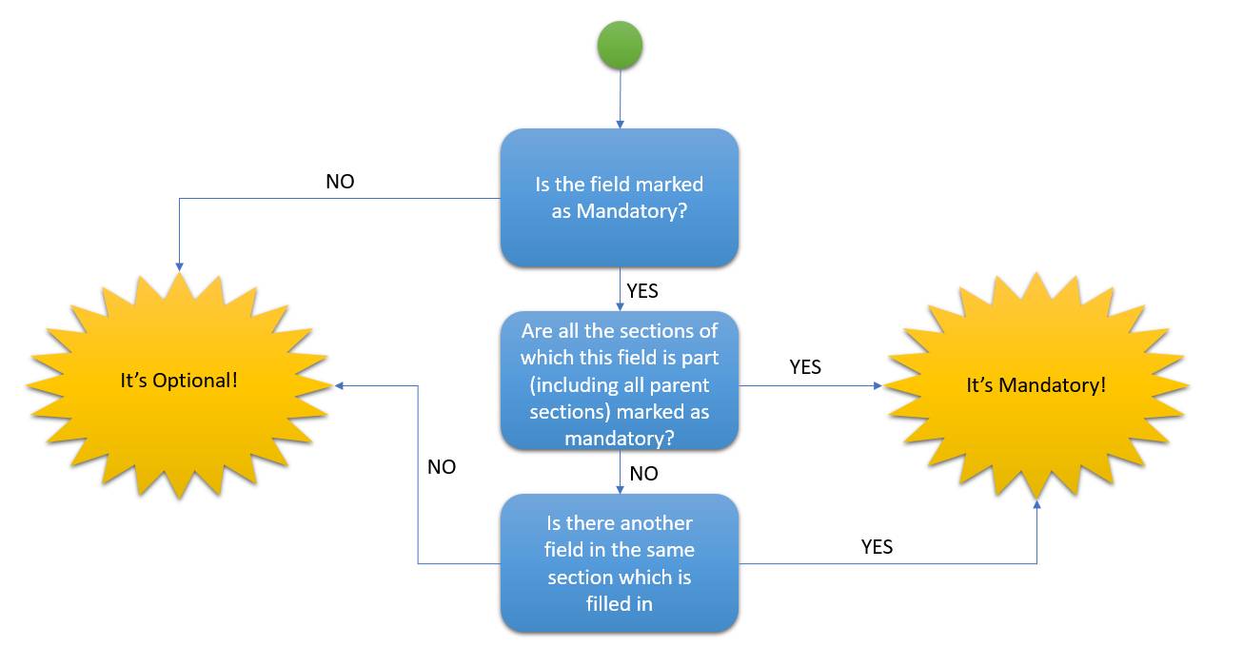
In order to understand if the field that is marked with (*) is mandatory, please follow the question/decision tree below:

