

EESSI Business Use Case



*P_BUC_02   
Survivors Pension Claim*



# Table of Contents

Table of Contents 2

1. Introduction 6

1.1. Purpose 6

1.2. Scope 6

1.3. 1.3 Definitions, Acronyms and Abbreviations 6

1.4. 1.4 References 7

1.5. 1.5 Overview 7

2. Description 8

2.1. Business Scenario 8

2.2. Legal Base 8

3. Actors & Roles 10

4. Use Case 11

4.1. RUP Table Representation 11

4.2. Request – Reply SEDs 26

4.3. Attachments 26

4.4. Artefacts used 26

5. Business Processes 28

5.1. Case Owner 28

5.2. Counterparty 29

5.3. Sub Processes 30

6. Appendices 30

6.1. Issues 30

**Document Control Information**

|  |  |
| --- | --- |
| Settings | Value |
| Document Title: | Business Use Case  P_BUC_02 – Survivors Pension Claim |
| Project Title: | EESSI (Electronic Exchange of Social Security Information) Project |
| Document Author: | European Commission, DG EMPL F5 |
| System Owner: | European Commission, DG EMPL D2 |
| Doc. Version: | v4.1.0 |
| Sensitivity: | Public |
| Date: | 03/08/2018 |

**Document history:**

The Document Author is authorized to make the following types of changes to the document without requiring that the document be re-approved:

Editorial, formatting, and spelling

Clarification

To request a change to this document, contact the Document Author or Owner.

|  |  |  |  |
| --- | --- | --- | --- |
| **Revision** | **Date** | **Created by** | **Short Description of Changes** |
| v0.1.0 | 15/10/2015 | Phil Cummings | First Draft |
| v0.1.1 | 15/01/2015 | Phil Cummings | Corrections to Scenario chapter to include other types of claimant (eg children).  Other small text corrections. |
| v0.2.0 | 20/04/2016 | Cristina Ezaru | Incorporated review received from AHG:  1.Minor formatting, date and grammar changes  2.new SR8 added  7.P7000 allows attachments |
| v0.3.0 | 22/06/2016 | Carine Molle | Alignment to the standard description and layout of the BUC. |
| v0.4.0 | 14/07/2016 | Cristina Ezaru | Incorporated review received during the AHG meeting (13/07/2016)  1. Main Scenario, step 15 updated  2. Branch13 updated: removing participants should be able to any participant (within their own MS)  3. Branch14 updated: adding participants should be able to any participant (within their own MS)  4. SR5 updated  5. updated Attachments Allowed table: P7000 Not Allowed  6. updated Sub-process table: AD_BUC_07 is used  7. removed Issues from 6.1 Issues table |
| v0.5.0 | 12/09/2016 | Cristina Ezaru | Incorporated AC comments:  1. Branch 11: use "Counterparty(ies)" instead of "Counterpart(ies)"  2. Branch 16: remove the points 2. And 3.  3. Branch 16 and 17: use "The Case Owner" instead of "The Cae Owner"  4. Includes: wrong link – use "4.4" instead of "4.2" |
| v0.99.0 | 30/09/2016 | Cristina Ezaru | Candidate for AC Approval.  Incorporated review received during the AHG meeting (29/09/2016)  1. Branch4 updated: step 3 – Branch24  2. Branch4 updated: step 5 – Branch25  3. Branch11 updated: "…any **Participant(s)** may optionally choose…"  4. Branch19 updated:"..reverts to **[step 8]"**  5. Branch20 updated:"..reverts to **[step 12]**  6. Branch21 updated:"..reverts to **[step 17]**  7. SR7 updated: added text "…or other equivalent information…"  8. other small grammatical corrections  9. Main Scenario updated: step 1 – reworded |
| v1.0.0 | 19/10/2016 | Cristina Ezaru | **AC APPROVED VERSION** |
| v1.0.1 | 26/06/2017 | Madalina Alecsandrescu | Last version BPMN diagram section 5 |
| v1.0.2 | 11/08/2017 | Eric Briffoz | - Included the version of the BPMN diagram in section 5.  - Correction in the sub process table in section 4.5.  -removed Use Case diagram |
|  |  | Madalina Alecsandrescu | |  | | --- | | Align wording for Invalidate SED and Forward participant | |
| v4.1.0 | 03/08/2018 | Madalina Alecsandrescu | - Section 4.4 merged 2 tables (for SED & for Subprocesses) into 1 BUC Artefact table."  - Version adaptations to release 4.1.0.  - Correction in wording in SR – [Branch 15] – May be invoked only once, per Participant |

# Introduction

## Purpose

The purpose of this document is to construct an external view of, part of, the 'EESSI business system' as described in EC Regulations 883/2004 and 987/2009. The ‘EESSI Business System’ describes the business and expected business processes without consideration as to which part(s) may be realized by an IT System (i.e. the proposed EESSI IT System).

The external view comprises of models and descriptions of business use cases, the services of a business system offered to business actors: customers, business partners, or other business systems.

A business use case is described from an actor's perspective; it describes the interaction between an actor and the business system, meaning it describes the behaviours of the business system that the actor utilizes. The Business Use Case includes Use Case Diagrams and Business Process Models.

Use case diagrams show actors, business use cases, and their relationships. Use case diagrams do not describe procedures. Alternative scenarios also remain hidden. These diagrams give a good overview of the behaviours of the EESSI business system which will direct and govern part of the expected behaviours and functionality delivered by the EESSI IT System.

## Scope

This document is limited to the external view on the pensions´ sector process of the Survivors Pension Claim. The different elements like use case description, actors, and business process as well as supporting UML diagrams and BPMN models pertaining to the Survivors Pension Claim.

## 1.3 Definitions, Acronyms and Abbreviations

Please see the EESSI Project Glossary [here](https://webgate.ec.europa.eu/CITnet/confluence/display/EESSI/Project+Information+for+Stakeholders).

## 1.4 References

|  |  |  |
| --- | --- | --- |
| **#** | **Description** |  |
| 1 | EC Regulation 883/2004 | Regulation EC No 883- 2004.pdf |
| 2 | EC Regulation 987/2009 | Regulation EC No 987-2009.pdf |
| 3 | UML 2.x | <http://www.omg.org/spec/UML/> |
| 4 | BPMN 2.0 | <http://www.omg.org/spec/BPMN/index.htm> |
| 5 | UML 2.0 In Action | Henriette Baumann, Patrick Grassle & Philippe Baumann, 2005, ISBN 1904811558 |
| 6 | RUP@EC standard 5.0 | <http://www.cc.cec/RUPatEC_Standard/> |
| 7 | RUP op maat | <http://www.rupopmaat.nl/> |

## 1.5 Overview

Chapter 1 introduces the external view on the business system under review and lists the elements of this specification.

Chapter 2 introduces us to the Survivors Pension Claim business process. The chapter gives a short and detailed description as well as a reference to business process´ legal base.

Chapter 3 lists the actors involved in the Survivors Pension Claim business process.

Chapter 4 describes in detail the Survivors Pension Claim business process based on the RUP use case template, as well as the relationship to other use cases.

Chapter 5 describes the Survivors Pension Claim business process using business process modelling notation (BPMN).

# 2. Description



## Business Scenario

In a situation where an insured person has died, one or more survivors (such as but not limited to spouse, registered partner, cohabiting partner, former spouse, own child , adopted child, foster child, step child, grand child, sibling or other relative ) will claim a Survivors Pension (the person who is the survivor becomes a claimant). Where the deceased person has lived or worked in more than one EU Member State then a specific institution assumes responsibility for coordinating the survivors claim (this is usually the place where the claimant resides provided the deceased person had previously paid insurance there, if not other rules apply see 987/09 Art. 47 (1)). This institution assumes the role of the Contact Institution (Case Owner) and is responsible for starting and coordinating a process which assures that the claimant receives the Survivors Pension they are entitled to and are not disadvantaged by the deceased persons decision to exercise their right to free movement and work or live in more than one EU Member State.

## Legal Base

This Business Use Case document's legal base is described in the following Regulations

* basic Regulation (EC) No 883/2004
* implementing Regulation (EC) No 987/2009

The following matrix specifies the SEDs that are used in this Business Use Case and documents the articles that provide the legal basis for each SED.

|  |  |  |  |  |  |  |  |  |  |  |  |  |  |  |  |  |  |  |  |  |  |  |
| --- | --- | --- | --- | --- | --- | --- | --- | --- | --- | --- | --- | --- | --- | --- | --- | --- | --- | --- | --- | --- | --- | --- |
| **SED** | **Basic Reg (883/04)** | | | | | | | | **Implementing Reg (987/09)** | | | | | | | | | | | | | |
| **1** | **6** | **45** | **49** | **51** | **52** | **57** | **60** | **12(1)** | **45(4)** | **46(1)** | **46(3)** | **47(1)** | **47(4)** | **47(5)** | **47(6)** | **48** | **48(1)** | **48(2)** | **50(1)** | **51(2)** | **52(1)b** |
| P2100 |  |  |  |  |  |  |  |  |  | **✓** | **✓** |  |  | **✓** | **✓** |  |  |  |  |  |  |  |
| P3000 | **✓** |  |  |  |  |  |  |  |  | **✓** | **✓** |  |  | **✓** | **✓** |  |  |  |  |  |  |  |
| P4000 |  |  |  |  |  |  |  |  | **✓** |  | **✓** |  |  | **✓** |  |  |  |  |  |  |  |  |
| P5000 | **✓** | **✓** | **✓** | **✓** | **✓** | **✓** | **✓** | **✓** | **✓** |  |  |  |  | **✓** | **✓** |  |  |  |  |  |  | **✓** |
| P6000 |  |  |  |  |  |  |  |  |  |  |  |  |  |  |  | **✓** |  | **✓** |  |  | **✓** |  |
| P7000 |  |  |  |  |  |  |  |  |  |  |  |  |  |  |  |  | **✓** |  |  |  |  |  |
| P8000 |  |  |  |  |  |  |  |  |  |  |  |  | **✓** | **✓** |  |  |  |  |  |  |  |  |
| P9000 |  |  |  |  |  |  |  |  |  |  |  |  | **✓** | **✓** |  |  |  |  |  |  |  |  |
| P10000 |  |  |  |  |  |  |  |  |  |  |  | **✓** | **✓** | **✓** |  |  |  |  | **✓** |  |  |  |

Table 1: SED – Legal base relationship matrix

|  |
| --- |
|  |

# Actors & Roles

This chapter captures details of the actors which are important to understand the different types of system users. An actor is anyone or anything that exchanges data with the business system. An actor can be a user, external hardware, or another system.

The overarching description of each actor described in this Business Use Case can be found in the Glossary. Below you will find a short description which provides further clarity of this actor within the context of this Business Use Case.

|  |  |
| --- | --- |
| **Actor name** | **Description** |
| ***Case Owner*** | In this BUC the Case Owner is a Competent Institution who performed the role of the Contact Institution as described by the Regulations |
| ***Counterparty*** | In this BUC the Counterparty(ies) are Competent Institutions who perform the role of Institutions Concerned as described by the Regulations |
| ***Claimant*** | In this BUC the Claimant is the Person who wishes to claim the Survivors Pension |
| ***Deceased Person*** | In this BUC the Deceased Person is a Person who has died and upon whose the claim and insurance periods the Survivors Pension is based. |

# Use Case

## RUP Table Representation

|  |  |  |  |  |
| --- | --- | --- | --- | --- |
| **Use Case ID:** | **P_BUC_02** | | | |
| **Use Case Name:** | Claim for Survivors Pension | | | |
| **Created By:** | Phil Cummings | | **Last Updated By:** | Cristina Ezaru |
| **Date Created:** | 15/10/2015 | | **Last Revision Date:** | 30/09/2016 |
| **Actors:** | | Claimant  Deceased Person  Case Owner  Counterparty | | |
| **Description:** | | In a situation where an insured person has died, one or more survivors (such as but not limited to spouse, registered partner, cohabiting partner, former spouse, own child , adopted child, foster child, step child, grand child, sibling or other relative ) will claim a Survivors Pension (the person who is the survivor becomes a claimant). Where the deceased person has lived or worked in more than one EU Member State then a specific institution assumes responsibility for coordinating the survivors claim (this is usually the place where the claimant resides provided the deceased person had previously paid insurance there, if not other rules apply see 987/09 Art. 47 (1)). This institution assumes the role of the Contact Institution (Case Owner) and is responsible for starting and coordinating a process which assures that the claimant receives the Survivors Pension they are entitled to and are not disadvantaged by the deceased persons decision to exercise their right to free movement and work or live in more than one EU Member State. | | |
| **Trigger:** | | A person claims Survivors Pension from one or more EU Member State. | | |
| **Preconditions:** | | none | | |
| **Post conditions:** | | The Claimant is informed of the decisions made in respect to their Survivors Pension Claim from each Member State. | | |
| **Main Scenario:** | | **Identify Participants**   1. The Case Owner identifies the Member States where the deceased person has lived or worked previously. 2. The Case Owner then identifies the correct institution or institutions (the Counterparty(ies)) in each Member State that are responsible for making a decision on the claim for survivors pension. There will be one counterparty or more. The Case Owner and the Counterparty(ies) are herein collectively referred to as the Participants.   **Send Survivors Pension Claim**   1. The Case Owner fills out a Survivors Pension Claim (P2100) by entering all the required Survivors Pension data; 2. The Case Owner sends the Survivors Pension Claim (P2100), including any attachments, to all Counterparties.     **Process Claim & Send Decision**   1. Each Counterparty will receive a Survivors Pension Claim (P2100) with the fitting personal ID dataset of the deceased person and the survivor and all attachments, after which their Claim investigation will start; 2. The Case Owner then optionally fills in a Report on Insurance and Residence Periods (P5000) which provides detailed insurance information of the deceased person to assist the Survivors pension processing; 3. The Case Owner sends the P5000 to all other Participants; **[Steps 6 and 7]** collectively may optionally be repeated by the Case Owner many times after this step; 4. The Case Owner fills in an Pension Decision (P6000) by entering all the required information about the Pension decision they have made; 5. The Case Owner sends the P6000 to all counterparties; **[Steps 8 and 9]** collectively may optionally be repeated by the Case Owner many times after this step; 6. Each Counterparty then optionally fills in a Report on Insurance and Residence Periods (P5000) which provides detailed insurance information to assist the Survivors pension processing; 7. Each Counterparty then sends the P5000 to all other Participants; **[Steps 10 and 11]** collectively may optionally be repeated by each Counterparty many times after this step; 8. Each Counterparty fills in a Pension Decision (P6000) by entering all the required information about the Pension decision they have made; 9. Each Counterparty then sends their P6000 to the Case Owner and any other Counterparties; **[Steps 12 and 13]** collectively may optionally be repeated by each Counterparty many times after this step; 10. **[Steps 6 and 7]** collectively, **[Steps 8 and 9]** collectively, **[Steps 10 and 11]** collectively and **[Steps 12 and 13]** collectively may occur in any order.   **Receive & Process Pension Decisions**   1. Each time the Case Owner receives a Pension Decision (P6000) from a Counterparty, or it sends a P6000, it checks if:    * + - There is at least one valid P6000 or other equivalent information, from each participant involved, that P7000 can be issued.   If this is true the Case Owner OR at the discretion of the Case Owner from each Member State involved continues to the **[Next Step].** If not, repeat **[This Step].**  **Finalize Claim for Survivors Pension**   1. The Case Owner fills in a Portable Document (P1) by entering specific data provided in the Pension Decisions (P6000) exchanged by all participants. The completed P1 is then sent to the claimant to inform them of the Pensions decisions taken by all participants and their right to review; 2. The Case Owner fills in a Summary of Pension Decisions (P7000) by entering specific data provided in the Pension Decisions (P6000) exchanged by all participants; 3. The Case Owner sends the P7000 to all Counterparties 4. Upon sending the P7000 the Survivors Pension Claim is complete; 5. The use case ends here. | | |
| **Alternative Scenarios:** | | 1. ***at any step after [step 5] the Case Owner may optionally choose to fill in and send Country Specific Information.*** 2. The Case Owner fills in Country Specific Information (P3000_XX) which provides supplementary information to assist the Survivors pension processing in the Member State it was designed for; 3. The Case Owner sends the P3000_xx to specific counterparties (see Special Requirements) 4. [This Branch] Ends. | | |
| 1. ***at any step after [step 5] the Case Owner may optionally choose to fill in and send a Report on Insurance History.*** 2. The Case Owner fills in Report on Insurance History (P4000) which provides supplementary information to assist the Survivors pension processing; 3. The Case Owner sends the P4000 to all Counterparties 4. [This Branch] Ends. | | |
| 1. ***[Removed]*** | | |
| 1. ***at any step after [step 5] any Participant may optionally choose to fill in a Request for Additional Information.*** 2. The Participant who invokes this branch fills in a Request for Additional Information (P8000) which details the additional information they need; 3. The Participant who wishes to request additional information sends the P8000 to one or more Participants (the receiving participants are at the discretion of the sending participant); 4. Each Participant who received a P8000 may optionally gather the requested information and fill in a Reply to Request for Additional Information (P9000) provided the P8000 is not declared to be invalid at **[invoking Branch 24];** 5. Where [Branch 4 Step 3] was completed each participant who filled out the P9000 sends the P9000, including any attachments, to the sender of the P8000 and all other Participants who received the P8000; 6. Upon receipt of a P9000 the Participant may optionally choose to send another P8000 provided the P9000 is not declared to be invalid at **[invoking Branch 25]; [go to Branch 4 Step 1];** 7. [This Branch] Ends. | | |
| 1. ***at any step after [step 5] any Participant may optionally choose to fill in a Transfer of Additional Information.***      1. The Participant who invokes this branch fills in a Transfer of Additional Information (P10000) which details the additional information they wish to transfer; 2. The Participant who wishes transfer the additional information sends the P10000, with any attachments, to one or more Participants (the receiving Participants are at the discretion of the sending Participant); 3. [This Branch] Ends. | | |
| ***The Following Branches Determine the use of Horizontally Defined Processes within this Business Process*** | | |
| 1. ***- Removed -*** | | |
| 1. ***- Removed -*** | | |
| 1. ***- Removed -*** | | |
| 1. ***- Removed*** | | |
| 1. ***at any step after [step 5] any Participant may optionally choose notify another Participant of the Death of a Person*** 2. The Participant executes business use case ***H_BUC_07*_Subprocess *– Notification of Death;*** 3. [This Branch] Ends. | | |
| 1. ***- at any step after [step 5] any Participant(s) may optionally choose to provide a Detailed Medical Report to the other Participant*** 2. The Participant executes business use case ***H_BUC_08_Subprocess – Exchange of* Medical Data*;*** 3. [This Branch] Ends. | | |
| 1. ***-Removed-*** | | |
| ***The Following Branches Determine the use of Administrative Processes within this Business Process*** | | |
| 1. ***at any step after [step 5] any Participant may choose to Remove participants to this Business Process. Case owner should be able to remove participants in any MS, Counterparties should be able to remove participants in their own MS.*** 2. The Participant executes business use case***AD_BUC_04_Subprocess – Remove Participant;*** 3. [This Branch] Ends. | | |
| 1. ***at any step after [step 5] any Participant may choose to Add new participants to this Business Process. Case owner should be able to add participants in any MS, Counterparties should be able to add participants in their own MS.*** 2. The Participant executes business use case ***AD_BUC_03_Subprocess – Add Participant;*** 3. [This Branch] Ends. | | |
| 1. ***at any step after [step 5] any Participant may choose to Forward this Business Process to another Competent Institution within their MS who assumes responsibility for handling it*** 2. The Participant executes business use case ***AD_BUC_05_Subprocess – Forward Case;*** 3. [This Branch] Ends. | | |
| 1. ***at any step after [step 5] the Case Owner may choose to advise all recipients of their P2100 that it is Invalid under Art 5 of 987/09*** 2. The Case Owner executes business use case ***AD_BUC_06_Subprocess - Invalidate_SED;*** 3. Optionally, the Case Owner fills in P2100 by entering all the required data; 4. Optionally, the Case Owner sends the P2100, including any attachments, to all counterparties; 5. [This Branch] Ends. | | |
| 1. ***at any step after [step 7] the Case Owner may choose to advise all recipients of their P5000 that it is Invalid under Art 5 of 987/09*** 2. The Case Owner executes business use case ***AD_BUC_06_Subprocess - Invalidate_SED;*** 3. Optionally, the Case Owner fills in P5000, by entering all the required data; 4. Optionally, the Case Owner sends the P5000, including any attachments, to all counterparties; 5. [This Branch] Ends. | | |
| 1. ***at any step after [step 11] a Counterparty may choose to advise all recipients of their P5000 that it is Invalid under Art 5 of 987/09*** 2. The Counterparty executes business use case ***AD_BUC_06_Subprocess - Invalidate_SED;*** 3. Optionally, the Counterparty fills in P5000, by entering all the required data; 4. Optionally, the Counterparty sends P5000, including any attachments, to all counterparties; 5. [This Branch] Ends. | | |
| 1. ***at any step after [step 9] the Case Owner may choose to advise all recipients of their P6000 that it is Invalid under Art 5 of 987/09*** 2. The Case Owner executes business use case ***AD_BUC_06_Subprocess - Invalidate_SED;*** 3. If no other Valid P6000 exists from the Case Owner then the Main Scenario reverts to **[step 8];** 4. [This Branch] Ends. | | |
| 1. ***at any step after [step 13] a Counterparty may choose to advise all recipients of their P6000 that it is Invalid under Art 5 of 987/09*** 2. The Counterparty executes business use case ***AD_BUC_06_Subprocess - Invalidate_SED;*** 3. If no other Valid P6000 exists for this Counterparty then theMain Scenario reverts to **[step 12];** 4. [This Branch] Ends. | | |
| 1. ***at any step after [step 18] , the Case Owner may choose to advise all recipients of their P7000 that it is Invalid under Art 5 of 987/09*** 2. The Case Owner executes business use case ***AD_BUC_06_Subprocess - Invalidate_SED****;* 3. The Main Scenario reverts to **[step 17];** 4. [This Branch] Ends**.** | | |
| 1. ***where [Branch 1 Step 2] has been executed then at any step after [Branch 1 Step 2] the Case Owner may choose to advise all recipients of their P3000_xx that it is Invalid under Art 5 of 987/09*** 2. The Case Owner executes business use case ***AD_BUC_06_Subprocess - Invalidate_SED;*** 3. Optionally, the Case Owner fills in P3000_xx, by entering all the required data; 4. Optionally, the Case Owner sends the P3000_xx, including any attachments, to all Counterparties; 5. [This Branch] Ends. | | |
| 1. ***where [Branch 2 Step 2] has been executed then at any step after [Branch 2 Step 2] the Case Owner may choose to advise all recipients of their P4000 that it is Invalid under Art 5 of 987/09*** 2. The Case Owner executes business use case ***AD_BUC_06 _Subprocess - Invalidate_SED;*** 3. Optionally, the Case Owner fills in P4000, by entering all the required data; 4. Optionally, the Case Owner sends P4000, including any attachments, to all Counterparties;   4. [This Branch] Ends. | | |
| 1. ***where [Branch 4 Step 2] has been executed then at any step after [Branch 4 Step 2] the participant who sent the P8000 may choose to advise all recipients of their P8000 that it is Invalid under Art 5 of 987/09*** 2. The Participant executes business use case ***AD_BUC_06_Subprocess - Invalidate_SED;*** 3. Optionally, the participant fills in P8000, by entering all the required data; 4. Optionally, the participant sends P8000, including any attachments, to all participants; 5. [This Branch] Ends. | | |
| 1. ***where [Branch 4 Step 4] has been executed then at any step after [Branch 4 Step 4] the participant who sent the P9000 may choose to advise all recipients of their P9000 that it is Invalid under Art 5 of 987/09*** 2. The Participant executes business use case ***AD_BUC_06_Subprocess - Invalidate_SED;*** 3. Optionally, the participant fills in P9000, by entering all the required data; 4. Optionally, the participant sends P9000, including any attachments, to all participants; 5. [This Branch] Ends. | | |
| 1. ***where [Branch 5 Step 2] has been executed then at any step after [Branch 5 Step 2] the participant who sent the P10000 may choose to advise all recipients of their P10000 that it is Invalid under Art 5 of 987/09*** 2. The Participant executes business use case ***AD_BUC_06_Subprocess - Invalidate_SED;*** 3. Optionally, the participant fills in in P10000, by entering all the required data; 4. Optionally, the participant sends P10000, including any attachments, to all participants; 5. [This Branch] Ends | | |
| 1. ***at any step after [step 5] the Case Owner may choose to send an updated version of P2100*** 2. The Case Owner executes business use case ***AD_BUC_10_Subprocess - Update_SED;*** 3. [This Branch] Ends. | | |
| 1. ***at any step after [step 7] the Case Owner may choose to send an updated version of their P5000*** 2. The Case Owner executes business use case ***AD_BUC_10_Subprocess - Update_SED;*** 3. [This Branch] Ends. | | |
| 1. ***at any step after [step 11] a counterparty may choose to send an updated version of their P5000*** 2. The Counterparty executes business use case ***AD_BUC_10_Subprocess - Update_SED;*** 3. [This Branch] Ends. | | |
| 1. ***at any step after [step 9] the Case Owner may choose to send an updated version of their P6000*** 2. The Case Owner executes business use case ***AD_BUC_10_Subprocess - Update_SED;*** 3. [This Branch] Ends. | | |
| 1. ***at any step after [step 13] a Counterparty may choose to send an updated version of their P6000*** 2. The Counterparty executes business use case ***AD_BUC_10_Subprocess - Update_SED;*** 3. [This Branch] Ends. | | |
| 1. ***at any step after [step 18] the Case Owner may choose to send an updated version of their P7000*** 2. The Case Owner executes business use case ***AD_BUC_10 _Subprocess - Update_SED;*** 3. [This Branch] Ends. | | |
| 1. ***where [Branch 1 Step 2] has been executed then at any step after [Branch 1 Step 2] the Case Owner may choose to send an updated version of their P3000_xx*** 2. The Case Owner executes business use case ***AD_BUC_10_Subprocess - Update_SED;*** 3. [This Branch] Ends. | | |
| 1. ***where [Branch 2 Step 2] has been executed then at any step after [Branch 2 Step 2] the Case Owner may choose to send an updated version of their P4000*** 2. The Case Owner executes business use case ***AD_BUC_10_Subprocess - Update_SED****;* 3. [This Branch] Ends. | | |
| 1. ***where [Branch 4 Step 2] has been executed then at any step after [Branch 4 Step 2] the participant who sent the P8000 may choose to send an updated version of their P8000*** 2. The Participant executes business use case ***AD_BUC_10_Subprocess - Update_SED;*** 3. [This Branch] Ends. | | |
| 1. ***where [Branch 4 Step 4] has been executed then at any step after [Branch 4 Step 4] the participant who sent the P9000 may choose to send an updated version of their P9000*** 2. The Participant executes business use case ***AD_BUC_10_Subprocess - Update_SED*;** 3. [This Branch] Ends. | | |
| 1. ***where [Branch 5 Step 2] has been executed then at any step after [Branch 5 Step 2] the participant who sent the P10000 may choose to send an updated version of their P10000*** 2. The Participant executes business use case ***AD_BUC_10_Subprocess - Update_SED*;** 3. [This Branch] Ends. | | |
| 1. ***at any step after [step 5] any Participant may optionally choose to send a Reminder to another Participant for the return of information they were expecting from that participant but did not receive.*** 2. The participant who invokes this branch executes business use case ***AD_BUC_07_Subprocess -*_*Reminder;*** 3. [This Branch] Ends. | | |
| **Exceptions:** | | ***Exception 1: [Removed]*** | | |
| **Includes:** | | See diagram at part 4.4 | | |
| **Special Requirements:** | | **SR1**: When Alternative **[Branch 1]** is invoked the Country Specific Information (P3000_XX) can only be sent to institutions in the MS it was designed for. This is identifiable by the last two characters of the P3000_XX – represented here as "XX" for example:  P3000_UK can only be sent to institutions in the UK  P3000_DE can only be sent to institutions in Germany  **SR2**: Rules about the invoking of Branches:  [Branch 1] – May only be invoked per Destination Member State (see **SR1**) when there is no valid P3000_xx  [Branch 2] – May only be invoked once. Per Participant  [Branch 4] – May be invoked more than once, per Participant  [Branch 5] – May be invoked more than once, per Participant  Horizontals  [Branch 10] to [Branch 11] - May be invoked once, per Participant  Administrative  [Branch 13] to [Branch 38] – May be invoked more than once, per Participant  exception [Branch 15] – May be invoked only once, per Participant  **SR3**: Rules about the destination for each SED Type when the SED is sent:  P2100 – Defines and is sent to all Active Participants  P3000_xx – Must be Sent to All Active Participants of the MS designed for (See **SR1**)  P4000 – Must be Sent to all Active Participants  P5000 - Must be Sent to all Active Participants  P6000 - Must be Sent to all Active Participants  P7000 - Must be Sent to all Active Participants  P8000 – Can be sent to one or more Active Participants  P9000 – Must be sent to all Active Participants that received the P8000  P10000 - Can be sent to one or more Active Participants  **SR4**: The term "Send/Sent to All Active Participants" does not include sending it themselves (i.e. to the senders institution)  **SR5**: Active Participants are defined as those participants identified at [**Step 2**] and those participants added through the execution of [**Branch 14**] and/or [**Branch 15**]and not removed through the execution of [**Branch 13**] and/or [**Branch 15**]  **SR6**: Alternative Branches 1 – 38 are non-interrupting Branches;  **SR7:** Clarification: where two or more institutions from the same MS are involved in the case, only one P6000 or other equivalent information needs to be exchanged from that MS to satisfy this rule.  **SR8**: "*at the discretion of the Case Owner*" – allows under exceptional circumstances for the Case Owner to progress to the next Steps without all P6000 information | | |
| **Assumptions:** | |  | | |
| **Notes and Issues:** | |  | | |

## 

## Request – Reply SEDs

The following table specifies the SEDs that have a logical pairing to one another, usually this is known as a request-reply pair.

|  |  |
| --- | --- |
| REQUEST SED | REPLY SED(s) |
| P8000 | P9000 |

## Attachments

The following table specifies whether attachments are permitted to be included when sending a SED type.

|  |  |
| --- | --- |
| SED | Attachments |
| P2100 | Allowed |
| P3000_XX | Allowed |
| P4000 | Allowed |
| P5000 | Not Allowed |
| P6000 | Allowed |
| P7000 | Not Allowed |
| P8000 | Allowed |
| P9000 | Allowed |
| P10000 | Allowed |

## Artefacts used

The following table specifies the artefacts that are used in this Business Use Case.

| Artefact name | Artefact type |
| --- | --- |
| P2100 | SED |
| P3000_XX | SED |
| P4000 | SED |
| P5000 | SED |
| P6000 | SED |
| P7000 | SED |
| P8000 | SED |
| P9000 | SED |
| P10000 | SED |
| H_BUC_07_Subprocess | BUC |
| H_BUC_08_Subprocess | BUC |
| AD_BUC_03_Subprocess – Add Participant | BUC |
| AD_BUC_04_Subprocess – Remove Participant | BUC |
| AD_BUC_05_Subprocess – Forward Case | BUC |
| AD_BUC_06_Subprocess – Invalidate SED | BUC |
| AD_BUC_07_Subprocess – Reminder | BUC |
| AD_BUC_10_Subprocess – Update SED | BUC |
| AD_BUC_11_Subprocess – Business Exception | BUC |
| AD_BUC_12_Subprocess – Change of Participant | BUC |

# Business Processes

This chapter describes the Business Use Case Survivors Pension Claim.

## Case Owner

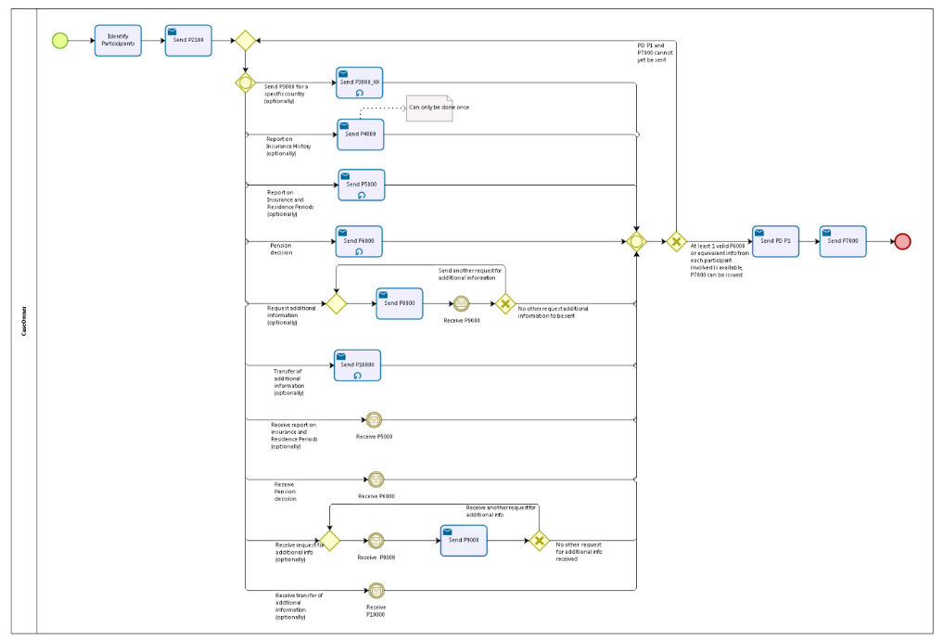

## Counterparty

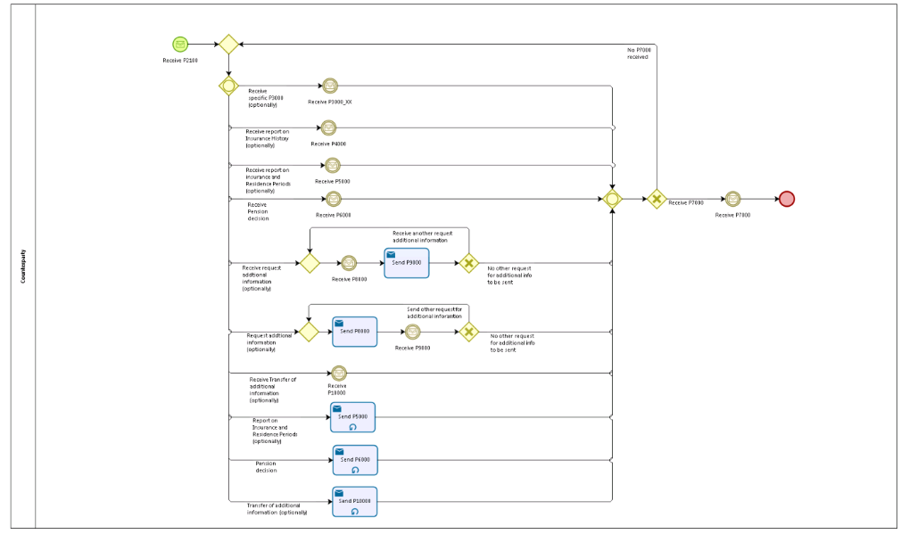

## Sub Processes

n/a

# Appendices

## Issues

|  |  |  |  |  |  |
| --- | --- | --- | --- | --- | --- |
| **#** | **Issue date** | **Description** | **Replies** | **Action/Resolution** | **Close date** |
| 1 |  |  |  |  |  |
| 2 |  |  |  |  |  |
| 3 |  |  |  |  |  |
| 4 |  |  |  |  |  |