

EESSI Business Use Case



*P_BUC_06*

*Notification of Pension Information*



# Table of Contents

Table of Contents 2

1. Introduction 7

1.1. Purpose 7

1.2. Scope 7

1.3. Definitions, Acronyms and Abbreviations 7

1.4. References 8

1.5. Overview 8

2. Description 9

2.1. Business Scenario 9

2.2. Legal Base 9

3. Actors & Roles 10

4. Use Case 11

4.1. RUP Table Representation 11

Request – Reply SEDs 16

4.2. 16

4.3. Attachments Allowed 16

4.4. Artefacts used 16

5. Business Processes 17

5.1. Case Owner and Counterparty 17

5.2 Sub Processes 19

6. Appendices 19

6.1. Issues 19

**Document Control Information**

|  |  |
| --- | --- |
| **Settings** | **Value** |
| **Document Title:** | **Business Use Case**  **P_BUC_06 – Notification of Pension Information** |
| **Project Title:** | **EESSI (Electronic Exchange of Social Security Information) Project** |
| **Document Author:** | **European Commission, DG EMPL F5** |
| **System Owner:** | **European Commission, DG EMPL D2** |
| **Doc. Version:** | **v4.1.0** |
| **Sensitivity:** | **Public** |
| **Date:** | **03/08/2018** |

**Document history:**

The Document Author is authorized to make the following types of changes to the document without requiring that the document be re-approved:

* Editorial, formatting, and spelling
* Clarification

To request a change to this document, contact the Document Author or Owner.

| **Revision** | **Date** | **Created by** | **Short Description of Changes** |
| --- | --- | --- | --- |
| v0.1.0 | 19/03/2016 | Phil Cummings | First Draft |
| v0.2.0 | 10/05/2016 | Cristina Ezaru | Incorporated review received from AHG:  1. Updated Business Scenario  2. Branch 5 : Case Owner is responsible for this scenario  3. Removed P4000 and P10000 from Attachments Allowed table and SED Versioning table  4. BUC correct name updated in all document  5. Updated Actors & Roles  6. Updated Main Scenario->Identify Participants step  7. *Proposal to remove P8000 and P9000, branch3, branch13, branch20, branch21, branch22, branch23, branch27, branch28, branch29, branch30 – the BUC is not yet updated*  8. Updated Branch15: Add Participant is allowed also for the Counterparty  9. Branch 31 removed  10. Minor formatting, date, version and grammar changes |
| v0.3.0 | 06/07/2016 | Cristina Ezaru | Alignment to the standard description and layout of the BUC. |
| v0.4.0 | 14/07/2016 | Cristina Ezaru | Incorporated review received during the AHG meeting (13/07/2016)  1. Rewording Purpose  2. Branch14 updated: removing participants should be able to any participant (within their own MS)  3. updated Sub-process table: AD_BUC_07 is used  4. *Proposal to remove P8000 and P9000, branch3, branch13, branch20, branch21, branch22, branch23, branch27, branch28, branch29, branch30*  *5.Proposal to add P4000 and P10000* |
| v0.5.0 | 25/07/2016 | Carine Molle | Alignment to the standard description and layout of the BUC. |
| v0.6.0 | 10/08/2016 | Cristina Ezaru | Incorporated review received from AHG:  1. P8000 and P9000 removed, with all related branches: Branch3, Branch20, Branch21, Branch24, Branch27, Branch28  2. Branch13 removed  3. Alternative Scenario updated: Branch6 added – Transfer of Additional Information (P10000)  4. Added Branch32, Branch33, Branch34 |
| v0.7.0 | 30/09/2016 | Cristina Ezaru | Incorporated review received during the AHG meeting (29/09/2016)  1. Branch4 removed, as well as the related branches: Branch22, Branch29  2. Branch2 updated: "**at [step 3]** the Case Owner may optionally…"  3. Branch6 updated: "**at [step 3]** the Case Owner may optionally…"  4. SR1 updated: Branch4 removed  Internal updated:  1. Branch5 removed. (Branch2 duplicate), as well as the related branches: Branch23, Branch30 |
| v0.8.0 | 11/11/2016 | Cristina Ezaru | Incorporated review received from AHG:  1. Minor formatting and grammar changes  2. Branch1, Branch2, Branch6- last step updated: "The use case ends here"  3. Branch14 removed  4. Branch 15, Branch16 updated: added conditions relating to Branch1, Branch2, Branch6  5. Branch 17, Branch18 updated: steps 2-3 removed  6. Branch34 moved to Branch20  7. updated Sub-process table: AD_BUC_04 Not used  8. BPMN updated  Incorporated review received from AC:  1. Branch32 updated: replaced [Step 3] with [Step 4]  2. Minor formatting and grammar changes |
| v0.8.1 | 17/11/2016 | Cristina Ezaru | Incorporated review received from AHG:  1. Branch2 updated: added "*Only the contact institution is allowed to send P7000"* |
| v0.99.0 | 17/11/2016 | Cristina Ezaru | Candidate for AC Approval |
| v1.0.0 | 14/12/2016 | Cristina Ezaru | **AC Approved version** |
| v1.0.1 | 26/06/2017 | Madalina Alecsandrescu | Latest version of BPMN on section 5 |
| v1.0.2 | 11/08/2017 | Eric Briffoz | -Included the version of the BPMN diagram used in section 5.  - Correction in the horizontal sub process table in 4.5  - Removed Use Case diagram |
|  |  | Madalina Alecsandrescu | Align wording for Invalidate SED and Forward participant |
| v4.1.0 | 03/08/2018 | Madalina Alecsandrescu | - Section 4.4 merged 2 tables (for SED & for Subprocesses) into 1 BUC Artefact table."  - Version adaptations to release 4.1.0.  - Corrections wording in SR, add exception in SR for [Branch 16] |

# Introduction

## Purpose

The purpose of this document is to construct an external view/part of the 'EESSI business system' as described in EC Regulations 883/2004 and 987/2009. The ‘EESSI Business System’ describes the business and expected business processes without consideration as to which part(s) may be realised by an IT System (i.e. the proposed EESSI IT System).

The external view comprises of models and descriptions of business use cases and the services of a business system offered to business actors: customers, business partners or other business systems.

A business use case is described from an actor's perspective; it describes the interaction between an actor and the business system, meaning it describes the behaviours of the business system that the actor utilizes. The Business Use Case includes Use Case Diagrams and Business Process Models.

Use case diagrams show actors, business use cases and their relationships. Use case diagrams do not describe procedures. Alternative scenarios also remain hidden. These diagrams give a good overview of the behaviours of the EESSI business system which will direct and govern part of the expected behaviours and functionality delivered by the EESSI IT System.

## Scope

This document is limited to the external view on the pension sector process of the Notification of Pension Information. The different elements like use case description, actors, and business process as well as supporting UML diagrams and BPMN models pertaining to the Notification of Pension Information.

## Definitions, Acronyms and Abbreviations

Please see the EESSI Project Glossary [here](https://webgate.ec.europa.eu/CITnet/confluence/display/EESSI/Project+Information+for+Stakeholders)

## References

|  |  |  |
| --- | --- | --- |
| **#** | **Description** |  |
| 1 | EC Regulation 883/2004 | Regulation EC No 883- 2004.pdf |
| 2 | EC Regulation 987/2009 | Regulation EC No 987-2009.pdf |
| 3 | UML 2.x | <http://www.omg.org/spec/UML/> |
| 4 | BPMN 2.0 | <http://www.omg.org/spec/BPMN/index.htm> |
| 5 | UML 2.0 In Action | Henriette Baumann, Patrick Grassle & Philippe Baumann, 2005, ISBN 1904811558 |
| 6 | RUP@EC standard 5.0 | <http://www.cc.cec/RUPatEC_Standard/> |
| 7 | RUP op maat | <http://www.rupopmaat.nl/> |

## Overview

Chapter 1 introduces the external view on the business system under review and lists the elements of this specification.

Chapter 2 introduces us to the Notification of Pension Information business process. The chapter gives a short and detailed description as well as a reference to business process´ legal base.

Chapter 3 lists the actors involved in the Notification of Pension Information business process.

Chapter 4 describes in detail the Notification of Pension Information business process based on the RUP use case template, as well as the relationship to other use cases.

Chapter 5 describes the Notification of Pension Information business process using business process modelling notation (BPMN).

# Description

## Business Scenario

At any time outside the pension claim process changes may occur in one Member State that may result in changes in another Member State. Example of such changes may include (but not exhaustive):

* A change/update to the Insurance Periods/Residence in a Member State
* A change/update to the Amount of Pension being paid in each Member State
* A change/update to the circumstances of the Insured Person, Claimant
* A change/update to the Decision in a Member State

In such circumstances the Member State where the change occurred must inform other relevant Member States (e.g. Member States where the citizen has also previously lived and worked) of the change.

## Legal Base

This Business Use Case document's legal base is described in the following Regulations

* basic Regulation (EC) No 883/2004
* implementing Regulation (EC) No 987/2009

The following matrix specifies the SEDs that are used in this Business Use Case and documents the articles that provide the legal basis for each SED.

|  |  |  |  |  |  |  |  |  |  |  |  |  |  |  |  |  |  |  |  |  |  |  |
| --- | --- | --- | --- | --- | --- | --- | --- | --- | --- | --- | --- | --- | --- | --- | --- | --- | --- | --- | --- | --- | --- | --- |
| **SED** | **Basic Reg (883/04)** | | | | | | | | **Implementing Reg (987/09)** | | | | | | | | | | | | | |
| **1** | **6** | **45** | **49** | **51** | **52** | **57** | **60** | **12(1)** | **45(4)** | **46(1)** | **46(3)** | **47(1)** | **47(4)** | **47(5)** | **47(6)** | **48** | **48(1)** | **48(2)** | **50(1)** | **51(2)** | **52(1)b** |
| P5000 | **✓** | **✓** | **✓** | **✓** | **✓** | **✓** | **✓** | **✓** | **✓** |  |  |  |  | **✓** | **✓** |  |  |  |  |  |  | **✓** |
| P6000 |  |  |  |  |  |  |  |  |  |  |  |  |  |  |  | **✓** |  | **✓** |  |  | **✓** |  |
| P7000 |  |  |  |  |  |  |  |  |  |  |  |  |  |  |  |  | **✓** |  |  |  |  |  |
| P10000 |  |  |  |  |  |  |  |  |  |  |  | **✓** | **✓** | **✓** |  |  |  |  | **✓** |  |  |  |

Table 1: SED – Legal base relationship matrix

# Actors & Roles

This chapter captures details of the actors which are important to understand the different types of system users. An actor is anyone or anything that exchanges data with the business system. An actor can be a user, external hardware, or another system.

The overarching description of each actor described in this Business Use Case can be found in the Glossary. Below you will find a short description which provides further clarity of this actor within the context of this Business Use Case.

|  |  |
| --- | --- |
| **Actor name** | **Description** |
| ***Case Owner*** | In this BUC the Case Owner is a Competent Institution who needs to inform another institution(s) of a change of the citizen’s insurance record, decision etc. |
| ***Counterparty*** | In this BUC the Counterparty(ies) is/are the Competent Institution(s) that receives the information sent by the case owner. |

# Use Case

## RUP Table Representation

|  |  |  |  |  |
| --- | --- | --- | --- | --- |
| **Use Case ID:** | **P_BUC_06** | | | |
| **Use Case Name:** | Notification of Pension Information | | | |
| **Created By:** | Phil Cummings | | **Last Updated By:** | Cristina Ezaru |
| **Date Created:** | 19/03/2015 | | **Last Revision Date:** | 17/11/2016 |
| **Actors:** | | Case Owner  Counterparty | | |
| **Description:** | | At any time outside the pension claim process changes may occur in one Member State that may result in changes in another Member State. An example of such changes would be (but not exhaustive):   * A change/update to the Insurance/Residence Periods in a Member State * A change/update to the Amount of Pension being paid in each Member State * A change/update to the circumstances of the Insured Person, Claimant * A change/update to the Decision in a Member State   In such circumstances the Member State where the change occurred must inform other relevant Member States (e.g. Member States where the citizen has also previously lived and worked) of the change. | | |
| **Trigger:** | | An institution needs to inform another institution(s) of a change of the citizen’s insurance record, decision, amount of pension, etc | | |
| **Preconditions:** | | There is a need to inform one or more institution(s). | | |
| **Post conditions:** | | The Case Owner has informed the Counterparties of the new information | | |
| **Main Scenario:** | | **Identify Participants**   1. The Case Owner identifies the Member State(s) that needs to be informed about changes; 2. The Case Owner then identifies the correct institution(s) (the Counterparty(ies)) in each Member State which must be notified about the changes. There will be one Counterparty or more. The Case Owner and the Counterparty(ies) are herein collectively referred to as the Participants.   **Send Pension Information**   1. The Case Owner fills in a Report on Insurance/Residence Periods (P5000) which provides a detailed summary of the citizen’s insurance periods in their Member State; 2. The Case Owner sends the P5000 to all counterparties of the case.   **Receive Pension Information**   1. Each Counterparty receives the P5000; 2. The use case ends here. | | |
| **Alternative Scenarios:** | | 1. ***at [step 3] the Case Owner may choose to fill in and send a Pension Decision.*** 2. The Case Owner fills in a Pension Decision (P6000) by entering all the required information about the Pension decision they have made; 3. The Case Owner sends the P6000 to all participants of the case; 4. Each Counterparty receives the P6000; 5. The use case ends here. | | |
| 1. ***at [step 3] the Case Owner may choose to fill in and send a Summary of Pension Decisions. Only the contact institution is allowed to send P7000.*** 2. The Case Owner fills in a Summary of Pension Decisions (P7000) which provides a detailed summary of the citizen’s pension decision; 3. The Case Owner sends the P7000 to all participants of the case; 4. Each Counterparty receives the P7000; 5. The use case ends here. | | |
| 1. ***[Removed]*** | | |
| 1. ***[Removed]*** | | |
| 1. ***[Removed]*** | | |
| 1. ***at [step 3] the Case Owner may choose to fill in a Transfer of Additional Information.*** 2. The Case Owner fills in a Transfer of Additional Information (P10000) which details the additional information they wish to transfer; 3. The Case Owner sends the P10000 to all participants of the case; 4. The use case ends here. | | |
| ***The Following Branches Determine the use of Horizontally Defined Sub Processes within this Business Process*** | | |
| 1. ***[Removed]*** | | |
| 1. ***[Removed]*** | | |
| 1. ***[Removed]*** | | |
| 1. ***[Removed]*** | | |
| 1. ***[Removed]*** | | |
| 1. ***[Removed]*** | | |
| 1. ***[Removed]*** | | |
| ***The Following Branches Determine the use of Administrative Sub Processes within this Business Process*** | | |
| 1. ***[Removed]*** | | |
| 1. ***at any step after [step 4] or after [Branch 1 step 2] or after [Branch 2 Step 2] or after [Branch 6 Step 2] any participant may choose to Add new participants to this Business Process.*** ***Case owner should be able to add participants in any MS, Counterparties should be able to add participants in their own MS.*** 2. The Participant executes business use case ***AD_BUC_03*_Subprocess *– Add Participant;*** 3. [This Branch] Ends. | | |
| 1. ***at any step after [step 4] or after [Branch 1 step 2] or after [Branch 2 Step 2] or after [Branch 6 Step 2] any participant may choose to Forward this Business Process to another Competent Institution within their MS who assumes responsibility for handling it.*** 2. The participant executes business use case ***AD_BUC_05*_Subprocess *– Forward Case;*** 3. [This Branch] Ends | | |
| 1. ***where [Step 4] has been executed then at any step after [step 4] the Case Owner may choose to advise all recipients of their P5000 that it is Invalid under Art 5 of 987/09.*** 2. The Case Owner executes business use case ***AD_BUC_06*_Subprocess *- Invalidate_SED;*** 3. Optionally, the Case Owner fills in P5000, by entering all the required data; 4. Optionally, the Case Owner sends the P5000, including any attachments, to all counterparties; 5. [This Branch] Ends. | | |
| 1. ***where [Branch 1 Step 2] has been executed then at any step after [Branch 1 step 2] the Case Owner may choose to advise all recipients of their P6000 that it is Invalid under Art 5 of 987/09.*** 2. The Case Owner executes business use case **AD_BUC_06_Subprocess - Invalidate_SED**; 3. Optionally, the Case Owner fills in P6000, by entering all the required data; 4. Optionally, the Case Owner sends the P6000, including any attachments, to all counterparties; 5. [This Branch] Ends. | | |
| 1. ***where [Branch 2 Step 2] has been executed then at any step after [Branch 2 Step 2] the Case Owner may choose to advise all recipients of their P7000 that it is Invalid under Art 5 of 987/09.*** 2. The Case Owner executes business use case ***AD_BUC_06*_Subprocess *- Invalidate_SED;*** 3. Optionally, the Case Owner fills in the P7000, by entering all the required data; 4. Optionally, the Case Owner sends the P7000, including any attachments, to all counterparties; 5. [This Branch] Ends. | | |
| 1. ***where [Branch 6 Step 2] has been executed then at any step after [Branch 6 Step 2] the Case Owner may choose to advise all recipients of their P10000 that it is Invalid under Art 5 of 987/09.*** 2. The Case Owner executes business use case ***AD_BUC_06*_Subprocess *- Invalidate_SED;*** 3. Optionally, the Case Owner fills in P10000, by entering all the required data; 4. Optionally, the Case Owner sends the P10000, including any attachments, to all counterparties; 5. [This Branch] Ends. | | |
| 1. ***[Removed]*** | | |
| 1. ***[Removed]*** | | |
| 1. ***[Removed]*** | | |
| 1. ***[Removed]*** | | |
| 1. ***where [Branch 1 Step 2] has been executed then at any step after [Branch 1 Step 2] the Case Owner may choose to send an updated version of their P6000.***      1. The Case Owner executes business use case ***AD_BUC_10*_Subprocess *- Update_SED;*** 2. [This Branch] Ends. | | |
| 1. ***where [Branch 2 Step 2] has been executed then at any step after [Branch 2 Step 2] the Case Owner may choose to send an updated version of their P7000.***      1. The Case Owner executes business use case ***AD_BUC_10*_Subprocess *- Update_SED;*** 2. [This Branch] Ends. | | |
| 1. ***[Removed]*** | | |
| 1. ***[Removed]*** | | |
| 1. ***[Removed]*** | | |
| 1. ***[Removed]*** | | |
| 1. ***[Removed]*** | | |
| 1. ***where [Step 4] has been executed then at any step after [Step 4] the Case Owner may choose to send an updated version of their P5000.*** 2. The Case Owner executes business use case ***AD_BUC_10*_Subprocess *- Update_SED;*** 3. [This Branch] Ends. | | |
| 1. ***where [Branch 6 Step 2] has been executed then at any step after [Branch 6 Step 2] the Case Owner may choose to send an updated version of their P10000.*** 2. The Case Owner executes business use case ***AD_BUC_10*_Subprocess *- Update_SED;*** 3. [This Branch] Ends. | | |
| 1. ***[Moved in Branch20]*** | | |
| **Exceptions:** | | ***Exception 1: [Removed]*** | | |
| **Includes:** | | See diagram at part 4.4 | | |
| **Special Requirements:** | | **SR1**: Rules about the invoking of Branches:  [Branch 1] – May be invoked once, per Participant  [Branch 2] – May be invoked once, per Participant  [Branch 6] – May be invoked once, per Participant  Administrative  [Branch 15] to [Branch 33] – May be invoked more than once, per Participant, exception [Branch 16] – May be invoked only once, per Participant.  **SR2**: Rules about the destination for each SED Type when the SED is sent:  P5000 – [May Define and] must be Sent to all Active Participants  P6000 - [May Define and] must be Sent to all Active Participants  P7000 - [May Define and] must be Sent to all Active Participants  P10000 - [May Define and] must be Sent to all Active Participants  **SR3**: The term "Send/Sent to All Active Participants" does not include sending to themselves (i.e. to the senders institution)  **SR4**: Active Participants are defined as those participants identified at [**Step 2**] and those participants added through the execution of [**Branch 15**] and/or [**Branch 16**] and not removed through the execution of [**Branch 16**]  **SR5**: Alternative Branches 1 – 33 are non-interrupting Branches; | | |
| **Assumptions:** | |  | | |
| **Notes and Issues:** | |  | | |

## 

## Request – Reply SEDs

The following table specifies the SEDs that have a logical pairing to one another, usually this is known as a request-reply pair.

| REQUEST SED | REPLY SED(s) |
| --- | --- |
|  |  |

## Attachments Allowed

The following table specifies whether attachments are permitted to be included when sending a SED type.

| SED | Attachments |
| --- | --- |
| P5000 | Not Allowed |
| P6000 | Allowed |
| P7000 | Not Allowed |
| P10000 | Allowed |

## Artefacts used

The following table specifies the artefacts that are used in this Business Use Case.

| Artefact name | Artefact type |
| --- | --- |
| P5000 | SED |
| P6000 | SED |
| P7000 | SED |
| P10000 | SED |
| AD_BUC_03_Subprocess – Add Participant | BUC |
| AD_BUC_05_Subprocess – Forward Case | BUC |
| AD_BUC_06_Subprocess – Invalidate SED | BUC |
| AD_BUC_10_Subprocess – Update SED | BUC |
| AD_BUC_11_Subprocess – Business Exception | BUC |
| AD_BUC_12_Subprocess – Change of Participant | BUC |

# Business Processes

This chapter describes the Business Use Case Notification of Pension Information.

## Case Owner and Counterparty

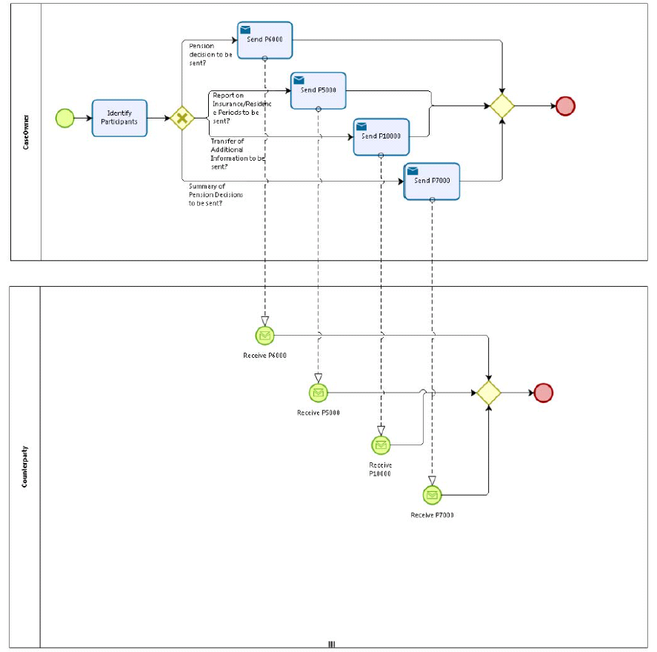

## 5.2 Sub Processes

n/a

# Appendices

## Issues

|  |  |  |  |  |  |
| --- | --- | --- | --- | --- | --- |
| **#** | **Issue date** | **Description** | **Replies** | **Action/Resolution** | **Close date** |
| 1 |  |  |  |  |  |
| 2 |  |  |  |  |  |
| 3 |  |  |  |  |  |
| 4 |  |  |  |  |  |