

EESSI Business Use Case



*P_BUC_09*

*Change in personal circumstances*





# Table of Contents

Table of Contents 2

1. Introduction 6

1.1. Purpose 6

1.2. Scope 6

1.3. Definitions, Acronyms and Abbreviations 6

1.4. References 7

1.5. Overview 7

2. Description 8

2.1. Business Scenario 8

2.2. Legal Base 8

3. Actors & Roles 9

4. Use Case 10

4.1. RUP Table Representation 10

4.2. Request – Reply SEDs 12

4.3. Attachments Allowed 12

4.4. BUC Artefacts used 12

5. Business Processes 13

5.1. Case Owner and Counterparty 13

5.2 Sub Processes 13

6. Appendices 13

6.1. Issues 13

**Document Control Information**

|  |  |
| --- | --- |
| **Settings** | **Value** |
| **Document Title:** | **Business Use Case**  **P_BUC_09 – Change in personal circumstances** |
| **Project Title:** | **EESSI (Electronic Exchange of Social Security Information) Project** |
| **Document Author:** | **European Commission, DG EMPL F5** |
| **System Owner:** | **European Commission, DG EMPL D2** |
| **Doc. Version:** | **v4.1.0** |
| **Sensitivity:** | **Public** |
| **Date:** | **03/08/2018** |

**Document history:**

The Document Author is authorised to make the following types of changes to the document without requiring that the document be re-approved:

Editorial, formatting, and spelling

Clarification

To request a change to this document, contact the Document Author or Owner.

|  |  |  |  |
| --- | --- | --- | --- |
| **Revision** | **Date** | **Created by** | **Short Description of Changes** |
| v0.1.0 | 20/04/2016 | Cristina Ezaru | First Draft |
| v0.2.0 | 06/06/2016 | Cristina Ezaru | Incorporated review received from AHG:  1. Branch3 updated: adding participants should be able to any participant (within their own MS)  2. BUC correct name updated in all document  3. Rewording Trigger  4. Updated "Actors & Roles"  5. Branch1 removed  6. Branch7 removed  7. Updated Attachments Allowed table: P14000 YES  8. Corrections/updates in Description  9. Corrections/updates in Main Scenario |
| v0.3.0 | 06/07/2016 | Cristina Ezaru | Alignment to the standard description and layout of the BUC. |
| v0.4.0 | 14/07/2016 | Cristina Ezaru | Incorporated review received during the AHG meeting (13/07/2016)  1. Branch2 updated: removing participants should be able to any participant (within their own MS) |
| v0.5.0 | 05/10/2016 | Cristina Ezaru | Incorporated review received during the AHG meeting (29/09/2016)  1. Branch2 updated: removing participants should be able to any participant – alignment to all Pensions BUCs. |
| v0.6.0 | 11/11/2016 | Cristina Ezaru | Incorporated review received from AC:  1. Minor formatting and grammar changes. |
| v0.7.0 | 17/11/2016 | Cristina Ezaru | Incorporated review received from AC:  1. Branch2 removed |
| v0.99.0 | 17/11/2016 | Cristina Ezaru | Candidate for AC Approval |
| v1.0.0 | 14/12/2016 | Cristina Ezaru | **AC Approved version** |
| v1.0.1 | 16/12/2016 | Cristina Ezaru | Incorporated review received from AC: (CZ Republic delegation)  1. SR1 and SR5 updated: use "Branch3" instead of "Branch2" |
| v1.0.2 | 26/06/2017 | Madalina Alecsandrescu | Last version BPMN section 5 |
| v1.0.3 | 11/08/2017 | Eric Briffoz | -Included version of the diagram used in section 5.  -Correction in horizontal sub process table in section 4.5  - Removed Use Case diagram |
|  |  | Madalina Alecsandrescu | Align wording for Invalidate SED and Forward participant |
| v4.1.0 | 03/08/2018 | Madalina Alecsandrescu | - Section 4.4 merged 2 tables (for SED & for Subprocesses) into 1 BUC Artefact table."  - Version adaptations to release 4.1.0.  - Correction in wording in SR, add exception in SR for [Branch 4] |

# Introduction

## Purpose

The purpose of this document is to construct an external view of, part of, the 'EESSI business system' as described in EC Regulations 883/2004 and 987/2009. The ‘EESSI Business System’ describes the business and expected business processes without consideration as to which part(s) may be realised by an IT System (i.e. the proposed EESSI IT System).

The external view comprises of models and descriptions of business use cases, the services of a business system offered to business actors: customers, business partners, or other business systems.

A business use case is described from an actor's perspective; it describes the interaction between an actor and the business system, meaning it describes the behaviours of the business system that the actor utilises. The Business Use Case includes Use Case Diagrams and Business Process Models.

Use case diagrams show actors, business use cases, and their relationships. Use case diagrams do not describe procedures. Alternative scenarios also remain hidden. These diagrams give a good overview of the behaviours of the EESSI business system which will direct and govern part of the expected behaviours and functionality delivered by the EESSI IT System.

## Scope

This document is limited to the external view on the pension sector process of the Change in personal circumstances. The different elements like use case description, actors, and business process as well as supporting UML diagrams and BPMN models pertaining to the Change in personal circumstances.

## Definitions, Acronyms and Abbreviations

Please see the EESSI Project Glossary [here](https://webgate.ec.europa.eu/CITnet/confluence/display/EESSI/Project+Information+for+Stakeholders)

## References

|  |  |  |
| --- | --- | --- |
| **#** | **Description** |  |
| 1 | EC Regulation 883/2004 | Regulation EC No 883- 2004.pdf |
| 2 | EC Regulation 987/2009 | Regulation EC No 987-2009.pdf |
| 3 | UML 2.x | <http://www.omg.org/spec/UML/> |
| 4 | BPMN 2.0 | <http://www.omg.org/spec/BPMN/index.htm> |
| 5 | UML 2.0 In Action | Henriette Baumann, Patrick Grassle & Philippe Baumann, 2005, ISBN 1904811558 |
| 6 | RUP@EC standard 5.0 | <http://www.cc.cec/RUPatEC_Standard/> |
| 7 | RUP op maat | <http://www.rupopmaat.nl/> |

## Overview

Chapter 1 introduces the external view on the business system under review and lists the elements of this specification.

Chapter 2 introduces us to the Change in personal circumstances business process. The chapter gives a short and detailed description as well as a reference to business process legal base.

Chapter 3 lists the actors involved in the Change in personal circumstances business process.

Chapter 4 describes in detail Change in personal circumstances business process based on the RUP use case template, as well as the relationship to other use cases.

Chapter 5 describes the Change in personal circumstances business process using business process modelling notation (BPMN).

# Description

## Business Scenario

This Business Use Case describes a situation where an Institution wishes to transfer information to another institution about changes in personal circumstances during pension payments as a notification without a previous request, according to Art. 76(4) of Reg. 883/2004.

Implementation of this BUC is optional.

## Legal Base

This Business Use Case document's legal base is described in the following Regulations:

* basic Regulation (EC) No 883/2004

The following matrix specifies the SEDs that are used in this Business Use Case and documents the articles that provide the legal basis for each SED.

|  |  |
| --- | --- |
|  | **Basic Reg (883/04)** |
| **Art 76(4)** |
| P14000 | **✓** |

Table 1: SED – Legal base relationship matrix

# Actors & Roles

This chapter captures details of the actors which are important to understanding the different types of system users. An actor is anyone or anything that exchanges data with the business system. An actor can be a user, external hardware, or another system.

The overarching description of each actor described in this Business Use Case can be found in the Glossary. Below you will find a short description which provides further clarity of this actor within the context of this Business Use Case.

|  |  |
| --- | --- |
| **Actor name** | **Description** |
| **Case Owner** | In this BUC the Case Owner is a Competent Institution who needs to inform another institution(s) of a change in personal circumstances. |
| **Counterparty** | In this BUC the Counterparty(ies) are Competent Institutions that receives the information Case Owner has sent. |

# Use Case

## RUP Table Representation

|  |  |  |  |  |
| --- | --- | --- | --- | --- |
| **Use Case ID:** | **P_BUC_09** | | | |
| **Use Case Name:** | **Change in personal circumstances** | | | |
| **Created By:** | Cristina Ezaru | | **Last Updated By:** | Cristina Ezaru |
| **Date Created:** | 20/04/2016 | | **Last Revision Date:** | 16/12/2016 |
| **Actors:** | | Case Owner  Counterparty | | |
| **Description:** | | This Business Use Case describes a situation where an Institution wishes to transfer information to another institution about changes in personal circumstances during pension payments as a notification without a previous request, according to Art. 76(4) of Reg. 883/2004. | | |
| **Trigger:** | | An institution needs to inform another institution(s) of a change in i.e. nationality of a person, an address of a person, date of death of a person, etc | | |
| **Preconditions:** | | An award of Pension (Old-age, Survivors or Invalidity) has been made | | |
| **Post conditions:** | | The Case Owner has informed the Counterparty(ies) of the new information | | |
| **Main Scenario:** | | **Identify Participants**   1. The Case Owner identifies the Member State(s). 2. The Case Owner then identifies the correct institution or institutions (the Counterparty(ies)) in each Member State where to send the Change in circumstances they need. There will be one Counterparty or more. The Case Owner and the Counterparty(ies) are herein collectively referred to as the Participants;   **Send Personal circumstances changes**   1. The Case Owner fills in a report Change in personal circumstances (P14000) which provides a detailed summary of the changes in personal circumstances. 2. The Case Owner sends the P14000 to all participants.   **Receive Personal circumstances changes**   1. Each Counterparty receives the P14000 2. The use case ends here | | |
|  | | ***The Following Branches determine the use of Horizontally Defined Sub Processes within this Business Process*** | | |
| 1. ***[Removed]*** | | |
| ***The Following Branches Determine the use of Administrative Sub Processes within this Business Process*** | | |
| 1. ***[Removed]*** | | |
| 1. ***at any step after [step 4] any Participant may choose to Add new participants to this Business Process.*** ***Case owner should be able to add participants in any MS, Counterparties should be able to add participants in their own MS.*** 2. The Participant executes business use case ***AD_BUC_03*_Subprocess *– Add Participant;*** 3. [This Branch] Ends | | |
| 1. ***at any step after [step 4] any Participant may choose to Forward this Business Process to another Competent Institution within their MS who assumes responsibility for handling it*** 2. The Participant executes business use case ***AD_BUC_05*_Subprocess *– Forward Case;*** 3. [This Branch] Ends | | |
| 1. ***at any step after [step 4] the Case Owner may choose to advise all recipients of their P14000 that it is Invalid under Art 5 of 987/09*** 2. The Case Owner executes business use case ***AD_BUC_06*_Subprocess *- Invalidate_SED;*** 3. Optionally, the Case Owner fills in P14000, by entering all the required data; 4. Optionally, the Case Owner sends the P14000, including any attachments, to all counterparties; 5. [This Branch] Ends | | |
| 1. ***at any step after [step 4] the Case Owner may choose to send an updated version of P14000*** 2. The Case Owner executes business use case ***AD_BUC_10*_Subprocess *- Update_SED;*** 3. [This Branch] Ends | | |
| 1. ***removed*** | | |
| **Exceptions:** | | none | | |
| **Includes:** | | See diagram at part 4.4 | | |
| **Special Requirements:** | | **SR1**: Rules about the invoking of Branches:  Administrative  [Branch 3] to [Branch 6] – May be invoked more than once, per Participant, exception [Branch 4] – May be invoked only once,per Participant.  **SR2**: Rules about the destination for each SED Type when the SED is sent:  P14000 – Can be sent to one or more Active Participants  **SR3**: The term "Send/Sent to All Active Participants" does not include sending to themselves (i.e. to the senders institution)  **SR4**: Active Participants are defined as those participants identified at [**Step 2**] and those participants added through the execution of [**Branch 3**] and/or [**Branch 4**]and not removed through the execution of [**Branch 4**]  **SR5**: Alternative Branches 3 – 6 are non-interrupting Branches; | | |
| **Assumptions:** | |  | | |
| **Notes and Issues:** | |  | | |

## Request – Reply SEDs

The following table specifies the SED that have a logical pairing to one another, usually this is known as a request-reply pair.

| REQUEST SED | REPLY SED(s) |
| --- | --- |
| - | - |

## Attachments Allowed

The following table specifies whether attachments are permitted to be included when sending a SED type.

| SED | Attachments |
| --- | --- |
| P14000 | Allowed |

## Artefacts used

The following table specifies the artefacts that are used in this Business Use Case.

| Artefact name | Artefact type |
| --- | --- |
| P14000 | SED |
| AD_BUC_03_Subprocess – Add Participant | BUC |
| AD_BUC_05_Subprocess – Forward Case | BUC |
| AD_BUC_06_Subprocess – Invalidate SED | BUC |
| AD_BUC_10_Subprocess – Update SED | BUC |
| AD_BUC_11_Subprocess – Business Exception | BUC |
| AD_BUC_12_Subprocess – Change of Participant | BUC |

# Business Processes

This chapter describes the Business Use Case Change in personal circumstances.

## Case Owner and Counterparty

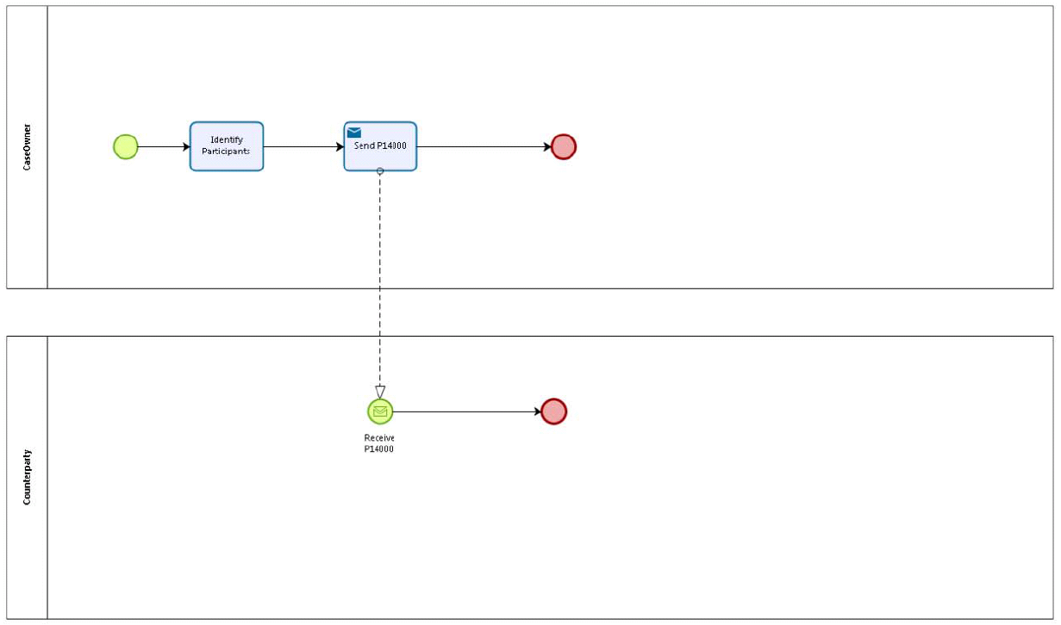

## 5.2 Sub Processes

n/a

# Appendices

## Issues

|  |  |  |  |  |  |
| --- | --- | --- | --- | --- | --- |
| **#** | **Issue date** | **Description** | **Replies** | **Action/Resolution** | **Close date** |
| 1 |  |  |  |  |  |
| 2 |  |  |  |  |  |
| 3 |  |  |  |  |  |
| 4 |  |  |  |  |  |