

EESSI Business Use Case



*P_BUC_10   
 Transitional cases*



# Table of Contents

Table of Contents 2

1. Introduction 7

1.1. Purpose 7

1.2. Scope 7

1.3. Definitions, Acronyms and Abbreviations 7

1.4. References 8

1.5. Overview 8

2. Description 9

2.1. Business Scenario 9

2.2. Legal Base 9

3. Actors & Roles 10

4. Use Case 11

4.1. RUP Table Representation 11

4.2. Request – Reply SEDs 20

4.3. Attachments Allowed 20

**4.4. Artefacts used** 21

5. Business Processes 22

5.1. Case Owner and Counterparty 22

5.2. Sub Processes 22

6. Appendices 24

6.1. Issues 24

**Document Control Information**

|  |  |
| --- | --- |
| **Settings** | **Value** |
| **Document Title:** | **Business Use Case**  **P_BUC_10 - Transitional Cases** |
| **Project Title:** | **EESSI (Electronic Exchange of Social Security Information) Project** |
| **Document Author:** | **European Commission, DG EMPL F5** |
| **System Owner:** | **European Commission, DG EMPL D2** |
| **Doc. Version:** | **v4.1.0** |
| **Sensitivity:** | **Public** |
| **Date:** | **03/08/2018** |

**Document history:**

The Document Author is authorized to make the following types of changes to the document without requiring that the document be re-approved:

* Editorial, formatting, and spelling
* Clarification

To request a change to this document, contact the Document Author or Owner.

|  |  |  |  |
| --- | --- | --- | --- |
| **Revision** | **Date** | **Created by** | **Short Description of Changes** |
| v0.1.0 | 14/10/2016 | Cristina Ezaru | First Draft |
| v0.2.0 | 19/12/2016 | Cristina Ezaru | Incorporated feedback received from AHG:  1. legal base updated for P15000  2. Preconditions updated  3. Main Scenario- Identify participants updated  4. Actors & Roles updated  5. Trigger updated  6. Post conditions updated  7. Process claim & send decision - step 5 updated  8. Receive & process pension decisions – steps 15, 16, 17, 18 updated – replaced "Case Owner" by "Participant"  9. Branch2 updated  10. updated references for Branch3 step4-5; Branch 20; Branch 21; Branch 22; Branch 26; Branch 27; Branch 32; Branch 33; Branch 34.  11. all branches renumbering  12. new Branch added – H_BUC_09 Notification of a medical report  13. Branch9 and Branch10 updated – restriction for adding/removing participants by CO and CP was removed  14. Branch17, Branch18, Branch19, Branch28, Branch29, Branch30 updated – replaced "Case Owner/ Counterparty" by "Participant"  15. SR7 updated  16. Business Scenario updated |
| v0.3.0 | 13/01/2017 | Cristina Ezaru | Incorporated feedback received from AHG:  1. Main Scenario step 1 updated  2. "Case Owner", "Counterparty" and "Participant" replaced by "Contact Institution" in:  - Main Scenario steps 15, 16, 17, 18  - Branches 12, 13, 14, 15, 16, 17, 18, 19, 23, 24, 25, 26, 27, 28, 29, 30  - SR8  3. H_BUCs name updated: Branches 5, 6, 7, 8  4. Branch 3 updated: steps 3 and 5 – invoking Branch 20/ Branch 21  5. Branch 16 updated: step 2 – "reverts to step 8"  6. Actors&Roles updated: added Contact Institution reference |
| v0.4.0 | 20/02/2017 | Cristina Ezaru | Incorporated review received during the AHG meeting (15/02/2017):  1. "Contact Institution" replace by "Participant"in:  - Main Scenario 15, 18 (only the receiver)  - Branches 14, 16, 25, 27  2. "Contact Institution" replace by "Case Owner"in:  - Branches 12, 13, 15, 23, 24, 26  3. "Case Owner" replaced by "Contact Institution"in:  - Branches 1, 2  Incorporated feedback received from AC:  1. Legal Base matrix updated – P3000  2. SR2 updated for Branch6, Branch11  3. SR6 updated for Branch11, Branch12  4. Business Scenario Description updated – time limited rephrased  5. Business Scenario Description updated – "Aps" removed  6. Post Conditions updated  7. Trigger updated  8. Header updated |
| v0.4.1 | 23/02/2017 | Cristina Ezaru | Incorporated feedback received from AHG:  1. Business Scenario Description updated – "Aps" removed  2. Actors&Roles updated for Contact Institution  3. Main Scenario: Send Claim replaced by Send P15000.  4. Trigger updated |
| v0.99.0 | 23/02/2017 | Cristina Ezaru | **Candidate for AC Approval** |
| v 0.99.1 | 28/06/2017 | A Madalina Alecsandrescu | included BPMN last version |
| v1.0.0 | 05/07/2017 | A Madalina Alecsandrescu | Changed version according D2 and team leader |
| v1.0.1 | 08/08/2017 | A Madalina Alecsandrescu | Included BPMN last version (added subprocesses) |
| v1.0.2 | 11/08/2017 | Eric Briffoz | -Included the version of the BUC Diagram used in section 5.  -Correction in horizontal sub-process table in section 4.5  - Removed Use Case diagram |
|  |  | Madalina Alecsandrescu | Align wording for Invalidate SED and Forward participant |
| v4.1.0 | 03/08/2018 | Madalina Alecsandrescu | - Section 4.4 merged 2 tables (for SED & for Subprocesses) into 1 BUC Artefact table."  - Version adaptations to release 4.1.0.  - Corrections in wording |

# Introduction

## Purpose

The purpose of this document is to construct an external view of, part of, the 'EESSI business system' as described in EC Regulations 883/2004 and 987/2009. The ‘EESSI Business System’ describes the business and expected business processes without consideration as to which part(s) may be realized by an IT System (i.e. the proposed EESSI IT System).

The external view comprises of models and descriptions of business use cases, the services of a business system offered to business actors: customers, business partners, or other business systems.

A business use case is described from an actor's perspective; it describes the interaction between an actor and the business system, meaning it describes the behaviours of the business system that the actor utilizes. The Business Use Case includes Use Case Diagrams and Business Process Models.

Use case diagrams show actors, business use cases, and their relationships. Use case diagrams do not describe procedures. Alternative scenarios also remain hidden. These diagrams give a good overview of the behaviours of the EESSI business system which will direct and govern part of the expected behaviours and functionality delivered by the EESSI IT System.

## Scope

This document is limited to the external view on the pension sector process of the Transitional Cases. The different elements like use case description, actors, and business process as well as supporting UML diagrams and BPMN models pertaining to the Transitional Cases.

## Definitions, Acronyms and Abbreviations

Please see the EESSI Project Glossary [here](https://webgate.ec.europa.eu/CITnet/confluence/display/EESSI/Project+Information+for+Stakeholders)

## References

|  |  |  |
| --- | --- | --- |
| **#** | **Description** |  |
| 1 | EC Regulation 883/2004 | Regulation EC No 883- 2004.pdf |
| 2 | EC Regulation 987/2009 | Regulation EC No 987-2009.pdf |
| 3 | UML 2.x | <http://www.omg.org/spec/UML/> |
| 4 | BPMN 2.0 | <http://www.omg.org/spec/BPMN/index.htm> |
| 5 | UML 2.0 In Action | Henriette Baumann, Patrick Grassle & Philippe Baumann, 2005, ISBN 1904811558 |
| 6 | RUP@EC standard 5.0 | <http://www.cc.cec/RUPatEC_Standard/> |
| 7 | RUP op maat | <http://www.rupopmaat.nl/> |

## Overview

Chapter 1 introduces the external view on the business system under review and lists the elements of this specification.

Chapter 2 introduces us to the Transitional cases business process. The chapter gives a short and detailed description as well as a reference to business process´ legal base.

Chapter 3 lists the actors involved in the Transitional cases business process.

Chapter 4 describes in detail the Transitional cases business process based on the RUP use case template, as well as the relationship to other use cases.

Chapter 5 describes the Transitional cases business process using business process modelling notation (BPMN).

# Description

## Business Scenario

This Business Use Case describes the transition of a pension claim from paper to electronic SEDs for cases started before EESSI is going in production. The use of the BUC is time limited after the end of the transition period.

Such a case, "on-going-case", is one which has started on paper and where the institutions involved have become EESSI enabled before the case is completed.

Definition of an "on-going-case":

1. At least one initial paper transmission of data has taken place between institutions in two or more Member States, and
2. At least one further exchange is expected before the case becomes resolved, and
3. The institutions involved have, subsequent to the initial paper exchange(s), become EESSI enabled. This may have occurred during the Transitional Period itself or at the point when the Transitional Period ends.

## Legal Base

This Business Use Case document's legal base is described in the following Regulations

* basic Regulation (EC) No 883/2004
* implementing Regulation (EC) No 987/2009

The following matrix specifies the SEDs that are used in this Business Use Case and documents the articles that provide the legal basis for each SED.

|  |  |  |  |  |  |  |  |  |  |  |  |  |  |  |  |  |  |  |  |  |  |  |  |
| --- | --- | --- | --- | --- | --- | --- | --- | --- | --- | --- | --- | --- | --- | --- | --- | --- | --- | --- | --- | --- | --- | --- | --- |
|  | **Basic Reg (883/04)** | | | | | | | |  | **Implementing Reg (987/09)** | | | | | | | | | | | | | |
| **1** | **6** | **45** | **49** | **51** | **52** | **57** | **60** | **12(1)** | **45(4)** | **46(1)** | **46(3)** | **47(1)** | **47(4)** | **47(5)** | **47(6)** | **48** | **48(1)** | **48(2)** | **51(2)** | **52(1)b** | **95** | **AC E1** |
| P3000 | **✓** |  |  |  |  |  |  |  |  | **✓** | **✓** |  |  | **✓** | **✓** |  |  |  |  |  |  |  |  |
| P4000 |  |  |  |  |  |  |  |  | **✓** |  | **✓** |  |  | **✓** |  |  |  |  |  |  |  |  |  |
| P5000 | **✓** | **✓** | **✓** | **✓** | **✓** | **✓** | **✓** | **✓** | **✓** |  |  |  |  | **✓** | **✓** |  |  |  |  |  | **✓** |  |  |
| P6000 |  |  |  |  |  |  |  |  |  |  |  |  |  |  |  | **✓** |  | **✓** |  | **✓** |  |  |  |
| P7000 |  |  |  |  |  |  |  |  |  |  |  |  |  |  |  |  | **✓** |  |  |  |  |  |  |
| P8000 |  |  |  |  |  |  |  |  |  |  |  |  | **✓** | **✓** |  |  |  |  |  |  |  |  |  |
| P9000 |  |  |  |  |  |  |  |  |  |  |  |  | **✓** | **✓** |  |  |  |  |  |  |  |  |  |
| P10000 |  |  |  |  |  |  |  |  |  |  |  | **✓** | **✓** | **✓** |  |  |  |  | **✓** |  |  |  |  |
| P15000 |  |  |  |  |  |  |  |  |  |  |  | **✓** | **✓** | **✓** |  |  |  |  |  |  |  | **✓** | **✓** |

Table 1: SED – Legal base relationship matrix

# Actors & Roles

This chapter captures details of the actors which are important to understanding the different types of system users. An actor is anyone or anything that exchanges data with the business system. An actor can be a user, external hardware, or another system.

The overarching description of each actor described in this Business Use Case can be found in the Glossary. Below you will find a short description which provides further clarity of this actor within the context of this Business Use Case.

|  |  |
| --- | --- |
| **Actor name** | **Description** |
| ***Case Owner*** | In this BUC the Case Owner is the participant that needs to send the next SED in the claim procedure that has started on paper and after all participants have become EESSI enabled. It can be the Contact Institution or any other participant involved in the claim procedure. |
| ***Counterparty*** | In this BUC the Counterparties are the other participants that are involved in the claim procedure. Even the actual Contact Institution can be a Counterparty in a transitional case. |
| ***Claimant*** | In this BUC the Claimant is the Person who claimed one of the following claim types: Old Age Pension, Survivors Pensions or Invalidity Pension. |
| ***Contact Institution*** | In this BUC the Contact Institution (as described by the Regulations) can perform the role of the Case Owner or the Counterparty. |

# Use Case

## RUP Table Representation

|  |  |  |  |  |
| --- | --- | --- | --- | --- |
| **Use Case ID:** | **P_BUC_10** | | | |
| **Use Case Name:** | Transitional cases | | | |
| **Created By:** | Cristina Ezaru | | **Last Updated By:** | Cristina Ezaru |
| **Date Created:** | 14/10/2016 | | **Last Revision Date:** | 23/02/2017 |
| **Actors:** | | Case Owner  Counterparty  Claimant  Contact Institution | | |
| **Description:** | | This Business Use Case describes the transition of a pension claim from paper to electronic SEDs for cases started before EESSI is going in production. The use of the BUC is time limited after the end of the transition period.  Such a case, "on-going-case", is one which has started on paper and where the institutions involved have become EESSI enabled before the case is completed.  Definition of an "on-going-case":   1. At least one initial paper transmission of data has taken place between institutions in two or more Member States, and 2. At least one further exchange is expected before the case becomes resolved, and 3. The institutions involved have, subsequent to the initial paper exchange(s), become EESSI enabled. This may have occurred during the Transitional Period itself or at the point when the Transitional Period ends. | | |
| **Trigger:** | | The institutions involved have, subsequent to the initial paper exchange(s), become EESSI enabled and the Case Owner (can be Contact Institution or any Participant in the claim procedure) needs to send the following SED. | | |
| **Preconditions:** | | An initial pension claim (P_BUC_01 Old Age pension, P_BUC_02 Survivor pension or P_BUC_03 Invalidity pension) had been made on paper or in other form outside EESSI. | | |
| **Post conditions:** | | The claim procedure is finalized in EESSI and the Claimant is informed of the decisions made in respect to their Pension Claim from each Member States. | | |
| **Main Scenario:** | | **Identify Participants**   1. The Case Owner identifies a case in which a request has been made or a claim has been started on paper or in any other form outside EESSI; 2. The Case Owner then identifies the correct institution or institutions (the Counterparty(ies)) in each Member State that are involved in the claim procedure. There will be one Counterparty or more. The Case Owner and the Counterparty(ies) are herein collectively referred to as the Participants;   **Send P15000**   1. The Case Owner fills in an Transition of Pension Case to EESSI (P15000) by entering all the required data; 2. The Case Owner sends the P15000, including any attachments, to all Counterparties;   **Process Claim & Send Decision**   1. Each Counterparty will receive a Transition of Pension Case to EESSI (P15000) with the fitting personal ID dataset and any attachments. 2. The Case Owner then optionally fills in a Report on Insurance and Residence Periods (P5000) which provides detailed insurance information to assist the pension processing; 3. The Case Owner sends the P5000 to all other Participants; **[Steps 6 and 7]** collectively may optionally be repeated by the Case Owner many times after this step 4. The Case Owner fills in an Pension Decision (P6000) by entering all the required information about the Pension decision they have made; 5. The Case Owner sends the P6000 to all counterparties; **[Steps 8 and 9]** collectively may optionally be repeated by the Case Owner many times after this step 6. Each Counterparty then optionally fills in a Report on Insurance and Residence Periods (P5000) which provides detailed insurance information to assist the pension processing; 7. Each Counterparty then sends the P5000 to all other Participants; **[Steps 10 and 11]** collectively may optionally be repeated by each Counterparty many times after this step 8. Each Counterparty fills in a Pension Decision (P6000) by entering all the required information about the Pension decision they have made; 9. Each Counterparty then sends their P6000 to the Case Owner and any other Counterparties; **[Steps 12 and 13]** collectively may optionally be repeated by each Counterparty many times after this step 10. **[Steps 6 and 7]** collectively, **[Steps 8 and 9]** collectively, **[Steps 10 and 11]** collectively and **[Steps 12 and 13]** collectively may occur in any order   **Receive & Process Decisions**   1. Each time the Contact Institution receives a Pension Decision (P6000) from other Participant, or it sends a P6000, it checks if:    * + - There is at least one valid P6000 or other equivalent information from each Participant involved, that P7000 can be issued.   If this is true, the Contact Institution, **OR** at the discretion of the Contact Institution, continues to the **[Next Step]** if not it repeats **[This Step];**  **Finalize Claim**   1. The Contact Institution fills in a Portable Document (P1) by entering specific data provided in the Pension Decisions (P6000) exchanged by all participants. The completed P1 is then sent to the claimant to inform them of the Pensions decisions taken by all participants and their right to review; 2. The Contact Institution fills in a Summary of Pension Decisions (P7000) by entering specific data provided in the Pension Decisions (P6000) exchanged by all participants; 3. The Contact Institution sends the P7000 to all Participants. 4. Upon the sending of the P7000 the Pension Claim is complete 5. The use case ends here. | | |
| **Alternative Scenarios:** | | 1. ***at any step after [step 5] the Contact Institution may optionally choose to fill in and send Country Specific Information.*** 2. The ***Contact Institution*** fills in Country Specific Information (P3000_XX) which provides supplementary information to assist the pension processing in the Member State it was designed for; 3. The ***Contact Institution*** sends the P3000_xx to specific Participants (see Special Requirements) 4. [This Branch] Ends | | |
| 1. ***at any step after [step 5] the Contact Institution, may optionally choose to fill in and send a Report on Insurance History.*** 2. The ***Contact Institution*** fills in Report on Insurance History (P4000) which provides supplementary information to assist the old-age pension processing; 3. The ***Contact Institution*** sends the P4000 to all Participants 4. [This Branch] Ends | | |
| 1. ***at any step after [step 5] any Participant may optionally choose to fill in a Request for Additional Information.*** 2. The Participant who invokes this branch fills in a Request for Additional Information (P8000) which details the additional information they need; 3. The Participant who wishes to request additional information sends the P8000 to one or more participants (the receiving participants are at the discretion of the sending participant) 4. Each Participant who received a P8000 gather the requested information and fill in a Reply to Request for Additional Information (P9000) provided the P8000 is not declared to be invalid at **[invoking Branch 20];** 5. Where [Branch 3 Step 3] was completed each participant who filled out the P9000 sends the P9000, including any attachments, to the sender of the P8000 and all other participants who received the P8000. 6. Upon receipt of a P9000 the participant may optionally choose to send another P8000 provided the P9000 is not declared to be invalid at **[invoking Branch 21];** **[go to Branch 3 Step 1]** 7. [This Branch] Ends | | |
| 1. ***at any step after [step 5] any Participant may optionally choose to fill in a Transfer of Additional Information.*** 2. The Participant who invokes this branch fills in a Transfer of Additional Information (P10000) which details the additional information they wish to transfer; 3. The Participant who wishes transfer the additional information sends the P10000, with any attachments, to one or more participants (the receiving participants are at the discretion of the sending participant) 4. [This Branch] Ends | | |
| ***The Following Branches determine the use of Horizontally Defined Sub Processes within this Business Process*** | | |
| 1. ***at any step after [step 5] any Participant may optionally choose to request the Reimbursement of Administrative Check or Medical Examination from another Participant*** 2. The Participant executes business use case **H_BUC_04_Subprocess – Reimbursement of Administrative Check or Medical Examination**; 3. [This Branch] Ends | | |
| 1. ***at any step after [step 5] any Participant may optionally choose notify another Participant of the Death of a Person*** 2. The Participant executes business use case **H_BUC_07_Subprocess – Notification of Death**; 3. [This Branch] Ends | | |
| 1. ***at any step after [step 5] any Participant may optionally choose to request and exchange Medical Information with another Participant*** 2. The Participant executes business use case **H_BUC_08_Subprocess – Medical Information**; 3. [This Branch] Ends | | |
| 1. ***at any step after [step 5] any Participant may optionally choose to notify another Participant of the Medical Information*** 2. The Participant executes business use case **H_BUC_09_Subprocess – Notification of Medical Information**; 3. [This Branch] Ends | | |
| ***The Following Branches Determine the use of Administrative Sub Processes within this Business Process*** | | |
| 1. ***at any step after [step 5] any Participant may choose to Remove participants from this Business Process.*** 2. The Participant executes business use case **AD_BUC_04_Subprocess – Remove Participant**; 3. [This Branch] Ends | | |
| 1. ***at any step after [step 5] any Participant may choose to Add new participants to this Business Process.*** 2. The Participant executes business use case **AD_BUC_03_Subprocess – Add Participant**; 3. [This Branch] Ends | | |
| 1. ***at any step after [step 5] any Participant may choose to Forward this Business Process to another Competent Institution within their MS who assumes responsibility for handling it.*** 2. The Participant executes business use case **AD_BUC_05_Subprocess – Forward Case**; 3. [This Branch] Ends | | |
| 1. ***at any step after [step 5] the Case Owner may choose to advise all recipients of their P15000 that it is Invalid under Art 5 of 987/09*** 2. The Case Ownerexecutes business use case **AD_BUC_06_Subprocess - Invalidate_SED**; 3. Optionally, the Case Owner fills in P15000, by entering all the required data; 4. Optionally, the Case Owner sends the P15000, including any attachments, to all counterparties; 5. [This Branch] Ends | | |
| 1. ***at any step after [step 7] the Case Owner may choose to advise all recipients of their P5000 that it is Invalid under Art 5 of 987/09*** 2. The ***Case Owner*** executes business use case **AD_BUC_06_Subprocess - Invalidate_SED**; 3. Optionally, the Case Owner fills in P5000, by entering all the required data; 4. Optionally, the Case Owner sends the P5000, including any attachments, to all counterparties; 5. [This Branch] Ends | | |
| 1. ***at any step after [step 11] any Participant may choose to advise all recipients of their P5000 that it is Invalid under Art 5 of 987/09*** 2. The ***Participant*** executes business use case **AD_BUC_06_Subprocess - Invalidate_SED**; 3. Optionally, the participant fills in P5000, by entering all the required data; 4. Optionally, the participant sends the P5000, including any attachments, to all participants; 5. [This Branch] Ends | | |
| 1. ***at any step after [step 9] the Case Owner may choose to advise all recipients of their P6000 that it is Invalid under Art 5 of 987/09*** 2. The ***Case Owner*** executes business use case **AD_BUC_06_Subprocess - Invalidate_SED**; 3. If no other valid P6000 exists from the ***Case Owner*** then the Main Scenario reverts to **[step 8].** 4. [This Branch] Ends | | |
| 1. ***at any step after [step 13] any Participant may choose to advise all recipients of their P6000 that it is Invalid under Art 5 of 987/09*** 2. The ***Participant*** executes business use case **AD_BUC_06_Subprocess - Invalidate_SED**; 3. If no other valid P6000 exists for this ***Participant*** then the Main Scenario reverts to **[step 12].** 4. [This Branch] Ends | | |
| 1. ***at any step after [step 18] the Contact Institution may choose to advise all recipients of their P7000 that it is Invalid under Art 5 of 987/09*** 2. The Contact Institution executes business use case **AD_BUC_06_Subprocess - Invalidate_SED**; 3. The Main Scenario reverts to **[step 16].** 4. [This Branch] Ends. | | |
| 1. ***where [Branch 1 Step 2] has been executed then at any step after [Branch 1 Step 2] the Contact Institution may choose to advise all recipients of their P3000_xx that it is Invalid under Art 5 of 987/09*** 2. The Contact Institution executes business use case **AD_BUC_06_Subprocess - Invalidate_SED**; 3. Optionally, the Contact Institution fills in P3000_xx, by entering all the required data; 4. Optionally, the Contact Institution sends the P3000_xx, including any attachments, to all counterparties; 5. [This Branch] Ends | | |
| 1. ***where [Branch 2 Step 2] has been executed then at any step after [Branch 2 Step 2] the Contact Institution may choose to advise all recipients of their P4000 that it is Invalid under Art 5 of 987/09*** 2. The Contact Institution executes business use case **AD_BUC_06_Subprocess - Invalidate_SED**; 3. Optionally, the Contact Institution fills in the P4000, by entering all the required data; 4. Optionally, the Contact Institution sends the P4000, including any attachments, to all counterparties; 5. [This Branch] Ends | | |
| 1. ***where [Branch 3 Step 2] has been executed then at any step after [Branch3 Step 2] the Participant who sent the P8000 may choose to advise all recipients of their P8000 that it is Invalid under Art 5 of 987/09*** 2. The Participant executes business use case **AD_BUC_06_Subprocess - Invalidate_SED**; 3. Optionally, the participant fills in P8000, by entering all the required data; 4. Optionally, the participant sends the P8000, including any attachments, to all participants; 5. [This Branch] Ends | | |
| 1. ***where [Branch 3 Step 4] has been executed then at any step after [Branch 3 Step 4] the Participant who sent the P9000 may choose to advise all recipients of their P9000 that it is Invalid under Art 5 of 987/09*** 2. The Participant executes business use case **AD_BUC_06_Subprocess - Invalidate_SED**; 3. Optionally, the participant fills in P9000, by entering all the required data; 4. Optionally, the participant sends the P9000, including any attachments, to all participants; 5. [This Branch] Ends | | |
| 1. ***where [Branch 4 Step 2] has been executed then at any step after [Branch 4 Step 2] the Participant who sent the P10000 may choose to advise all recipients of their P10000 that it is Invalid under Art 5 of 987/09*** 2. The Participant executes business use case **AD_BUC_06_Subprocess - Invalidate_SED**; 3. Optionally, the participant fills in P10000, by entering all the required data; 4. Optionally, the participant sends the P10000, including any attachments, to all participants; 5. [This Branch] Ends | | |
| 1. ***at any step after [step 5] the Case Owner may choose to send an updated version of P15000*** 2. The ***Case Owner*** executes business use case **AD_BUC_10_Subprocess - Update_SED**; 3. [This Branch] Ends | | |
| 1. ***at any step after [step 7] the Case Owner may choose to send an updated version of their P5000*** 2. The ***Case Owner*** executes business use case **AD_BUC_10_Subprocess - Update_SED**; 3. [This Branch] Ends | | |
| 1. ***at any step after [step 11] any Participants may choose to send an updated version of their P5000*** 2. The ***Participants*** executes business use case **AD_BUC_10_Subprocess - Update_SED**; 3. [This Branch] Ends | | |
| 1. ***at any step after [step 9] the Case Owner may choose to send an updated version of their P6000*** 2. The ***Case Owner*** executes business use case **AD_BUC_10_Subprocess - Update_SED**; 3. [This Branch] Ends | | |
| 1. ***at any step after [step 13] any Participants may choose to send an updated version of their P6000*** 2. The ***Participants*** executes business use case **AD_BUC_10_Subprocess - Update_SED**; 3. [This Branch] Ends | | |
| 1. ***at any step after [step 18] the Contact Institution may choose to send an updated version of their P7000*** 2. The Contact Institution executes business use case **AD_BUC_10_Subprocess - Update_SED**; 3. [This Branch] Ends | | |
| 1. ***where [Branch 1 Step 2] has been executed then at any step after [Branch 1 Step 2] the Contact Institution may choose to send an updated version of their P3000_xx*** 2. The Contact Institution executes business use case **AD_BUC_10_Subprocess - Update_SED**; 3. [This Branch] Ends | | |
| 1. ***where [Branch 2 Step 2] has been executed then at any step after [Branch 2 Step 2] the Contact Institution may choose to send an updated version of their P4000*** 2. The Contact Institution executes business use case **AD_BUC_10_Subprocess - Update_SED**; 3. [This Branch] Ends | | |
| 1. ***where [Branch 3 Step 2] has been executed then at any step after [Branch 3 Step 2] the Participant who sent the P8000 may choose to send an updated version of their P8000*** 2. The Participant executes business use case **AD_BUC_10_Subprocess - Update_SED**; 3. [This Branch] Ends | | |
| 1. ***where [Branch 3 Step 4] has been executed then at any step after [Branch 3 Step 4] the Participant who sent the P9000 may choose to send an updated version of their P9000*** 2. The Participant executes business use case **AD_BUC_10_Subprocess - Update_SED**; 3. [This Branch] Ends | | |
| 1. ***where [Branch 4 Step 2] has been executed then at any step after [Branch 4 Step 2] the Participant who sent the P10000 may choose to send an updated version of their P10000*** 2. The Participant executes business use case **AD_BUC_10_Subprocess - Update_SED**; 3. [This Branch] Ends | | |
| 1. ***at any step after [step 5] any Participant may optionally choose to send a Reminder to another Participant for the return of information they were expecting from that participant but did not receive.*** 2. The Participant who invokes this branch executes business use case **AD_BUC_07_Subprocess -_Reminder**; 3. [This Branch] Ends | | |
| **Exceptions:** | |  | | |
| **Includes:** | | See diagram at part 4.4 | | |
| **Special Requirements:** | | **SR1**: When Alternative **[Branch 1]** is invoked the Country Specific Information (P3000_XX) can only be sent to institutions in the MS it was designed for. This is identifiable by the last two characters of the P3000_XX – represented here as "XX" for example:  P3000_UK can only be sent to institutions in the UK  P3000_DE can only be sent to institutions in Germany  **SR2**: Rules about the invoking of Branches:  [Branch 1] – May only be invoked per Destination Member State (see **SR1**) when there is no valid P3000_xx  [Branch 2] – May only be invoked once, per Participant  [Branch 3] – May be invoked more than once, per Participant  [Branch 4] – May be invoked more than once, per Participant  Horizontals  [Branch 6] – May only be invoked once, per Participant  [Branch 5,7,8] - May be invoked more than once, per Participant  Administrative  [Branch 9] to [Branch 10] – May be invoked more than once, per Participant  [Branch 11] – May only be invoked once, per Participant  [Branch 12] to [Branch 34] – May be invoked more than once, per Participant  **SR3**: Rules about the destination for each SED Type when the SED is sent:  P15000 – Defines and is sent to all Active Participants  P3000_xx – Must be Sent to All Active Participants of the MS designed for (See **SR1**)  P4000 – Must be Sent to all Active Participants  P5000 - Must be Sent to all Active Participants  P6000 - Must be Sent to all Active Participants  P7000 - Must be Sent to all Active Participants  P8000 – Can be sent to one or more Active Participants  P9000 – Must be sent to all Active Participants that received the P8000  P10000 - Can be sent to one or more Active Participants  **SR4**: The term "Send/Sent to All Active Participants" does not include sending it himself (i.e. to the senders institution)  **SR5**: Active Participants are defined as those participants identified at **[Step 2]** and those participants added through the execution of **[Branch 10]** and/or **[Branch 11]** and not removed through the execution of **[Branch 9]** and/or **[Branch 11]**  **SR6**: Alternative Branches 11 – 12 are interrupting Branches;  Alternative Branches 1 – 10 are non-interrupting Branches;  Alternative Branches 13 – 34 are non-interrupting Branches;  **SR7**: Clarification: where two or more institutions from the same MS are involved in the case, only one P6000 or other equivalent information needs to be exchanged from that MS to satisfy this rule.  **SR8**: "at the discretion of the Contact Institution" – allows under exceptional circumstances for the Contact Institution to progress to the next Steps without all P6000 information. | | |
| **Assumptions:** | |  | | |
| **Notes and Issues:** | |  | | |

## Request – Reply SEDs

The following table specifies the SED that have a logical pairing to one another, usually this is known as a request-reply pair.

| REQUEST SED | REPLY SED(s) |
| --- | --- |
| P8000 | P9000 |

## Attachments Allowed

The following table specifies whether attachments are permitted to be included when sending a SED type.

| SED | Attachments |
| --- | --- |
| P3000_XX | Allowed |
| P4000 | Allowed |
| P5000 | Not Allowed |
| P6000 | Allowed |
| P7000 | Not Allowed |
| P8000 | Allowed |
| P9000 | Allowed |
| P10000 | Allowed |
| P15000 | Allowed |

* 1. **Artefacts used**

The following table specifies the artefacts that are used in this Business Use Case.

| Artefacts name | Artefacts type |
| --- | --- |
| P15000 | SED |
| P3000_XX | SED |
| P4000 | SED |
| P5000 | SED |
| P6000 | SED |
| P7000 | SED |
| P8000 | SED |
| P9000 | SED |
| P10000 | SED |
| H_BUC_04_Subprocess | BUC |
| H_BUC_07_Subprocess | BUC |
| H_BUC_08_Subprocess | BUC |
| H_BUC_09_Subprocess | BUC |
| AD_BUC_03_Subprocess – Add Participant | BUC |
| AD_BUC_04_Subprocess – Remove Participant | BUC |
| AD_BUC_05_Subprocess – Forward Case | BUC |
| AD_BUC_06_Subprocess – Invalidate SED | BUC |
| AD_BUC_07_Subprocess – Reminder | BUC |
| AD_BUC_10_Subprocess – Update SED | BUC |
| AD_BUC_11_Subprocess – Business Exception | BUC |
| AD_BUC_12_Subprocess – Change of participant | BUC |

# Business Processes

This chapter describes the Business Use Case Transitional Cases.

## Case Owner and Counterparty

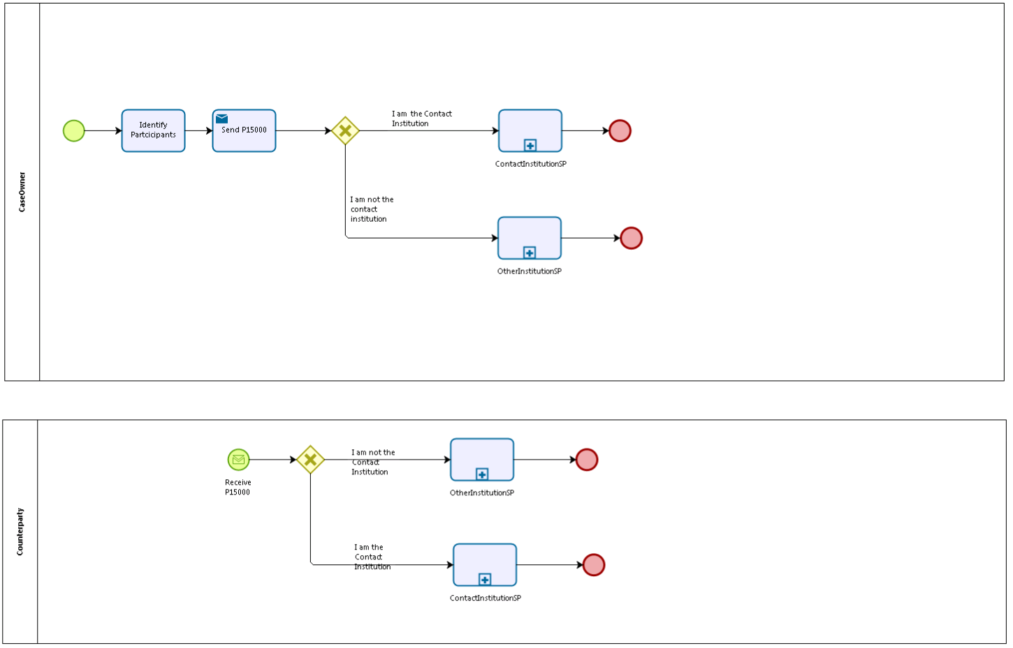

## 5.2. Sub Processes

5.2.1. ContactInstitutionSP

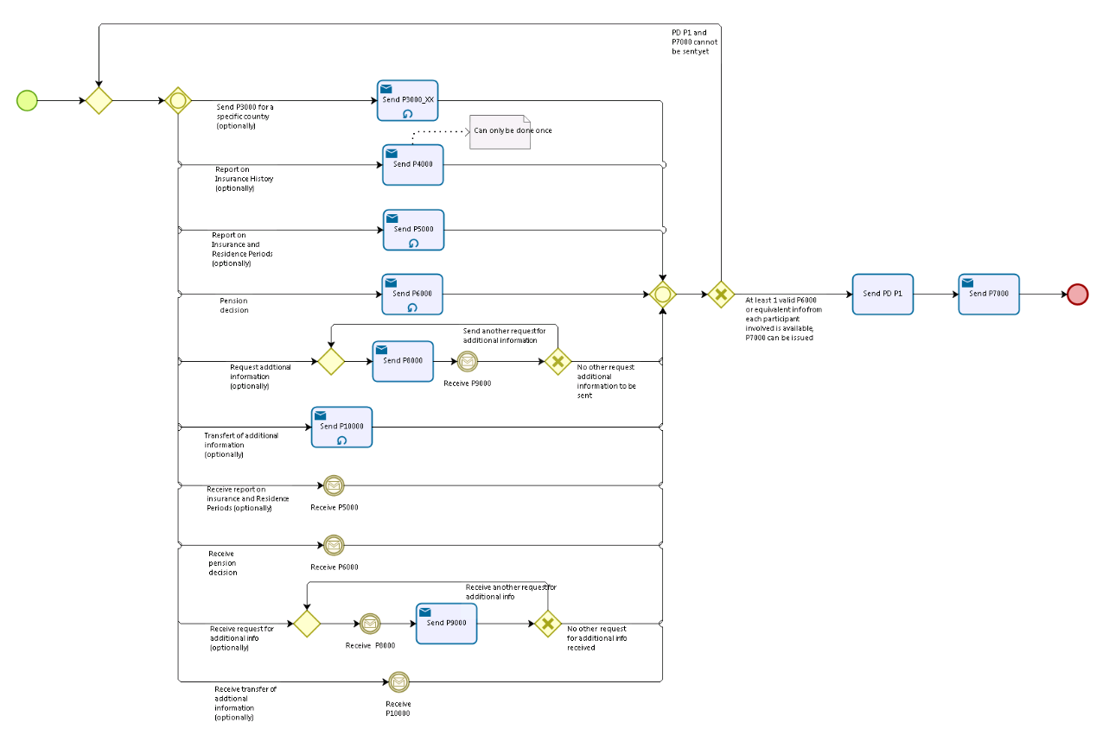

5.2.2. OtherInstitutionSP

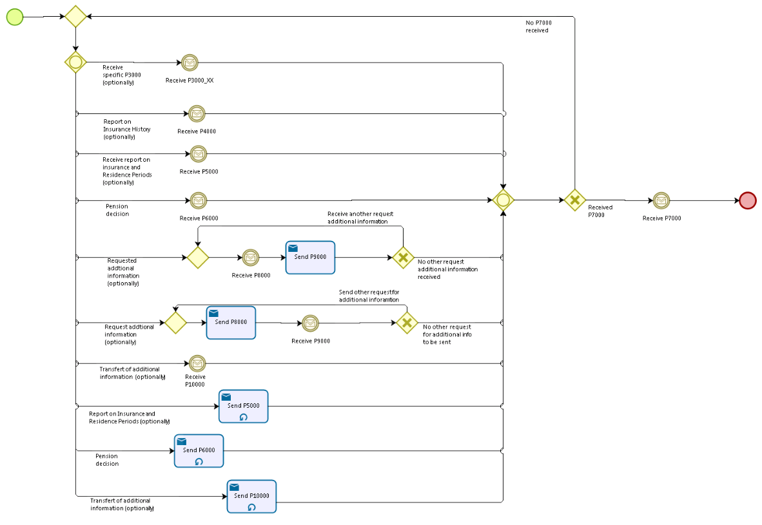

# Appendices

## Issues

|  |  |  |  |  |  |
| --- | --- | --- | --- | --- | --- |
| **#** | **Issue date** | **Description** | **Replies** | **Action/Resolution** | **Close date** |
| 1 |  |  |  |  |  |
| 2 |  |  |  |  |  |
| 3 |  |  |  |  |  |
| 4 |  |  |  |  |  |