How do I notify a change of applicable legislation?
H_BUC_03a_Subprocess: Change of Legislation Applicable, Notification
The Horizontal sub-process 'Change of Legislation Applicable, Notification' is used to notify the change of legislation applicable described in Article 20 (2) of Implementing Regulation (EC) No 987/2009, within an existing sectorial case. It can be used to notify the institution in the former Member State on the date when the new Member State’s legislation became applicable to the person concerned.

Legal base:
SED | Implementing Regulation 987/2009
 | 20 (2) | 2(2)
H010 Notification of Change of Legislation Applicable

Glossary of relevant terms used in H_BUC_03a_Subprocess:
Actor name | Description
Triggering Participant | The Triggering Participant (you) is an active participant in the main process who triggers this BUC. This will be an Institution where the main process permits their role to do so
Other Participant(s) | Other Participant(s) represents all other active participants in the main process. This will be one or more Institutions as determined by the main process.

Steps:
To notify this information, send a ‘Notification of Change of Legislation applicable’ SED H010 to Other Participant(s). In general, you will not receive a specific reply to your H010, the use case ends here.

Special Requirements:
- H010 must be sent to all Participants

Business process:
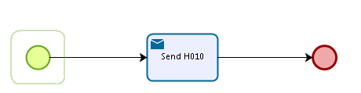

Administrative sub-processes available to the Triggering Participant:
I have sent H010 and I want to invalidate it (AD_BUC_06).
I have sent H010 and I want to update the information contained in it (AD_BUC_10).

Sub-processes 'Invalidate' and 'Update' can be used more than once by the Triggering Participant.

