How do I claim a Reimbursement of Administrative check or Medical Information?
H_BUC_04_Subprocess: Reimbursement of Administrative check or Medical Information
The Horizontal sub-process 'Reimbursement of Administrative check or Medical Information' might be used only after administrative checks/ medical information have been requested, confirmed and provided within a sector case. It can be used to claim a reimbursement for Administrative Check or Medical Information.

Legal base:
SED | Implementing Regulation (987/2009)
 | 87
H020 Claim for Reimbursement - Administrative Check /Medical Information
H021 Reply to Claim for Reimbursement – Administrative check/Medical Information

Glossary of relevant terms used in H_BUC_04_Subprocess:
Actor name | Description
Triggering Participant | The Triggering Participant (you) is an active participant in the main process who triggers this BUC. This will be an Institution where the main process permits their role to do so
Other Participant(s) | Other Participant(s) represents all other active participants in the main process. This will be one or more Institutions as determined by the main process.

Steps:
You have to fill in a 'Claim for Reimbursement – Administrative check/Medical Information' SED H020 and send it, including any attachments, to Other Participant(s). The Other Participant(s) review H020 and the possible attachments and each send back a 'Reply to Claim for Reimbursement – Administrative check/Medical Information' SED H021. You receive H021, verify its content and take note of the fact that the total requested amount was approved. The use case ends here.

Business process:
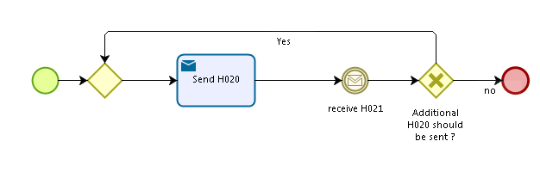
Administrative sub-processes available to the Triggering Participant and Other Participant(s):

I want to Update information contained in a sent SED (AD_BUC_10)
Sub-process 'Update' can be used more than once by the Triggering Participant and Other Participant(s).

