How do I transfer a claim, document or information to an institution in another Member State which is competent to process it?
H_BUC_06_Subprocess: Transfer of Claim/Document/Information
The Horizontal sub-process 'Transfer of Claim/Document/Information' is used to transfer a claim, a document or any relevant information to the institution in the member state which is competent to process a claim under the Implementing Regulation No 987/2009 within an existing sectorial case in situation when this either was submitted mistakenly by a person to the wrong institution, or the data were submitted to the liaison body. The SED H065 contains a specific set of data, with which a claim, document or other information which has mistakenly been provided to the wrong institution by a person, is transmitted.
Legal base:

 | Implementing Regulation 987/2009
SED | Article 2 (3) (4)
H065 Transmission of claim/document/information
H066 Reply to transmission of claim/document/information
Glossary of relevant terms used in H_BUC_06_Subprocess:
Actor name | Description
Triggering Participant | The Triggering Participant is an active participant in the main process who triggers this BUC. This will be an Institution where the main process permits their role to do so
Other Participant(s) | Other Participant(s) represents all other active participants in the main process. This will be one or more Institutions as determined by the main process.
Steps:
You have to send a ‘Transmission of Claim/document/information’ SED H065 by entering all the required information to Other Participant(s), namely the institution/s identified as the competent institution/s by the Triggering Participant. The Other Participant(s) receive the H065 after which the decision process is taken and answer with a ‘Reply to transmission of the claim/document/information’ SED H066 by entering a decision on the transmission. The H066 is sent back to you and to all other active Participants in the main process, you receive it and the case ends here.
Special Requirements:
- H065 and H066 can be sent only once. If you need to change or add to the information that you provided, you can use the possibility to update the information provided in your initial H065 or H066.
- Other Participant(s) can send only one H066 in reply to your H065.
Business process:
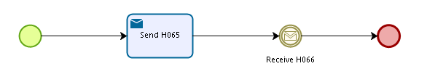

Administrative sub-processes available to the Triggering Participant and the Other Participant(s):
I want to invalidate a sent SED (AD_BUC_06).
I want to update the information contained in a sent SED (AD_BUC_10).
Sub-process 'Invalidate' can be used only once by the Triggering Participant and Other Participant(s).
Sub-process 'Update' can be used more than once by the Triggering Participant and Other Participant(s).

