How do I request necessary medical information from an institution in another Member State?
H_BUC_08_Subprocess: Medical Information
The Horizontal sub-process 'Medical Information' allows for the exchange of medical data especially Medical Reports prepared by doctors of the Member State where the person resides/stays.

Legal base:
SED | Implementing Regulation (987/2009) |  |  |  |  |  | Basic Regulation (883/2004)
 | 2(2) | 27(5)(6)(10) | 28(3)(5) | 33(1) | 34(4) | 87(1)(2)(4) | 21 | 34 | 36(3) | 82
H120 Request for Medical Information
H121 Reply/Notification for Medical Information

Glossary of relevant terms used in H_BUC_08_Subprocess:
Actor name | Description
Triggering Participant | The Triggering Participant (you) is a Competent Institution who requires a Medical information for the purposes of checking a right/entitlement under the provision of the Regulations
Other Participant(s) | Other Participant is an Institution (usually the MS of Residence/Stay) that is requested to carry out a medical examination of a person or to provide medical information.

Steps:
If you need to request such information, you have to fill out a ‘Request for Medical Information’ SED H120 by entering all the necessary information about the required Medical Information. In case of a request for a medical report, please specify the type of report you would like (basic report, detailed report, etc.) and send the H120, including any attachments, to the Other Participant(s) in the state where the person resides/stays. The Other Participant(s) undertakes any national arrangement to have the person medically examined or find out the medical information requested and afterwards fills out and sends a ‘Reply/Notification for Medical Information’ SED H121 with all the required administrative information about the medical examination, if it has taken place, and might attach the Medical Report (short or detailed). The Use case ends here.
Business process:
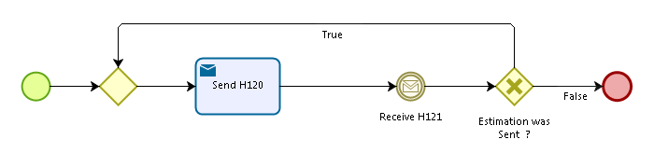
Administrative sub-processes available to the Triggering Participant or Other Participant(s):
I want to invalidate a sent SED (AD_BUC_06).
I want to update the information contained in a sent SED (AD_BUC_10).
Sub-process 'Invalidate' can be used only once by the Triggering Participant and Other Participant(s).
Sub-process 'Update' can be used more than once by the Triggering Participant and Other Participant(s).

