How do I provide medical information to an institution in another Member State?
H_BUC_09_Subprocess: Notification of Medical Information
The Horizontal sub-process 'Notification of Medical Information' allows for the notification of medical information (Medical Report) prepared by the doctors of the Member State where the person resides.

Legal base:

SED | Basic Regulation (883/2004) | Implementing Regulation (987/2009)
 | 82 | 87 | 34(2)(4) | 26
H121 Reply/Notification for Medical Information

Glossary of relevant terms used in H_BUC_09_Subprocess:
Actor name | Description
Triggering Participant | The Triggering Participant (you) is an Institution who sends Medical Information for the purposes of checking a right/entitlement under the provision of the Regulations
Other Participant(s) | Other Participant is an Institution who receives the medical information.

Steps:
If you want to transmit such information, you have to send a ‘Reply/Notification for Medical Information’ SED H121, including any attachments, to the Other Participant(s). The Other Participant(s) will process this information locally and undertake any national consideration the receipt of the new Medical Information may generate. In general, you will not receive a specific reply to your H121 and the use case ends here.

Special Requirements:
- H121 is sent to all Active Participants

Business process:

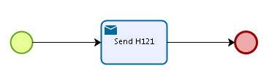
Administrative sub-processes available to the Triggering Participant:
I want to invalidate a sent SED (AD_BUC_06).
I want to update the information contained in a sent SED (AD_BUC_10).

Sub-process 'Invalidate' can be used only once by the Triggering Participant.
Sub-process 'Update' can be used more than once by the Triggering Participant.

