BIZAGI Extended Attributes used in EESSI
Extended attributes are included to support the automation of the generation of the transactions needed in EESSI.
Three levels are used:
- On Diagram level
- On Pool level
- On Send task level

On Diagram Level
The properties on Diagram level in BIZAGI will show the following Extended Attributes:
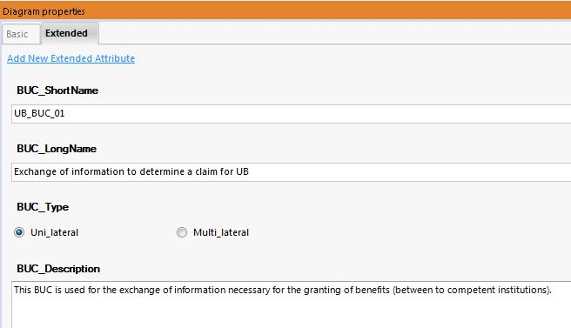

On Pool Level
The properties on Pool level in BIZAGI will show the following Extended Attributes:
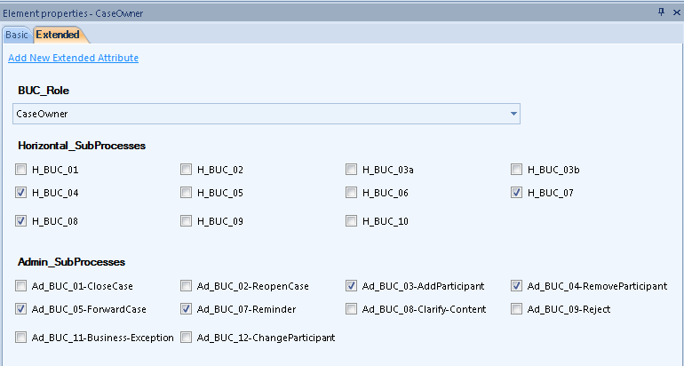

On Send task Level
The properties on Send task level in BIZAGI will show the following Extended Attributes:
