

Annex Nr.10 to the note AC 370/16rev

EESSI

P_BUC_07



*Request for Pension Amounts to Determine Supplements*



# Table of Contents

Table of Contents 2

1. Introduction 6

1.1. Purpose 6

1.2. Scope 6

1.3. Definitions, Acronyms and Abbreviations 6

1.4. References 7

1.5. Overview 7

2. Description 8

2.1. Detailed Description 8

2.2. Legal Base 8

3. Actors & Roles 9

4. Use Case 10

4.1. RUP Table Representation 10

4.2 Request – Reply SEDs 13

4.3. Attachments Allowed 14

4.4. Artefacts used 14

5. Business Processes 15

5.1 Case Owner and Counterparty 15

5.2 Sub Processes 16

6. Appendices 16

6.1. Issues 16

**Document Control Information**

|  |  |
| --- | --- |
| **Settings** | **Value** |
| **Document Title:** | **Business Use Case**  **P_BUC_07 - Request for Pension Amounts to Determine Supplements** |
| **Project Title:** | **EESSI (Electronic Exchange of Social Security Information) Project** |
| **Document Author:** | **European Commission, DG EMPL F5** |
| **Project Owner:** | **European Commission, DG EMPL D2** |
| **Doc. Version:** | **v4.1.0** |
| **Sensitivity:** | **Public** |
| **Date:** | **03/08/2018** |

**Document history:**

The Document Author is authorized to make the following types of changes to the document without requiring that the document be re-approved:

* Editorial, formatting, and spelling
* Clarification

To request a change to this document, contact the Document Author or Owner.

|  |  |  |  |
| --- | --- | --- | --- |
| **Revision** | **Date** | **Created by** | **Short Description of Changes** |
| v0.01 | 01/05/15 | Phil Cummings | Initial Draft |
| v0.02 | 03/08/2015 | Phil Cummings | Incorporating comments from AHG:   * Reference to European Commissions Decision No. P1 II from 12.06.2009 * Removal of attachments to enhance auto processing possibilities. |
| v0.3.0 | 25/04/2016 | Cristina Ezaru | Minor corrections/updates in Document Control Information and Purpose.  Update the document template with new subchapters 4.2; 4.3; 4.4; 4.5 |
| v0.4.0 | 16/05/2016 | Cristina Ezaru | Incorporated feedback received from AHG, key alteration made:  1. BUC correct name updated in all document  2. Branch3 updated: adding participants should be able to any participant (within their own MS)  3. updated Attachments Allowed table  4. updated Sub-process table: AD_BUC_11 is used |
| v0.5.0 | 20/05/2016 | Cristina Ezaru | Branch 3 updated: Case owner can add participants in any MS, Counterparties can add participants in their own MS. |
| v0.99.0 | 23/05/2016 | Cristina Ezaru | Candidate for AC Approval as agreed by the Pension rapporteur. |
| v0.99.1 | 30/05/2016 | Cristina Ezaru | Minor formatting, date, version and grammar changes  Updated Use Case diagram. |
| v0.99.2 | 13/06/2016 | Cristina Ezaru | SR1-Notification of Death couldn`t be more than once  Added BPMN |
| v1.0.0 | 14/07/2016 | Phil Cummings | **AC Approved Version** |
| v1.0.1 | 26/06/2017 | Madalina Alecsandrescu | Last version BPMN section 5 |
| v1.0.2 | 11/08/2017 | Eric Briffoz | -Included the version of the BPMN diagram used in section 5.  -Correction in horizontal sub process table in section 4.5  - Removed Use Case diagram |
|  |  | Madalina Alecsandrescu | Align wording for Invalidate SED and Forward participant |
| v4.1.0 | 03/08/2018 | Madalina Alecsandrescu | - Section 4.4 merged 2 tables (for SED & for Subprocesses) into 1 BUC Artefact table."  - Version adaptations to release 4.1.0.  - Correction in wording in SR for [Branch1] and adding exception in SR for [Branch4] |

# Introduction

## Purpose

The purpose of this document is to construct an external view of, part of, the 'EESSI business system' as described in EC Regulations 883/2004 and 987/2009. The ‘EESSI Business System’ describes the business and expected business processes without consideration as to which part(s) may be realized by an IT System (i.e. the proposed EESSI IT System).

The external view comprises of models and descriptions of business use cases, the services of a business system offered to business actors: customers, business partners, or other business systems.

A business use case is described from an actor's perspective; it describes the interaction between an actor and the business system, meaning it describes the behaviours of the business system that the actor utilizes. The Business Use Case includes Use Case Diagrams and Business Process Models.

Use case diagrams show actors, business use cases, and their relationships. Use case diagrams do not describe procedures. Alternative scenarios also remain hidden. These diagrams give a good overview of the behaviours of the EESSI business system which will direct and govern part of the expected behaviours and functionality delivered by the EESSI IT System.

## Scope

This document is limited to the external view on the pension sector process of the Request for Pension Amounts to Determine Supplements. The different elements like use case description, actors, and business process as well as supporting UML diagrams and BPMN models pertaining to the Request for Pension Amounts to Determine Supplements

## Definitions, Acronyms and Abbreviations

Please see the EESSI Project Glossary

## References

|  |  |  |
| --- | --- | --- |
| **#** | **Description** |  |
| 1 | EC Regulation 883/2004 | Regulation EC No 883- 2004.pdf |
| 2 | EC Regulation 987/2009 | Regulation EC No 987-2009.pdf |
| 3 | UML 2.x | <http://www.omg.org/spec/UML/> |
| 4 | BPMN 2.0 | <http://www.omg.org/spec/BPMN/index.htm> |
| 5 | UML 2.0 In Action | Henriette Baumann, Patrick Grassle & Philippe Baumann, 2005, ISBN 1904811558 |
| 6 | RUP@EC standard 5.0 | <http://www.cc.cec/RUPatEC_Standard/> |
| 7 | RUP op maat | <http://www.rupopmaat.nl/> |

## Overview

Chapter 1 introduces the external view on the business system under review and lists the elements of this specification.

Chapter 2 introduces us to the Request for Pension Amounts to Determine Supplements business process. The chapter gives a short and detailed description as well as a reference to business process´ legal base.

Chapter 3 lists the actors involved in the Request for Pension Amounts to Determine Supplements business process.

Chapter 4 describes in detail Request for Pension Amounts to Determine Supplements business process based on the RUP use case template, as well as the relationship to other use cases.

Chapter 5 describes the Request for Pension Amounts to Determine Supplements business process using business process modelling notation (BPMN).

# Description

## Detailed Description

This Business Use Case describes a situation where an Institution wishes to establish the right to a supplement according to Art. 58 of Reg. 883/2004, and needs to obtain information on pension amounts which have been awarded by the other EU institutions.

It is usually used after the common pension claim procedure has been completed (P_BUC_01, P_BUC_02 or P_BUC_03), and the institutions concerned have (or have not) awarded pensions, if an institution finds it necessary to apply Art. 58 of Reg. 883/2004 and award a supplement, it needs to request for information on pension amounts from all the institutions concerned to allow them to properly determine the correct amount of any supplement that is due. The detailed procedure is defined in the European Commissions Decision No. P1 II from 12.06.2009.

## Legal Base

This document's legal base is found the Europeans Commissions Decision No. P1 II from 12.06.2009 and the following EC Regulation:

* basic Regulation (EC) No 883/2004

The following matrix derived from version 3 SEDs, documented by the expert AHGs, lists the SEDs used in this Business Use Case and their relation with the articles mentioned above.

|  |  |
| --- | --- |
| **SED** | **Basic Reg (883/04)** |
| **Art 58** |
| P11000 | **✓** |
| P12000 | **✓** |
| P13000 | **✓** |

Table 1: SED – Legal base relationship matrix

# Actors & Roles

This chapter captures details of the actors which are important to understanding the different types of system users. An actor is anyone or anything that exchanges data with the business system. An actor can be a user, external hardware, or another system.

The overarching description of each actor described in this Business Use Case can be found in the Glossary. Below you will find a short description which provides further clarity of this actor within the context of this Business Use Case.

|  |  |
| --- | --- |
| **Actor name** | **Description** |
| ***Case Owner*** | In this BUC the Case Owner is a Competent Institution who is institution of place of residence of the claimant |
| ***Counterparty*** | In this BUC the Counterparty(ies) are Competent Institutions that are competent to pay the citizen a pension. |
| ***Claimant*** | The Claimant is a citizen who has been awarded a Pension from one or more MS under the provision of the Regulations. |

Table 2: Actors & Roles

# Use Case

## RUP Table Representation

|  |  |  |  |  |
| --- | --- | --- | --- | --- |
| **Use Case ID:** | **P_BUC_07** | | | |
| **Use Case Name:** | **Request for Pension Amount to Determine Supplements** | | | |
| **Created By:** | Phil Cummings | | **Last Updated By:** | Cristina Ezaru |
| **Date Created:** | 16/06/2015 | | **Last Revision Date:** | 13/06/2016 |
| **Actors:** | | Case Owner  Counterparty | | |
| **Description:** | | This Business Use Case describes a situation where an Institution wishes to establish the right to a supplement according to Art. 58 of Reg. 883/2004 and Decision no. P1 II, and needs to obtain information on pensions which have been awarded by the other EU institutions.    It is usually used after the common pension claim procedure has been completed (P_BUC_01, P_BUC_02 or P_BUC_03), and the institutions concerned have (or have not) awarded pensions, if an institution finds it necessary to apply Art. 58 of Reg. 883/2004 and award a supplement, it needs to request for information on pension amounts from all the institutions concerned to allow them to properly determine the correct amount of any supplement that is due. | | |
| **Trigger:** | | An institution requires specific information to determine the right to a supplement | | |
| **Preconditions:** | | none | | |
| **Post conditions:** | | The Case Owner has received the information they require to determine the right to a supplement.  The Counterparty(ies) are informed of the amount of the supplement being paid by the Case Owner where they have requested it. | | |
| **Main Scenario:** | | **Identify Participants**   1. The Case Owner identifies the Member State(s) that they require the information from; 2. The Case Owner then identifies the correct institution or institutions (the Counterparty(ies)) in each Member State that are responsible for providing the Pensions Information they need. There will be one Counterparty or more. The Case Owner and the Counterparty(ies) are herein collectively referred to as the Participants;   **Send Request for Pension Amounts to Determine Supplements**   1. The Case Owner fills in a Request for Additional Information (P11000) to request the Pension Amounts; 2. The Case Owner sends the P11000 to all participants.   **Provide Pension Amounts**   1. Each Counterparty who received a P11000 gathers the information about Pension Amounts and fills in Information about Pension Amounts (P12000). When completing the P12000 each Counterparty will state at P12000 Part 6.1 "Please send us P13000" whether they require P13000. 2. Each Counterparty who filled in the P12000 sends the P12000 to the Case Owner.   **Provide Supplement Details**   1. Where at [step 5] one or more Counterparties requested P13000 (at P12000 Part 6.1 "Please send us P13000" = "Yes") then the Case Owner fills in Information about supplements (P13000); 2. The Case Owner sends the P13000 to the Counterparty(ies) that requested it (at P12000 Part 6.1 "Please send us P13000" = "Yes").   **This Business Use Case Ends** | | |
| **Alternative Scenarios** | | ***The Following Branches determine the use of Horizontally Defined Sub Processes within this Business Process*** | | |
| 1. ***at any step after [step 4] any Participant may optionally choose notify another Participant of the Death of a Person*** 2. The Participant executes business use case ***H_BUC_07*_Subprocess *– Notification of Death;*** 3. [This Branch] Ends | | |
| ***The Following Branches Determine the use of Administrative Sub Processes within this Business Process*** | | |
| 1. ***at any step after [step 4] the Case Owner may choose to Remove a Counterparty from this Business Process*** 2. The Case Owner executes business use case***AD_BUC_04*_Subprocess *– Remove Participant;*** 3. [This Branch] Ends | | |
| 1. ***at any step after [step 4] any Participant may choose to Add new participants to this Business Process.*** ***Case owner should be able to add participants in any MS, Counterparties should be able to add participants in their own MS.*** 2. The Participant executes business use case ***AD_BUC_03*_Subprocess *– Add Participant;*** 3. [This Branch] Ends | | |
| 1. ***at any step after [step 4] any Participant may choose to Forward this Business Process to another Competent Institution within their MS who assumes responsibility for handling it*** 2. The Participant executes business use case ***AD_BUC_05*_Subprocess *– Forward Case;*** 3. [This Branch] Ends | | |
| 1. ***at any step after [step 4] the Case Owner may choose to advise all recipients of their P11000 that it is Invalid under Art 5 of 987/09*** 2. The Participant executes business use case ***AD_BUC_06*_Subprocess *- Invalidate_SED;*** 3. Optionally, the Case Owner fills in a Request for Additional Information (P11000) to request the Pension Amounts; 4. Optionally, the Case Owner sends the P11000 to all participants. 5. [This Branch] Ends | | |
| 1. ***at any step after [step 6] a Counterparty may choose to advise all recipients of their P12000 that it is Invalid under Art 5 of 987/09*** 2. The Participant executes business use case ***AD_BUC_06*_Subprocess *- Invalidate_SED;*** 3. The Counterparty gathers the information about Pension Amounts and fills in Information about Pension Amounts (P12000). When completing the P12000 each Counterparty will state at P12000 Part 6.1 "Please send us P13000" whether they require P13000. 4. Each Counterparty who filled in the P12000 sends the P12000 to the Case Owner. 5. [This Branch] Ends | | |
| 1. ***at any step after [step 8] the Case Owner may choose to advise all recipients of their P13000 that it is Invalid under Art 5 of 987/09*** 2. The Participant executes business use case ***AD_BUC_06*_Subprocess *- Invalidate_SED;*** 3. Optionally, the Case Owner fills in a Information about supplements (P13000) to request the Pension Amounts; 4. Optionally, the Case Owner sends the P13000 to all participants. 5. [This Branch] Ends | | |
| 1. ***at any step after [step 4] the Case Owner may choose to send an updated version of P11000*** 2. The Case Owner executes business use case ***AD_BUC_10*_Subprocess *- Update_SED;*** 3. [This Branch] Ends | | |
| 1. ***at any step after [step 6] the Counterparty may choose to send an updated version of their P12000*** 2. The Counterparty executes business use case ***AD_BUC_10*_Subprocess *- Update_SED;*** 3. [This Branch] Ends | | |
| 1. ***at any step after [step 8] the Case Owner may choose to send an updated version of P13000*** 2. The Case Owner executes business use case ***AD_BUC_10*_Subprocess *- Update_SED;*** 3. [This Branch] Ends | | |
| 1. ***at any step after [step 4] any Participant may optionally choose to send a Reminder to another Participant for the return of information they were expecting from that participant but did not receive.*** 2. The Participant who invokes this branch executes business use case ***AD_BUC_07*_Subprocess *-*_*Reminder;*** 3. [This Branch] Ends | | |
| **Exceptions:** | | ***Exception 1: [Removed]*** | | |
| **Includes:** | | See diagram at part 4.2 | | |
| **Special Requirements:** | | **SR1**: Rules about the invoking of Branches:  Horizontal  [Branch 1]– May be invoked once, per Participant  Administrative  [Branch 2] to [Branch 11] – May be invoked more than once, per Participant, exception [Branch 4] – May be invoked only once, per Participant.  **SR3**: Rules about the destination for each SED Type when the SED is sent:  P11000 – Defines and is sent to all Active Participants  P12000 – Must be sent to the Case Owner  P13000 – Must be Sent to only those Counterparties that requested it  **SR4**: The term "Send/Sent to All Active Participants" does not include sending it himself (i.e. to the senders institution)  **SR5**: Active Participants are defined as those participants identified at [**Step 2**] and those participants added through the execution of [**Branch 3**] and/or [**Branch 4**] and not removed through the execution of [**Branch 2**] and/or [**Branch 4**]  **SR6**: Alternative Branches 1 – 11 are non-interrupting Branches; | | |
| **Assumptions:** | |  | | |
| **Notes and Issues:** | |  | | |

## 4.2 Request – Reply SEDs

The following table specifies the SED that have a logical pairing to one another, usually this is known as a request-reply pair.

| REQUEST SED | REPLY SED(s) |
| --- | --- |
| P11000 | P12000 |
| P12000 | P13000 |



## Attachments Allowed

The following table specifies whether attachments are permitted to be included when sending a SED type.

| SED | Attachments |
| --- | --- |
| P11000 | Not allowed |
| P12000 | Not allowed |
| P13000 | Not allowed |

* 1. **Artefacts used**

The following table specifies the artefacts that are used in this Business Use Case.

| Artefact name | Artefact type |
| --- | --- |
| P11000 | SED |
| P12000 | SED |
| P13000 | SED |
| H_BUC_07_Subprocess | BUC |
| AD_BUC_03_Subprocess – Add Participant | BUC |
| AD_BUC_04_Subprocess – Remove Participant | BUC |
| AD_BUC_05_Subprocess – Forward Case | BUC |
| AD_BUC_06_Subprocess – Invalidate SED | BUC |
| AD_BUC_07_Subprocess – Reminder | BUC |
| AD_BUC_10_Subprocess – Update SED | BUC |
| AD_BUC_11_Subprocess – Business Exception | BUC |
| AD_BUC_12_Subprocess – Change of Participant | BUC |

# Business Processes

The following paragraphs describe the Business Use Case Request for Pension Amounts to Determine Supplements.

## 5.1 Case Owner and Counterparty

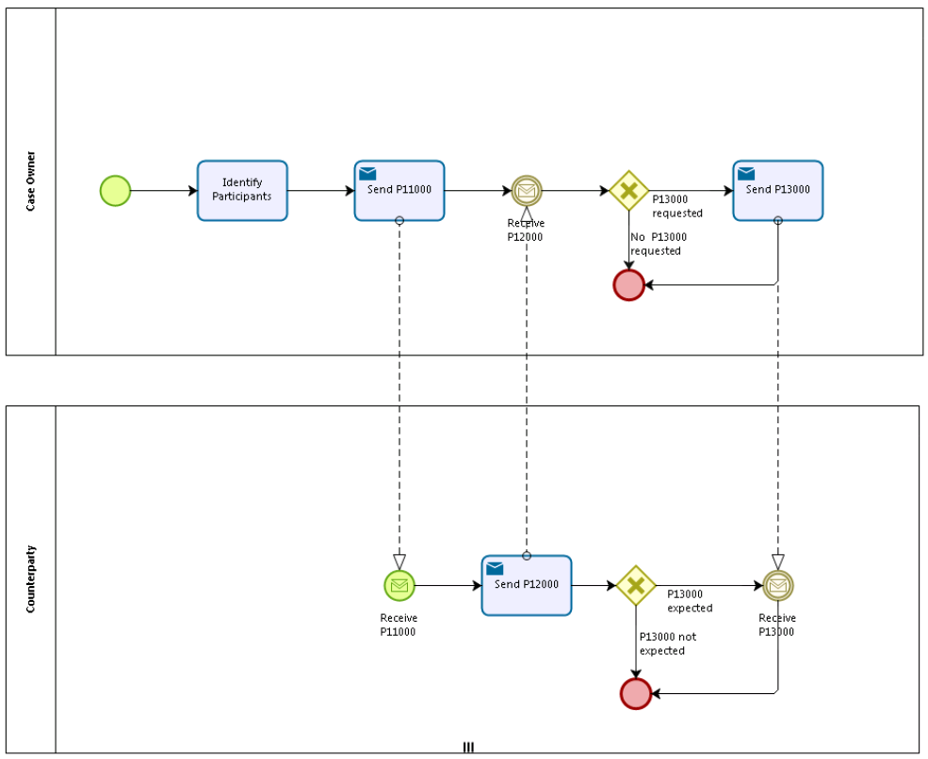

## 5.2 Sub Processes

n/a

# Appendices

## Issues

|  |  |  |  |  |  |
| --- | --- | --- | --- | --- | --- |
| **#** | **Issue date** | **Description** | **Replies** | **Action/Resolution** | **Close date** |
| 1 |  |  |  |  |  |
| 2 |  |  |  |  |  |
| 3 |  |  |  |  |  |
| 4 |  |  |  |  |  |