

EESSI Business Use Case

*P_BUC_08*

*Information on pension amount to award a pension supplement*





# Table of Contents

Table of Contents 2

1. Introduction 6

1.1. Purpose 6

1.2. Scope 6

1.3. Definitions, Acronyms and Abbreviations 6

1.4. References 7

1.5. Overview 7

2. Description 8

2.1. Business Scenario 8

2.2. Legal Base 8

3. Actors & Roles 9

4. Use Case 10

4.1. RUP Table Representation 10

4.2. Request – Reply SEDs 13

4.3. Attachments Allowed 13

4.4. Artefacts used 13

5. Business Processes 15

5.1. Case Owner and Counterparty 15

5.2. Sub Processes 15

6. Appendices 15

6.1. Issues 15

**Document Control Information**

|  |  |
| --- | --- |
| **Settings** | **Value** |
| **Document Title:** | **Business Use Case**  **P_BUC_08 – Information on pension amount to award a pension supplement** |
| **Project Title:** | **EESSI (Electronic Exchange of Social Security Information) Project** |
| **Document Author:** | **European Commission, DG EMPL F5** |
| **System Owner:** | **European Commission, DG EMPL D2** |
| **Doc. Version:** | **v4.1.0** |
| **Sensitivity:** | **Public** |
| **Date:** | **03/08/2018** |

**Document history:**

The Document Author is authorised to make the following types of changes to the document without requiring that the document be re-approved:

* Editorial, formatting, and spelling
* Clarification

To request a change to this document, contact the Document Author or Owner.

|  |  |  |  |
| --- | --- | --- | --- |
| **Revision** | **Date** | **Created by** | **Short Description of Changes** |
| v0.1.0. | 18/04/2016 | Cristina Ezaru | First Draft |
| v0.2.0 | 06/06/2016 | Cristina Ezaru | Incorporated review received from AHG:  1. BUC correct name updated in all document  2. Rewording in Main Scenario->Send Request for Pension Supplement  3. Branch3 updated: adding participants should be able to any participant (within their own MS) *– Proposal to remove branch3- not yet updated*  4. Branch 7 removed  5. Corrections/updates in Description  6. Updated Actors&Roles  7. Corrections/updates in Main Scenario, Post conditions  8. Updated Branch 5: Case Owner is responsible for this scenario  9. Updated Branch 6: Counterparty is responsible for this scenario  10. Branch 9 updated: Case Owner is responsible for this scenario |
| v0.3.0 | 06/07/2016 | Cristina Ezaru | Alignment to the standard description and layout of the BUC. |
| v0.4.0 | 14/07/2016 | Cristina Ezaru | Incorporated review received during the AHG meeting (13/07/2016)  1. Branch3 is kept in process  2. Branch2 updated: removing participants should be able to any participant (within their own MS)  3. updated Sub-process table: AD_BUC_03 and AD_BUC_04 are used |
| v0.5.0 | 05/10/2016 | Cristina Ezaru | Incorporated review received during the AHG meeting (29/09/2016)  1. Main Scenario: step 2 – allow more participants – "There will be one Counterparty or more."  2. Branch8 updated: step 1 – "The Case Owner executes business use case"  3. Branch9 updated: the correct SED is P13000 – "send an updated version of P13000"  4. updated Sub-process table: AD_BUC_03 and AD_BUC_04 are used  5. Rewording Main Scenario: removed reference to "Part 6.1" |
| v0.6.0 | 11/11/2016 | Cristina Ezaru | Incorporated review received from AC:  1. Branch5, Branch6, Branch8 – steps reference updated  2. Rewording Business Scenario  3. Attachments Table updated  4. Minor formatting and grammar changes. |
| v0.99.0 | 11/11/2016 | Cristina Ezaru | Candidate for AC Approval |
| v1.0.0 | 14/12/2016 | Cristina Ezaru | **AC Approved version** |
| v1.0.1 | 26/06/2017 | Madalina Alecsandrescu | Last version BPMN section 5 |
| v1.0.2 | 11/08/2017 | Eric Briffoz | - Included the version of the BPMN diagram used in section 5.  - Removed Use Case diagram |
|  |  | Madalina Alecsandrescu | Align wording for Invalidate SED and Forward participant |
| v4.1.0 | 03/08/2018 | Madalina Alecsandrescu | - Section 4.4 merged 2 tables (for SED & for Subprocesses) into 1 BUC Artefact table."  - Version adaptations to release 4.1.0.  - Correction in wording in SR for [Branch 1], add exception in SR for [Branch 4] |

# Introduction

## Purpose

The purpose of this document is to construct an external view of, part of, the 'EESSI business system' as described in EC Regulations 883/2004 and 987/2009. The ‘EESSI Business System’ describes the business and expected business processes without consideration as to which part(s) may be realised by an IT System (i.e. the proposed EESSI IT System).

The external view comprises of models and descriptions of business use cases, the services of a business system offered to business actors: customers, business partners, or other business systems.

A business use case is described from an actor's perspective; it describes the interaction between an actor and the business system, meaning it describes the behaviours of the business system that the actor utilises. The Business Use Case includes Use Case Diagrams and Business Process Models.

Use case diagrams show actors, business use cases, and their relationships. Use case diagrams do not describe procedures. Alternative scenarios also remain hidden. These diagrams give a good overview of the behaviours of the EESSI business system which will direct and govern part of the expected behaviours and functionality delivered by the EESSI IT System.

## Scope

This document is limited to the external view on the pension sector process of the Information on pension amount to award a pension supplement. The different elements like use case description, actors, and business process as well as supporting UML diagrams and BPMN models pertaining to the Information on pension amount to award a pension supplement.

## Definitions, Acronyms and Abbreviations

Please see the EESSI Project Glossary [here](https://webgate.ec.europa.eu/CITnet/confluence/display/EESSI/Project+Information+for+Stakeholders)

## References

|  |  |  |
| --- | --- | --- |
| **#** | **Description** |  |
| 1 | EC Regulation 883/2004 | Regulation EC No 883- 2004.pdf |
| 2 | EC Regulation 987/2009 | Regulation EC No 987-2009.pdf |
| 3 | UML 2.x | <http://www.omg.org/spec/UML/> |
| 4 | BPMN 2.0 | <http://www.omg.org/spec/BPMN/index.htm> |
| 5 | UML 2.0 In Action | Henriette Baumann, Patrick Grassle & Philippe Baumann, 2005, ISBN 1904811558 |
| 6 | RUP@EC standard 5.0 | <http://www.cc.cec/RUPatEC_Standard/> |
| 7 | RUP op maat | <http://www.rupopmaat.nl/> |

## Overview

Chapter 1 introduces the external view on the business system under review and lists the elements of this specification.

Chapter 2 introduces us to the Information on pension amount to award a pension supplement business process. The chapter gives a short and detailed description as well as a reference to business process´ legal base.

Chapter 3 lists the actors involved in the Information on pension amount to award a pension supplement business process.

Chapter 4 describes in detail Information on pension amount to award a pension supplement business process based on the RUP use case template, as well as the relationship to other use cases.

Chapter 5 describes the Information on pension amount to award a pension supplement business process using business process modelling notation (BPMN).

# Description

## Business Scenario

This Business Use Case describes a situation where an Institution sends information about the payment of pension to the institution in the country of residence that has granted a supplement according to Art.58 of Reg. 883/2004. If requested, information about the amount of the supplement has to be sent back to the institution that pays the pension.

## Legal Base

This Business Use Case document's legal base is described in the following Regulations:

* basic Regulation (EC) No 883/2004

The following matrix specifies the SEDs that are used in this Business Use Case and documents the articles that provide the legal basis for each SED.

|  |  |
| --- | --- |
|  | **Basic Reg (883/04)** |
| **Art 58** |
| P12000 | **✓** |
| P13000 | **✓** |

Table 1: SED – Legal base relationship matrix

# Actors & Roles

This chapter captures details of the actors which are important to understanding the different types of system users. An actor is anyone or anything that exchanges data with the business system. An actor can be a user, external hardware, or another system.

The overarching description of each actor described in this Business Use Case can be found in the Glossary. Below you will find a short description which provides further clarity of this actor within the context of this Business Use Case.

|  |  |
| --- | --- |
| **Actor name** | **Description** |
| **Case Owner** | In this BUC the Case Owner is a Competent Institution that pays the pension. |
| **Counterparty** | In this BUC the Counterparty is the Competent Institution that pays the supplement. |

# Use Case

## RUP Table Representation

|  |  |  |  |  |
| --- | --- | --- | --- | --- |
| **Use Case ID:** | **P_BUC_08** | | | |
| **Use Case Name:** | **Information on pension amount to award a pension supplement** | | | |
| **Created By:** | Cristina Ezaru | | **Last Updated By:** | Cristina Ezaru |
| **Date Created:** | 18/04/2016 | | **Last Revision Date:** | 11/11/2016 |
| **Actors:** | | Case Owner  Counterparty | | |
| **Description:** | | This Business Use Case describes a situation where an Institution sends information about the payment of pension to the institution in the country of residence that has granted a supplement according to Art.58 of Reg. 883/2004. If requested, information about the amount of the supplement has to be sent back to the institution that pays the pension. | | |
| **Trigger:** | | An institution is aware (because of an earlier communication in P_BUC_07 – Request for Pension Amounts to Determine Supplements), that another institution pays the supplement, and sends information about adjusted or changed pension amounts. | | |
| **Preconditions:** | | An award of Pension (Old-age, Survivors or Invalidity) has been made. | | |
| **Post conditions:** | | The counterparty has received the information they require to determine the right to a supplement.  The Case Owner is informed of the amount of the supplement being paid by the counterparty when they have requested it. | | |
| **Main Scenario:** | | **Identify Participants**   1. The Case Owner identifies the Member State that they need to send information to; 2. The Case Owner then identifies the correct institution (the Counterparty) in another Member State that is responsible for paying the supplement. There will be one Counterparty or more. The Case Owner and the Counterparty are herein collectively referred to as the Participants;   **Send Request for information on Pension Supplement**   1. The Case Owner fills in a Information on pension amount (P12000) and states at field "Please send us P13000" whether they require P13000 2. The Case Owner sends the P12000 to Counterparty.   **Provide Information on Pension Supplement**   1. Where at [step 3] the Case Owner requested P13000 (at P12000, where "Please send us P13000" = "Yes") then the Counterparty fills in Information about supplements (P13000); 2. Counterparty sends the P13000 to the Case Owner. 3. The use case ends here | | |
| **Alternative Scenarios** | |  | | |
| ***The Following Branches determine the use of Horizontally Defined Sub Processes within this Business Process*** | | |
| 1. ***at any step after [step 4] any Participant may optionally choose notify another Participant of the Death of a Person*** 2. The Participant executes business use case ***H_BUC_07*_Subprocess *– Notification of Death;*** 3. [This Branch] Ends | | |
| ***The Following Branches Determine the use of Administrative Sub Processes within this Business Process*** | | |
| 1. ***at any step after [step 4] any Participant may choose to Remove participants from this Business Process. Case owner should be able to remove participants in any MS, Counterparties should be able to remove participants in their own MS.*** 2. The Participant executes business use case***AD_BUC_04*_Subprocess *– Remove Participant;*** 3. [This Branch] Ends | | |
| 1. ***at any step after [step 4] any Participant may choose to Add new participants to this Business Process.*** ***Case owner should be able to add participants in any MS, Counterparties should be able to add participants in their own MS.*** 2. The Participant executes business use case ***AD_BUC_03*_Subprocess *– Add Participant;*** 3. [This Branch] Ends | | |
| 1. ***at any step after [step 4] any Participant may choose to Forward this Business Process to another Competent Institution within their MS who assumes responsibility for handling it*** 2. The Participant executes business use case ***AD_BUC_05*_Subprocess *– Forward Case;*** 3. [This Branch] Ends | | |
| 1. ***at any step after [step 4] a Case Owner may choose to advise the Counterparty that their P12000 that it is Invalid under Art 5 of 987/09*** 2. The Case Owner executes business use case ***AD_BUC_06*_Subprocess *- Invalidate_SED;*** 3. Optionally, the Case Owner fills in P12000, by entering all the required data; 4. Optionally, the Case Owner sends the P12000, including any attachments, to all counterparties; 5. [This Branch] Ends | | |
| 1. ***at any step after [step 6] the Counterparty may choose to advise all recipients of their P13000 that it is Invalid under Art 5 of 987/09*** 2. The Counterparty executes business use case ***AD_BUC_06*_Subprocess *- Invalidate_SED;*** 3. Optionally, the Counterparty fills in P13000, by entering all the required data; 4. Optionally, the Counterparty sends the P13000, including any attachments, to all counterparties; 5. [This Branch] Ends | | |
| 1. ***removed*** | | |
| 1. ***at any step after [step 4] the Case Owner may choose to send an updated version of their P12000***      1. The Case Owner executes business use case ***AD_BUC_10*_Subprocess *- Update_SED;*** 2. [This Branch] Ends | | |
| 1. ***at any step after [step 6] the Counterparty may choose to send an updated version of P13000*** 2. The Counterparty executes business use case ***AD_BUC_10*_Subprocess *- Update_SED;*** 3. [This Branch] Ends | | |
| 1. ***at any step after [step 4] Case Owner may optionally choose to send a Reminder to the Counterparty for the return of information they were expecting from that Counterparty but did not receive.*** 2. The Case Owner who invokes this branch executes business use case ***AD_BUC_07*_Subprocess *-*_*Reminder;*** 3. [This Branch] Ends | | |
| **Exceptions:** | | None | | |
| **Includes:** | | See diagram at part 4.4 | | |
| **Special Requirements:** | | **SR1**: Rules about the invoking of Branches:  Horizontal  [Branch 1]– May be invoked only once, per Participant.  Administrative  [Branch 2] to [Branch 10] – May be invoked more than once, per Participant, exception [Branch 4] – May be invoked only once, per Participant.  **SR3**: Rules about the destination for each SED Type when the SED is sent:  P12000 – Defines and is sent to all Active Participants  P13000 – Must be sent to the Case Owner  **SR4**: The term "Send/Sent to All Active Participants" does not include sending it himself (i.e. to the senders institution)  **SR5**: Active Participants are defined as those participants identified at [**Step 2**] and those participants added through the execution of [**Branch 3**] and/or [**Branch 4**] and not removed through the execution of [**Branch 2**] and/or [**Branch 4**]  **SR6**: Alternative Branches 1 – 10 are non-interrupting Branches; | | |
| **Assumptions:** | |  | | |
| **Notes and Issues:** | |  | | |

## Request – Reply SEDs

The following table specifies the SED that have a logical pairing to one another, usually this is known as a request-reply pair.

| REQUEST SED | REPLY SED(s) |
| --- | --- |
| P12000 | P13000 |

## Attachments Allowed

The following table specifies whether attachments are permitted to be included when sending a SED type.

| SED | Attachments |
| --- | --- |
| P12000 | Not Allowed |
| P13000 | Not Allowed |

## Artefacts used

The following table specifies the artefacts that are used in this Business Use Case.

| Artefact name | Artefact type |
| --- | --- |
| P12000 | SED |
| P13000 | SED |
| H_BUC_07_Subprocess | BUC |
| AD_BUC_03_Subprocess – Add Participant | BUC |
| AD_BUC_04_Subprocess – Remove Participant | BUC |
| AD_BUC_05_Subprocess – Forward Case | BUC |
| AD_BUC_06_Subprocess – Invalidate SED | BUC |
| AD_BUC_07_Subprocess – Reminder | BUC |
| AD_BUC_10_Subprocess – Update SED | BUC |
| AD_BUC_11_Subprocess – Business Exception | BUC |
| AD_BUC_12_Subprocess – Change of Participant | BUC |

# Business Processes

This chapter describes the Business Use Case Information on Pension Amount to award a Pension Supplement.

## Case Owner and Counterparty

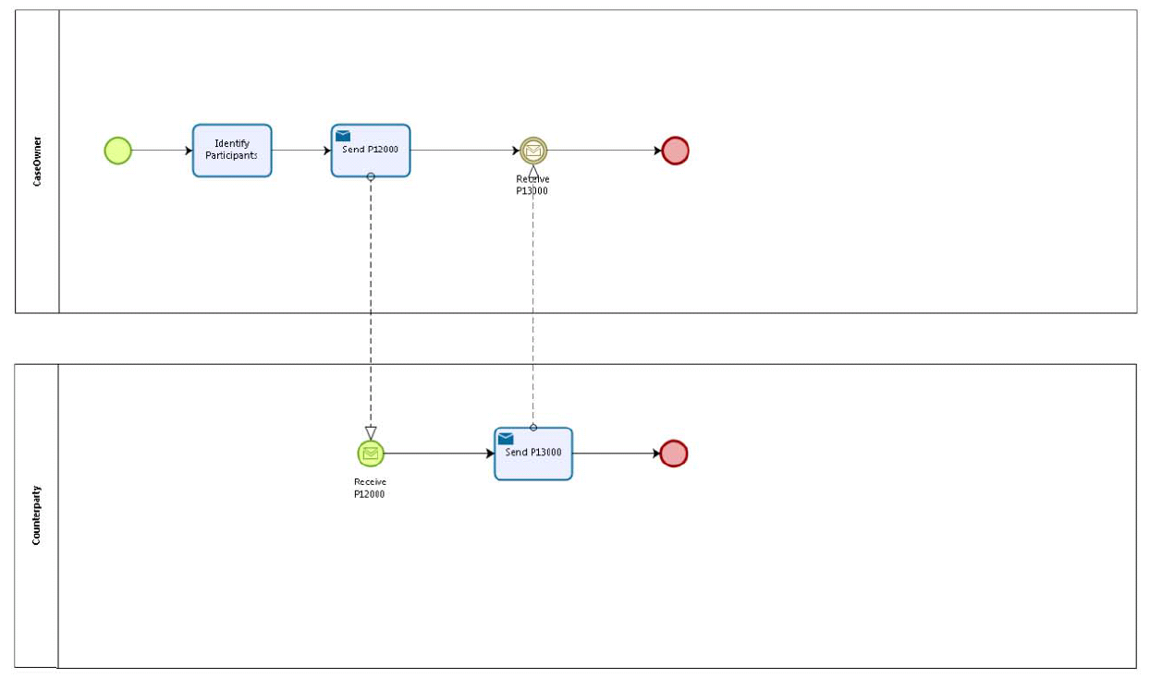

## Sub Processes

n/a

# Appendices

## Issues

|  |  |  |  |  |  |
| --- | --- | --- | --- | --- | --- |
| **#** | **Issue date** | **Description** | **Replies** | **Action/Resolution** | **Close date** |
| 1 |  |  |  |  |  |
| 2 |  |  |  |  |  |
| 3 |  |  |  |  |  |
| 4 |  |  |  |  |  |